News from Cremer’s Meadow, September 2015.

Many people went to mow . . . . . . What a difference! Most of the Meadow has been cut by members of the Conservation Volunteers and BADCOG, many thanks to all of them. See photo on the left below.

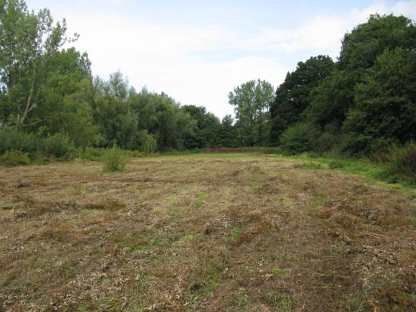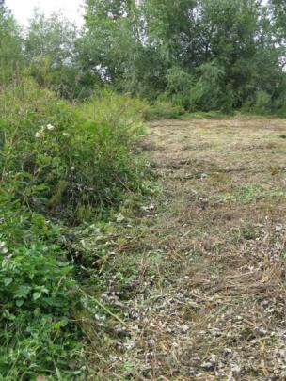

The tasks for Thursday 17th and Saturday 19th are to complete the mowing (see photo on the right), rake off the cut vegetation and remove it from the Meadow.

Old fashioned hay raking will begin at 10.00.
Cold drinks and sandwiches will be provided for lunch.
Please bring rakes and forks if you can.

If you think you can help the Friends of Cremer’s Meadow with the task of removing the mowings from the Meadow on Thursday 17th and/or Saturday 19th just turn up on the day. Any questions? Please contact Gill Buckley. 01603 717064

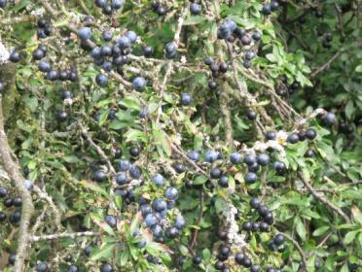 | The sloes are ripening nicely. In case you haven’t got a recipe for Sloe Gin, here’s one I found. You need a bottle of gin, 2 – 4 oz of sugar and 2 – 3 handfuls of sloes which have been pricked all over with a sewing needle.  Instructions.  Drink ¼ of the gin.  Put the sloes and sugar into the bottle.
Leave in a cool dark place until Christmas, inverting the bottle every day to mix the contents. Decant the liquid before drinking. You might like to try using the sloes in a pie or similar, but I find them still bitter. [You might need to lie down in a cool dark place after step 1!]

Jacky Heath 14/09/2015

