Come and join us for free Scones, Jam and Cream to celebrate the opening of

Cremer’s Meadow.

Saturday 17th September at 3.00 p.m.

Following two years of very hard work, the Friends of Cremer’s Meadow and Brundall Parish Council will be opening the site for general public access.

Come and join us as Shirley Cremer cuts the ribbon to celebrate Brundall’s new village open space.

Please arrive on foot or bicycle and wear appropriate footwear as the ground can be quite wet.

For more information contact: Gill Buckley.
01603 717064
i.am.gillbuckley@gmail.com

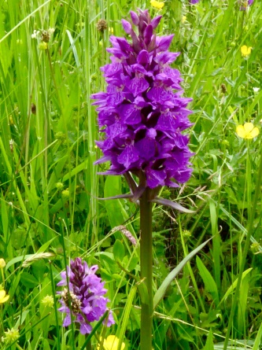

The entrance to the meadow is along the signposted footpath from Blofield road to Braydeston Church.

