Dear_____ resident,
We are writing to you to keep you informed of the actions that are being taken both nationally and locally to contain and ultimately defeat the COVID-19 Pandemic, and to reinforce the actions that we need you to take to help us in doing this.
Norfolk’s Councils have been working with community, voluntary sector and other public sector organisations in the county to prepare for when a situation like this might arise, while making sure they provide support to those who need it in our communities. But we also need each and every one of our residents to take action and help protect themselves and others.
We ask that you please read through the whole of this letter, which offers practical advice and directs you to key support packages if you are struggling at this time.
- Support for the vulnerable:
The Government announced on Sunday that it would be stepping up to directly support about 1.5m people identified as vulnerable in communities across the country.
Some people will already have received letters which asks them to contact a national helpline so support can be arranged for them. It is essential that we shield these people from the virus. As a county, we are aware this list will not identify all of the people in our communities that need assistance.
Therefore, if you are reading this letter and you are classed as vulnerable or you are in need of support, either now or in the coming weeks, please contact our designated phone line on 0344 8008020 and we will provide help. This line will be open from Monday (30th March), operating Monday to Friday, 9am-5pm.
- Volunteering:
Our community volunteers, local charities and council staff stand by to assist you. We ask that if you are able to volunteer some of your time to assist others in your community, we really need your help. If you are a business and can help with services, vehicles or other resources, we would love to hear from you, as together we really can make a difference. Individuals who want to volunteer should visit www.voluntarynorfolk.org.uk and businesses should email covidbusinessresponse@voluntarynorfolk.org.uk
- Financial help:
The Government has also provided a Hardship Fund and is putting in measures to help people if you are in need of this support, please visit your local council website and follow the advice.
Please do not visit your council offices, you will be able to access the information and ask for assistance either online or by phone. (District council number here)

- Help for businesses:
If you are a business in need of help, please visit the New Anglia Local Enterprise Partnership website www.newanglia.co.uk/free-support-for-your-business-during-coronavirus/
- Donations:
Finally, working with the Norfolk Community Foundation, we have launched a Norfolk Appeal Fund, which will be directed to charities on the front line of caring for people across the county. This fund will help us to support the people in our county who need it and is critical to our collective response. If you are able to support those in need in Norfolk, you can either go online to www.norfolkfoundation.com/giving-philanthropy/covid19communityresponsefund/ or through the post to: Covid-19 Response, Norfolk, Community Foundation, St James Mill, Whitefriars, Norwich, NR31TN. Cheques should be made out to Norfolk Community Foundation.
- Government directive:
It is essential that we take the direction we have been given by the Prime Minister and stay at home.
The advice was clear – leave home only for
Shopping for basic necessities
One form of exercise a day (on your own or in household groups)
Any medical need/care for the vulnerable
Travelling to and from work, only if absolutely necessary

- Public Health advice:
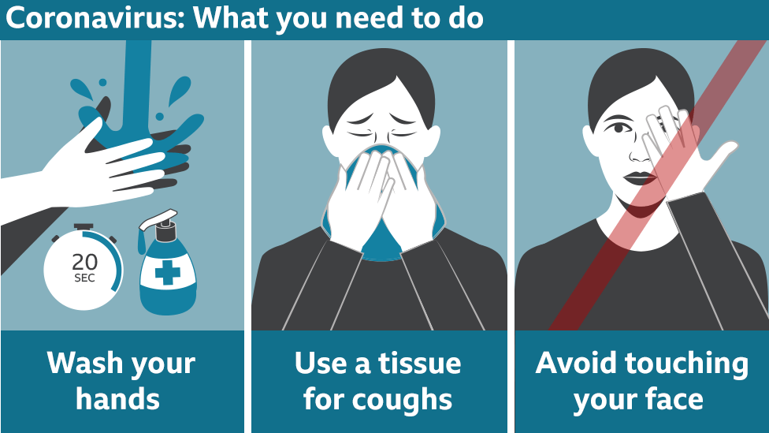
Norfolk was one of the last counties in the country to have confirmed cases of the COVID-19 virus, but this should not give us any false assurance. We like the rest of the country have a rapidly escalating situation that requires us all to act and act now. We need to take the advice to stay at home – the virus does not spread itself, we spread it and we need to stop.
For updates, please visit your local council website. www.norfolk.gov.uk and (district site here)
Signed…

