NORFOLK COUNTY COUNCIL
(brundall) (URGENT NOTICE)

TEMPORARY TRAFFIC RESTRICTION 2020
Road Traffic Regulation Act, 1984 – Section 14(2)

In accordance with the provisions of Section 14(2) of the Road Traffic Regulation Act, 1984, the Norfolk County Council HEREBY GIVE NOTICE that owing to essential gas connection works the use by vehicles of the Cucumber Lane from its junction with St Laurence Avenue for 20m northwards in the PARISH OF BRUNDALL will be temporarily prohibited from 21st December 2020 to 24th December 2020 for the duration of the works, expected to be about 4 days within the period. If necessary the restriction could run for a maximum period of 5 days.

Alternative route is via: Yarmouth Road, Stocks Lane, Blofield Road and vice versa

In the event of the start date being delayed the new start date will be displayed on site in advance.

The person dealing with enquiries at Norfolk County Council is Martin Dixon (Community and Environmental Services) Telephone 0344 800 8020.

Dated this 21st day of December 2020

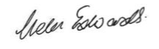

Helen Edwards
Chief Legal Officer

County Hall
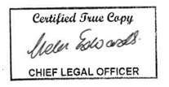
Martineau Lane
Norwich
NR1 2DH



