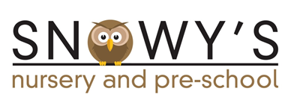
ADMINISTRATIVE ASSISTANT - PART TIME

We are creating a new post to support the work of Snowy’s Nursery and Pre-school. This will initially be for 6 hours per week, term time only.

The successful candidate will be able to fit into a small, friendly team and will be able to contribute to the smooth running of the office.

We are looking for someone who has good general office experience. The post will involve some financial tasks so some knowledge of bookkeeping and other financial aspects of an Early Years setting would be ideal. Both in-house and external training will be provided.

We will be looking for someone with good organisational skills, is flexible and reliable and has good interpersonal skills. An enjoyment of being around children would also be essential although the post would not involve directly working with them.

The hourly rate for the post would be £8.92 and the post includes 5.6 weeks holiday pay.

The post would require an enhanced DBS check which would be organised by Snowy’s.
If you are interested in the post and would like to request the application pack, please email the Chair of the Committee, Gill Buckley at gbuckley.snowys@gmail.com Completed applications to be submitted by Wednesday 10th February

