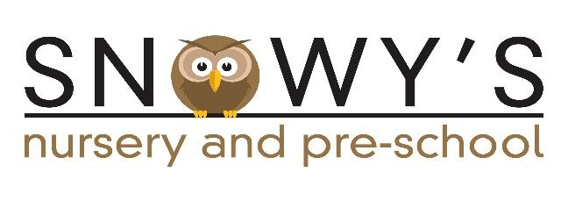
Come and join the Trustees

Snowy’s is our Brundall Nursery and Pre-school catering for children from 18 months up to school age.

As a non-profit-making charity, the setting requires a Committee of Trustees to support the established, very effective management team at Snowy’s. The Trustees are a welcoming group of people and value giving their time in such a worthwhile way.

This year there are 2 key vacancies due to the retirement of the Chair and Treasurer.

These roles become vacant from August but we are planning to recruit new people into those positions during the spring/summer terms. This will allow for a seamless handover and any training required.

It is not necessary to have a background in education to be a Trustee. The key requirements are enthusiasm and a drive to continue to maintain the high quality of the setting.

For more information, please contact Gill Buckley (current Chair) on gbuckley.snowys@gmail.com or phone 01603 717064

