Brundall Parish Council
Village Survey
As part of the development of the Land East of the Memorial Hall, there are 10 hectares of land that will be committed to leisure and recreational use for residents of the local area.
- 3 hectares in the parish of Brundall (dark green) – Formal and/or informal recreation
- 7 hectares in the parish of Blofield (light green) – Section 7 Countryside Act 1968
We are consulting the residents of Brundall through a survey to understand the aspirations of those who will be the main users of the space so that this can be fed into the initial design phase.
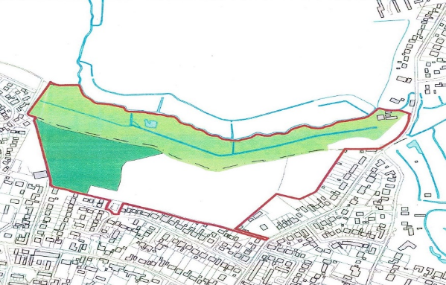
The survey can be found at the following online location from 1st October 2021:
https://b.link/brundall21
For those who are unable to complete the survey online we will offer the ability to complete the survey at the following locations:
Parish Clerk’s Office: Tuesday/Wednesday 11am to 1pm
Thursday/Friday 1pm to 3pm

All responses should be submitted by no later than Friday 12th November 2021 and the results will be published by Brundall Parish Council by mid-December 2021.
Thank you for your support in improving our village.
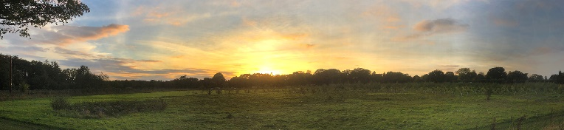
Photo: Greg Chandler

