Brundall Parish Council Land Management Committee

Minutes of a Meeting Held on 26th January 2023 at 10:30 in the Memorial Hall
Present: Cllr Graham Abbott (Chairman), Cllr Gill Buckley, Cllr Lawrence Britt, Cllr Mike Savory, Stuart Harper (parkrun director), Richard Farley (tree warden)
Deputy Parish Clerk: C Dickson
Chairman of Broadland Tree Warden Network: John Fleetwood
 | Details | Action
LM-0601 | Election of Chairman  It was agreed that the election of a chairman of the committee would be deferred to the next meeting.  Cllr Buckley was unanimously elected chairman for the meeting. She thanked Cllr Abbott for all his work as chairman.
LM-0602 | Apologies for Absence  Cllr Robin Tungate
LM-0603 | Declarations of Disclosable (DPI) or Non-Disclosable Pecuniary Interests (NDPI)  None received
LM-0604 | General Public Participation  None.
LM-0592 | Countryside Park Orchard and Hedging  Cllr Buckley summarised the history of the orchard and the items to be discussed:  The BTWN generously offered trees to create an orchard to replace the original one which had not thrived. At the last committee meeting the tree warden Richard Farley suggested surrounding it with a hedge to protect the trees as they were growing. A site visit was arranged. During discussions on site it became apparent the hedge could also offer a safe secure dog-free area, which might then attract young families to the Countryside Park. The possibility of a glade came out of this and repositioning of trees was considered and planned. The tree warden and BTWN subsequently advised that moving any trees would impact on pollination.  The committee ratified, with 1 abstention, the decision to approve the commencement of hedge planting.  The current plan (see below) would have a gate on the western edge leading to a glade of roughly 8m wide by 10-12m deep. This plan has been created from the original by moving 4 trees from the northern end and 2 trees to create a glade.  The BTWN have donated the trees at a cost of £2,170 and will undertake maintenance, pruning and training for the next few years. The committee is not unappreciative of what is being offered but the Parish Council has a duty to think about any additional value added benefit possible for the community.  Following discussions and debate the parkrun director suggested a new location for the glade and a new layout was agreed (see below). There will be one gate on the southeast corner and the orchard will be extended east to allow for an additional half row of trees or shrubs. This was unanimously approved by the committee. A site visit by several members of the committee will agree the location of the extended hedge line.  The tree warden and chairman of BTWN were thanked for their work and participation.
LM-0599 | Items for the next agenda  Orchard layout and hedge line
LM-0600 | Date for the next meeting(s) of the Land Management Committee  16th March 2023
Signed as a true record …………………………………………….……. Date …………………………

Current plan of the orchard

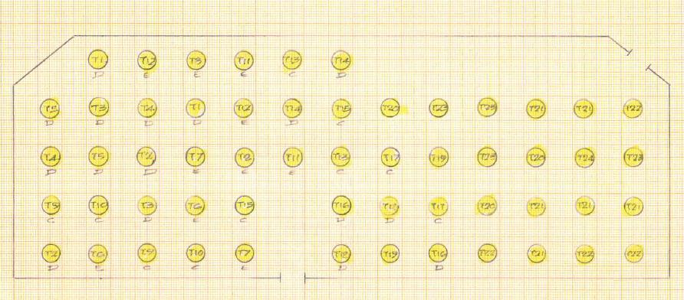

New plan for the orchard

