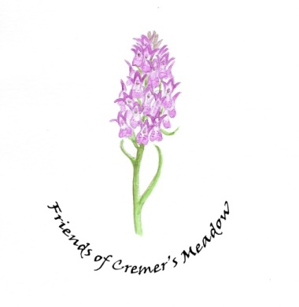
Cremer’s Meadow Land Management report 30th September 2021

Weekly work from the Friends continues to take place each Friday morning. There is now a rota of Team Leaders to ensure no one person is holding that regular responsibility.

Last month we altered our usual venue and did some clearing outside the Memorial Hall. This has vastly improved the look of the gardens there and allowed us to advertise the work of the Friends. From this event, we recruited one new regular member to the Friends.

Last week saw our annual Cut and Clear, supported by BADCOG and Bure Valley Conservation. It was a lovely day, enhanced by a lunch provided by the Central England Co-op. The sun shone and we managed to do the work in record time. 4 members of the public joined us and at least one of those is likely to join the regular working groups.

Vandalism continues on site with the latest being damage to the weir. This has now been repaired but it is disappointing that the Friends continue to have to repair these senseless activities. Fortunately, the damage to the windows on the hut seems to have abated due to Robs excellent shutters

Sam Brown from Norfolk Wildlife Trust visited us and is very happy with our management of the site. She gave us a few suggestions for some alternative ways we might like to consider which we will discuss at one of our planning meetings. She also helped us with useful information about the proposed bridge.

The planned work on the southern sluice is encountering some difficulties due to lack of engagement of our preferred contractor. Sharon has been requested to write to him giving him an official deadline. It may be that we have to wait until a lower water level is achieved ie next spring if he is unable to carry out the work this year – if at all.

The working party looking at the proposed bridge is very active. This is a separate agenda item for the meeting.

Gill Buckley.

