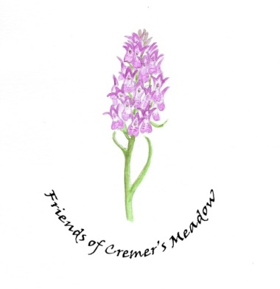
Cremer’s Meadow Land Management report 18th November 2021

We held our first indoor business meeting last week which enabled us to focus on the planning for the next 6 months. A list of jobs was created to take us over the winter months.

We resolved to limit our bonfires as much as possible, in line with the developing PC Clean Air policy. These are already significantly less than in previous years – only 2-3 in the last 12 months. We already use fallen logs etc for habitat piles but would like to look into shredding/chipping in the future if the need arises. We are also going to create formal compost bins. We anticipate having most of the materials on site for this but may have to ask for a small amount of funding if further wood etc is needed.

We are fortunate that Norfolk Wildlife Trust has offered us a donation of approximately £500 for tools which we are currently ordering. We are finding that we need tools with a bit more assistance as we are all getting older!

The frustration continues with the lack of action at the bottom of the watercourse. Despite frequent contact from both the Friends and the PC, the contractor has still not given us a start date. We continue to watch this space.

Following a summer visit by NWT we have resolved to slightly alter our Meadow mowing schedule next year. We plan to rotate just over 2/3 of the Water Meadow with half that amount being cut and cleared each year, the remaining half being left fallow. We will then “experiment” on the remaining land, dividing it into 3 parts and mowing at different times of year, starting in July. We want to see if we can encourage the Purple Loose Strife to grow and discourage some of the Meadow Sweet. We have seen alterations over the years in the amounts of both of these species. We will note and photo impact over 2-3 years.

The discussions about the potential bridge continue and are an agenda item for the LM meeting.

The work done by Rob to build shutters in the hut seems to be deterring the vandals who did damage in the past. Fingers crossed that this will continue to be the case.

The Friends hope to hold an impromptu Christmas lunch if the weather holds.

Gill Buckley.

