Brundall Parish Council Land Management reports to be considered

Name of organisation/group: Brundall parkrun – Countryside Park

Date: December 2023 Meeting

Highlights for sharing

Since the Land Management Committee last met, it is been a late Autumn of storms and cancellations, with the Run Directors taking the decision to cancel parkrun on 21st October and again on 18th November. On both occasions, heavy rain (following Storm Babet & Storm Ciaran) left the course (far!) too wet to safely hold an event. Whilst these cancellations are always regrettable, and not done lightly by the Run Directors, they are the right thing to do. We are ever conscious of both participant safety, and the impact on the course.

On a more positive note, we did manage to hold three events in the month of November, where a total of 270 people ran, jogged or walked – a healthy average of 90 participants per event.

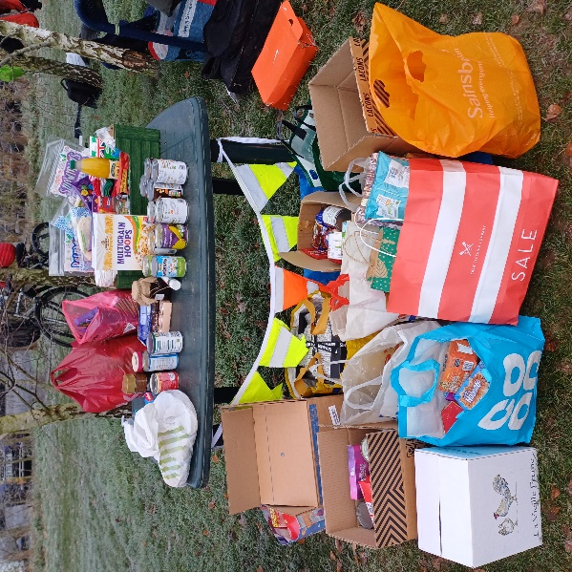
2nd December started our winter season, with 91 people enjoying the event on a crisp morning. Arguably more important than the participation was our pre Christmas donation drive for the Yare Valley Churches Community Pantry. Here our generous runners, walkers and volunteers donated a very good amount of food and small Christmas gifts - as requested by the Community Pantry. We know that the volunteers at the Church will distribute these donations wisely, and it was lovely to contribute back to our community.

Issues you wish Land Management to discuss

Potential sand (or other substance such as wood chip) for the course to ease the winter mud – clarification of the process to Brundall parkrun to follow for this to be considered.

Help requested from within Land Management groups

None at this stage.

