Matthew Davies
Project Officer
The Norman Centre

Bignold Road,
Norwich, NR3 2QZ

Mb: 07733102013
Email: matthewdavies1@norwich.gov.uk
Web site: www.norwichfringeproject.wordpress.com

16 November 2023

Draft Access Report for Church Fen Wooden Board Walk and soil path down to Brundall Staithe

Author: Matthew Davies Project Officer
Client: Brundall Parish Council

I have been asked to prepare a report for Brudnall Parish Council exploring the options for the future management of both the Woodland Board and soil path between the two ditches from the Railway Line down to Brundall Staithe.

I visited Church Fen, with members of the Parish Council during the summer of 2023. I was asked to look at the current set up and concerns regarding the short and long-term management of the wooden board walk. We also walked along the solid path between the two ditches as well and I was asked for my thoughts about the short- and long-term management of the two access paths.

I revisited Church Fen on Tuesday 19 September 2023 to review the two paths.
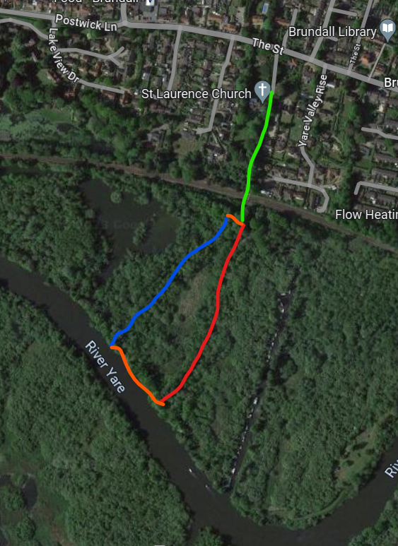
Access to Church Fen is from Church Lane off The Street Burndall, walking down Church Lane past St Laurence Church, which leads into a rough hard surface track down to the railway line.

Map location for the railway line crossing into Church Fen what3words /// The simplest way to talk about location

The wooden board walk, and earth path provide a circular walk between the railway line and Brundall Staithe on the River Yare

Wooden Board Walk
The board runs from the railway line to Brundall Staithe on the River Yare, through former marsh / fen habitat which includes wet and dry woodland species and habitat.

Installed in the mid to late noughties, by The Broads Authority National Park, the board walk consists of:
Sleepers laid on top of each other on the waterlogged ground, which support decking boards laid in long lengths, spanning in rows of 5 decking boards (between the wooden sleeper supports underneath)

Measurements
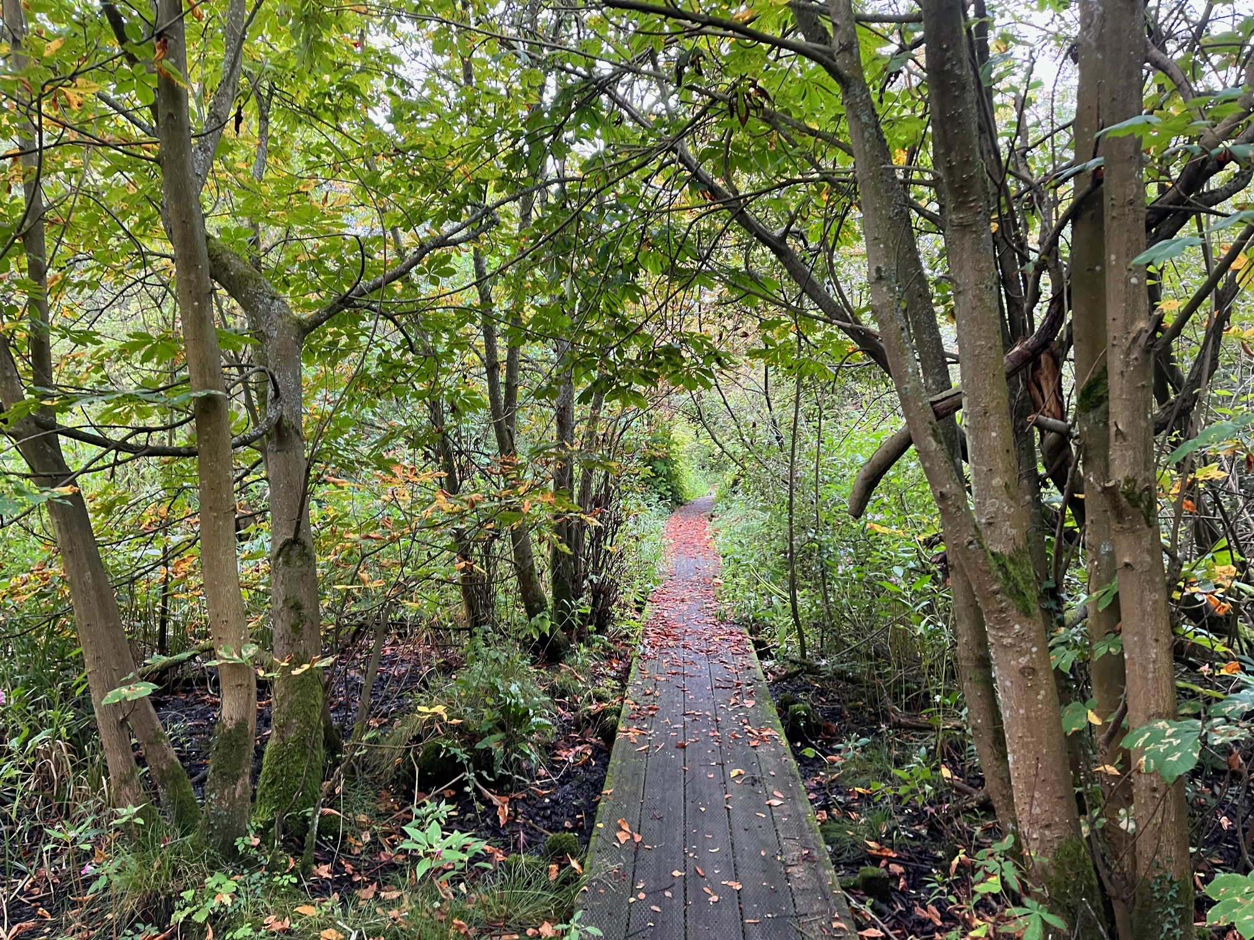
Decking boards are currently 4.4m x 200mm x 80mm.
Sleepers appear to be between 1.5 and 2m in length 150mm x 200mm
The height of the sleepers from the ground to board walk are between 300mm and 400mm
The length of the board walks is 282m long

Current maintenance constraints
Repairing the boards can be difficult due to having to remove the non-slip metal mesh and accessing the boards.

The way the decking boards have been laid can make them structurally weak and vulnerable to modern battery scooters and cycles. As there appears to be lack of support underneath the boards. It also makes them difficult to access and repair.

Boards walks are traditionally built this way, see picture below, which gives them more strength and easier access to repair. The decking boards are also lighter and easier to transport and move as they are shorter. Although access to the wooden beams underneath supporting the decking board can be difficult to access and replace.
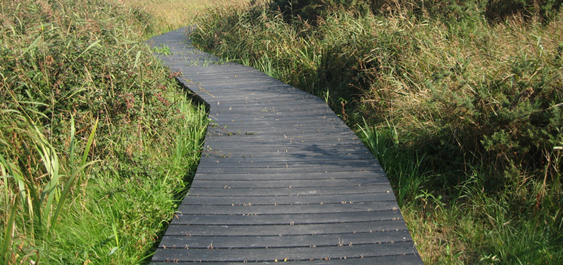
Current condition and maintenance
On a quick visual inspection, the wooden board walk, in general, appeared to be in good working order. Although some replacement of rotten decking boards had taken place, you could see that there is an ongoing need for more boards to be replaced.

There was a small section which had moved due to a fallen tree and needed repositioning.

As the wooden board walk starts to age there will be a need to replace more of the wooden decking boards and potentially the uprights. The construction of the board walk makes it difficult to replace the timbers.

Wood opposed to Recycled plastic
Around 2000 the wood treatment process changed. Companies stopped using certain chemicals in the wood treatment process, this has meant that the life expectancy of soft wood treated timber is between 10 and 15 years compared to a 25 to 30 life span for a board walk.

There are two options for purchasing soft wood pressure treated timber.
Option one
Timber which has been treated when straight out of the forest, so still wet as it hasn’t had time to dry out. This means that the wood treatment may not be as fully absorbed to the second option.

Option two
The soft wood timber has been kiln dried then pressure treated which means that the wood absorbs the wood treatment for readily.

Once you cut into treated timber it become vulnerable to decay as your break the treatment barrier.

Recycled plastic has become a very reliable product in replacing timber. Although more expensive it has a long lifespan, modern recycle plastic timber is more resilient to temperature changes and light. Although, there is a need to manage any residue from cutting and drilling the material on site.

Options for replacement of the Wooden board walk
- Do nothing
Not feasible as the current board walk needs to be repaired to keep it safe.

- Continue to repair the existing wooden structure
This is a possible option and would require an ongoing maintenance plan which would be indefinitely.

- Close the board walk and stop access, leave to rot down
This is possible although may cause public outcry and could create a health and safety issue.

- Remove the board walk and don’t replace
This is possible although may cause public outcry.

- Remove the board walk and replace with a raised hard surface path
The cost of doing this and the logistics with the amount of material needed, would not make it a feasible option. There will also be issues with needing permits from the Environment Agency and producing flood risk assessments.

- Remove the board walk in one go and replace with recycled plastic timber
This would be the most sustainable and long-term option, although expensive in the short term.

- Remove the board walk in a phased approach over a number years and replace a section at a time with recycled plastic
This would be the most sustainable and long-term option, with the cost being spread over several years.
The remaining wooden board walk would need maintaining until it was replaced with the recycled plastic timber.

Links to Plaswood who make the recycled plastic timber there are other companies.
Corporate Range Archives - Plaswood Group
plaswood-boardwalks-decking-fencing-guide-2021.pdf go to page 10

Raised path between the two ditches
This appears to be a historic access point down to Brundall Staithe, from the railway line crossing, where two ditches have been dug out and the soil used to create a path in between the two ditches.
Over the years trees have grown up alongside the path, with some trees showing signs that they have been managed through coppicing in the past. There are a number of semi-to-mature trees along the path as well, with tree roots being visible in a number of locations.
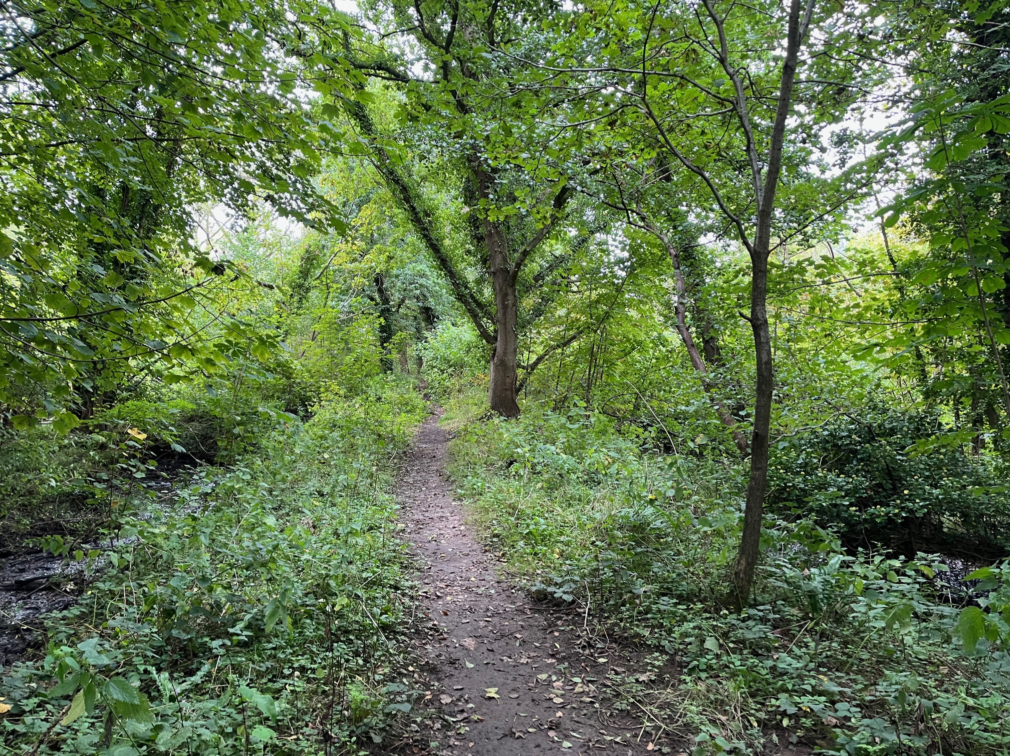
The path appears to become flooded in very wet weather and when there is a high tide.
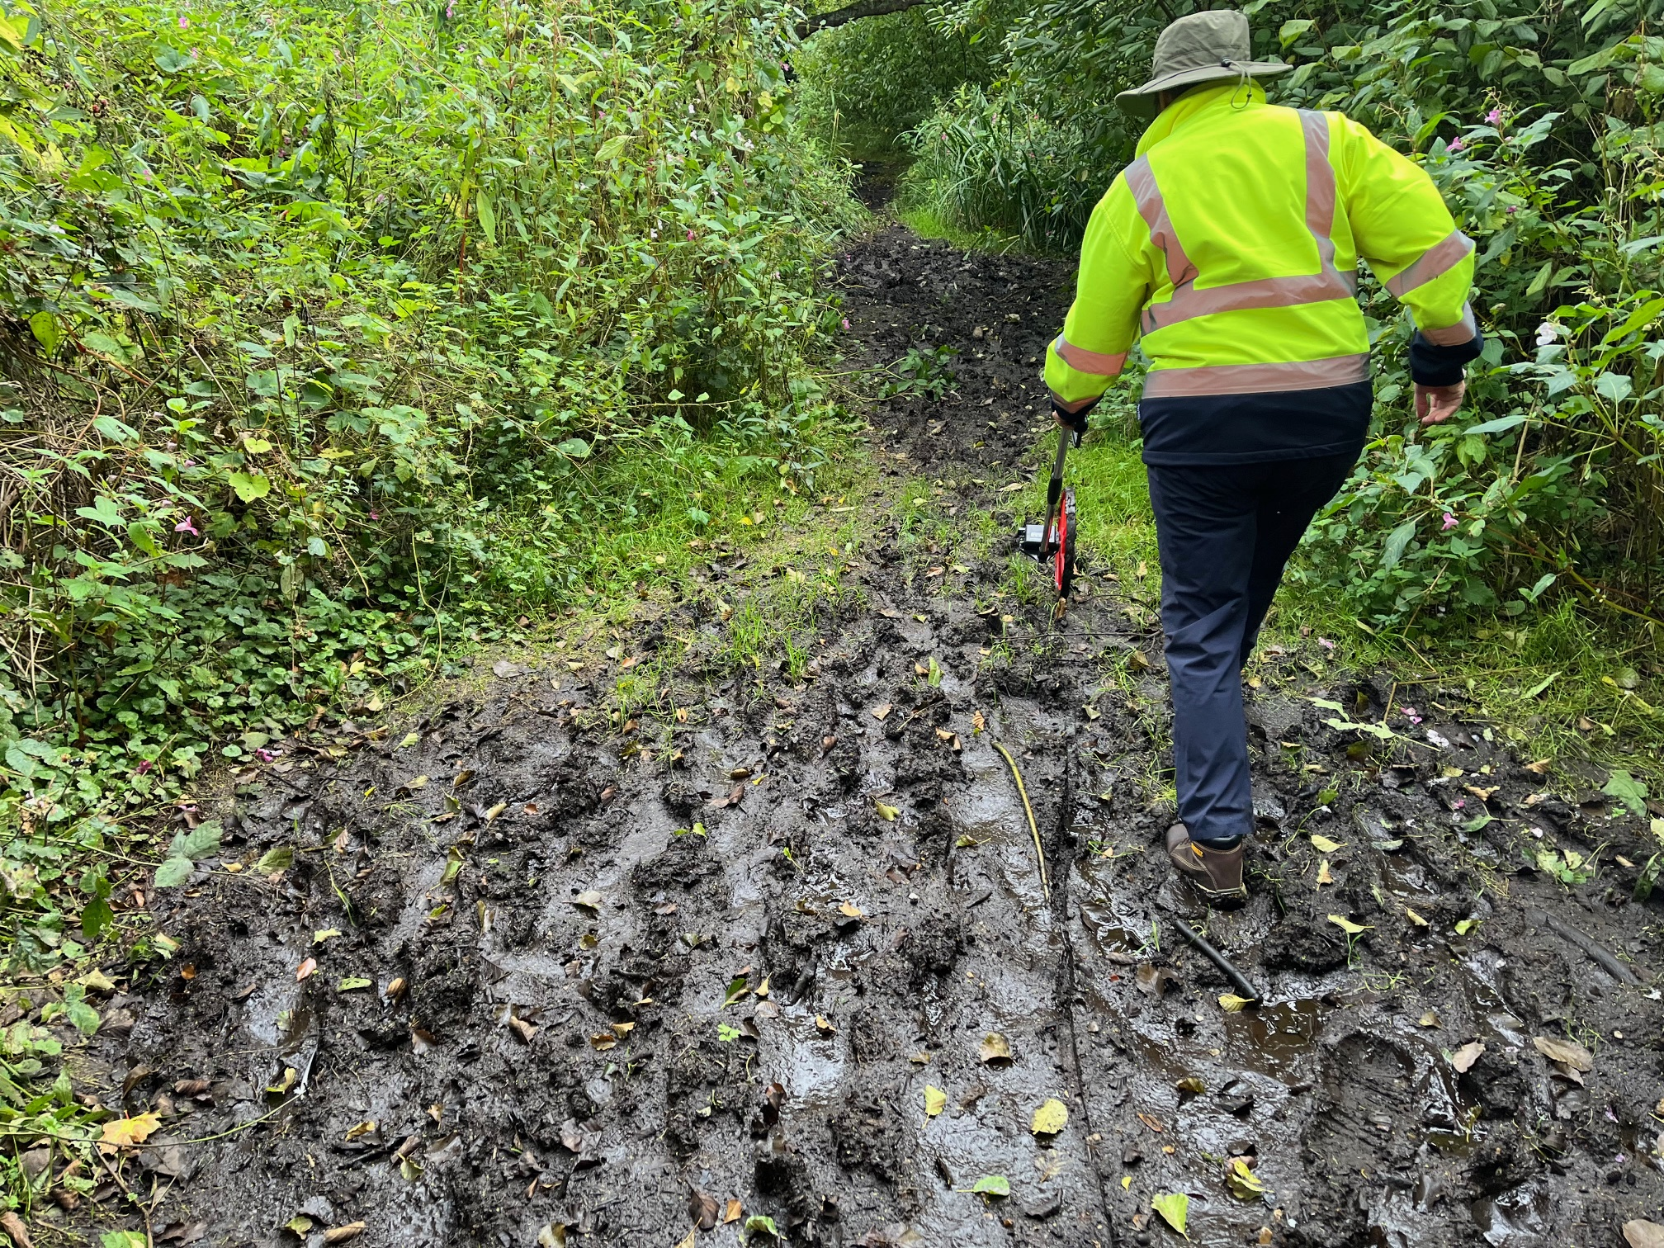

As you can see from the photo the path was muddy and difficult to pass in several places and would require suitable footwear. There are two pedestrian foot bridges along the route of the path, which would effect the use of machinery such as dumper trucks and 360 tracked excavators.

Options for improving the raised path

Do nothing
This is feasible as the path is still useable, although there are issues with exposed tree roots, making the path uneven. There are also several areas where the path is muddy and difficult to pass without the appropriate footwear on.

Raise the height of the path with gravel
The height of the path could be raised with type one granite. Where feasible, as tree roots will be a problem and advice would need to be taken from Broadland Councils Tree Officers re-covering the exposed tree roots with type one granite material. They may suggest putting a plastic board walk over the exposed tree routes to protect then and prevent route compaction. Although, the board would prevent/ restrict future machinery access for future maintenance of the gravel path.

Basic specification for installing an MOT Type one granite path, dig out 50mm to 75mm of the existing material on the path put to one side. Lay the geotextile or terram membrane and back fill with 150mm depth of MOT type one granite. To get the best result, the type one will need rolling with a compact road roller, although compact vibrating plate can be used.

The MOT type one granite can be left as the final path surface, with the removed soil used to feather edge the sides of the path.
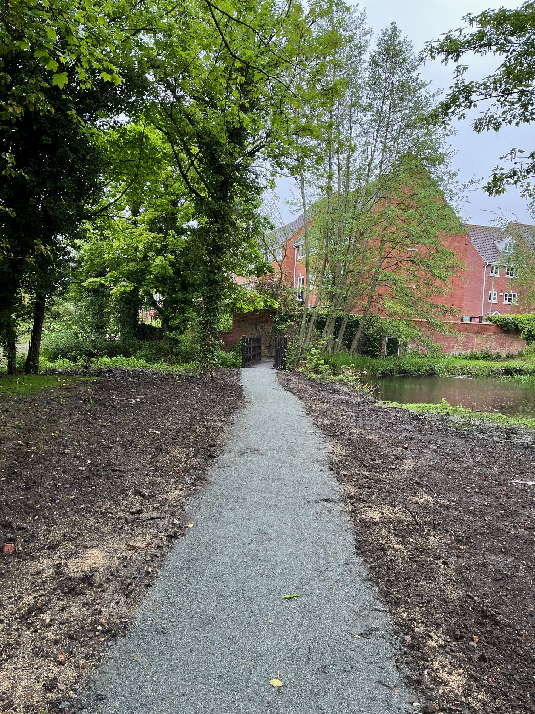
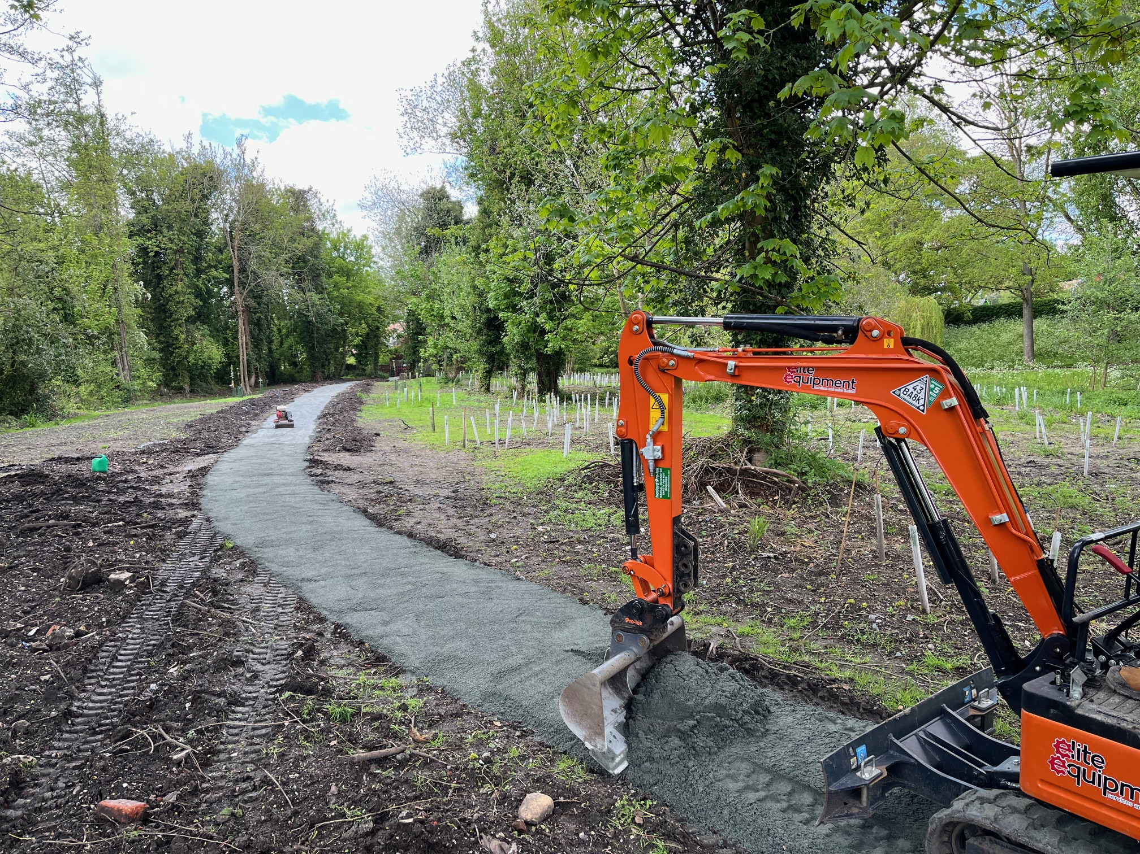

For a smoother finished surface, the path can be dressed to a depth of 25mm to 50mm with 0-5mm granite dust or to a depth of 50mm to 75mm with 20mm graded hoggin (hoggin needs to have a minimum clay content of 25% otherwise it won’t bind properly.

Raise the height of the path by digging out the ditches either side
Using a 360 tracked excavator dig out the ditches on both sides and put the arisings onto the existing path, between the two ditches. This will help to raise the height of the path and manage / open the ditch system.

Constraints to consider for these options
- Access in getting a suitable size 360 tracked excavator onto site due to the railway line on one side and the river Yare on the other

- There are two bridges along the route of the path, which would be in the way and would need to be removed and replaced with culverts.

- There is a significant number of trees on both sides of the path, with some of the trees requiring to be coppiced to allow access for the 360 excavators. The removal of the trees may not be feasible due to the environmental damage caused. Although at some point in time some of the trees will need to be re-coppiced. There would be issues around what to do with the coppiced timber and arisings. An Ecological Impact Assessment, EIA, would need to be carried out and advice and permissions required for the work from the Tree Officer at Broadland Council and potentially the Environment Agency.

- The wet arising’s from the ditch work on the path would take at least 6 months to dry out. There would be a need to regrade and level the arising on the path once it has dried out. There may be a need to surface the path with hard dressing material as discussed in the previous option. The path would need to be closed until the wet arisings have dried out fully and the path surface has been regraded.

Factors to consider for both access paths

Access
Access from Church Lane Brundall
The narrow and steep track, with limited parking, which in places is in a poor state of repair and the crossing of the railway line may be a potential issue. There may be a need to repair the track and cut back any hanging vegetation.
Difficult to get lorries down to site and across the railway line to deliver material particularly the type one gravel and dressing materials

Access from the River Yare to Brundall Staithe
This may be an alternative approach, with material and equipment being delivered by barge to site and kept securely on the barge.
The barge could be left on site during the project and the contactors access the site by vehicle from Church Lane

Machinery access for installing the hard surface path between the ditches
The two pedestrian bridges wouldn’t allow diggers and dumpers to access the path to undertake the path improvement work and ditch digging out work

The two pedestrian bridges may need replacing with culvert pipes to allow access for the machinery

Material storage
- Shipping container could be used to store the material on site
- Material stored securely on the barge
- For the gravel path a digger will be needed to unload the gravel from the barge
- Material could be stored on the other side of the railway line at the entrance to Church Fen, although as mentioned access to the railway line by heavy plant equipment may be an issue.

Welfare unit
This will be required with generator to recharge the batteries from drills etc. and for the contractors to have a basis, toilet, tool storage etc.

Tree and vegetation management
There will be a need to cut back the willow scrub, trees and vegetation over hanging and close to the board walk. This will make it easier to access the board walk, remove the old board walk and install the new board walk

As mentioned there would be a need to coppice a number of the trees on the path between the two dykes for access.

Risk
We met a local couple who visit the site on a regular basis, they asked what we where doing and we explained that we were surveying the site, to make recommendations for the improving the board walk.

The couple mentioned that flooding of the earth path and board walk is becoming more regular, and the height of the structures should be considered.

They also felt that the modern battery powered scooters and pedestrian bikes, where causing the timber board walk to fail due to their weight.

There is a need to ascertain at what height both paths need to be raised to prevent future flooding issues.

Time of year to carry out the work - considerations
Flooding due to rain fall and tidal conditions
Visitor pressures during the boating season
The paths will need to be closed for access restricted when the work is being undertaken

Environment agency consent
The environment agency would need to be contacted to ascertain if any permits are required and any consent is needed for working in the flood plain. Particularly if additional material is being brought on site, which may affect the capacity of the flood plain.

Planning permission
Both the Broads Authority and Broadland District Councils would need to be consulted to see if planning permission is required for the work.

Ecological Impact Assessment, EIA
If you were looking to coppice, fell any trees and to dig out the ditches and use the arising to raise the height of the path. Then an EIA would be required and potentially be needed as part of any planning conditions and Environment Agency consent.

Communication and community consultation
You may wish to consider undertaking a community consultation about the planned work, to get public support. This could take the form of:
- Short survey using monkey survey
- Site meetings
- Posters placed up on site
- You may wish to consult other organisations such as the Broads Authority, Broadland District Council, Environment Agency, local boat owners and any local community groups.

