Brundall Parish Council Land Management reports to be considered

Name of organisation/group: Brundall parkrun – Countryside Park

Date: February 2024 Meeting

Highlights for sharing

Since the Land Management Committee last met, it is been a wet winter of rain, Named Storms and sadly (more!) parkrun cancellations. The Run Directors took the difficult decisions to cancel parkrun on both 1st January and then again on 6th January. Heavy rain had left the course (far!) too wet to safely hold an event. Whilst these cancellations are always regrettable, and not done lightly by the Run Directors, they are the right thing to do. We are ever conscious of both participant safety, and the impact on the park.

On a more positive note, we are grateful for the 1 tonne of sand, which enabled us to treat at least some of the more slippery parts of the course. The parkrun volunteers undertook a simple 3 stage process – raking leaves and twigs from the course, aerating with a garden fork, then thinly spreading the sand. 6 weeks after this process, we can still see the benefits. Ideally, we would like to repeat this process in mid February to a few more parts of the course to improve safety – please see ‘Issues to Discuss’ Section below.

From a participation perspective, when we did get going, the New Year has started strongly with good numbers of runners and walkers enjoying some bright sunny winter mornings: 109 for the first event on 13th January, 107 for the most recent on 27th January.

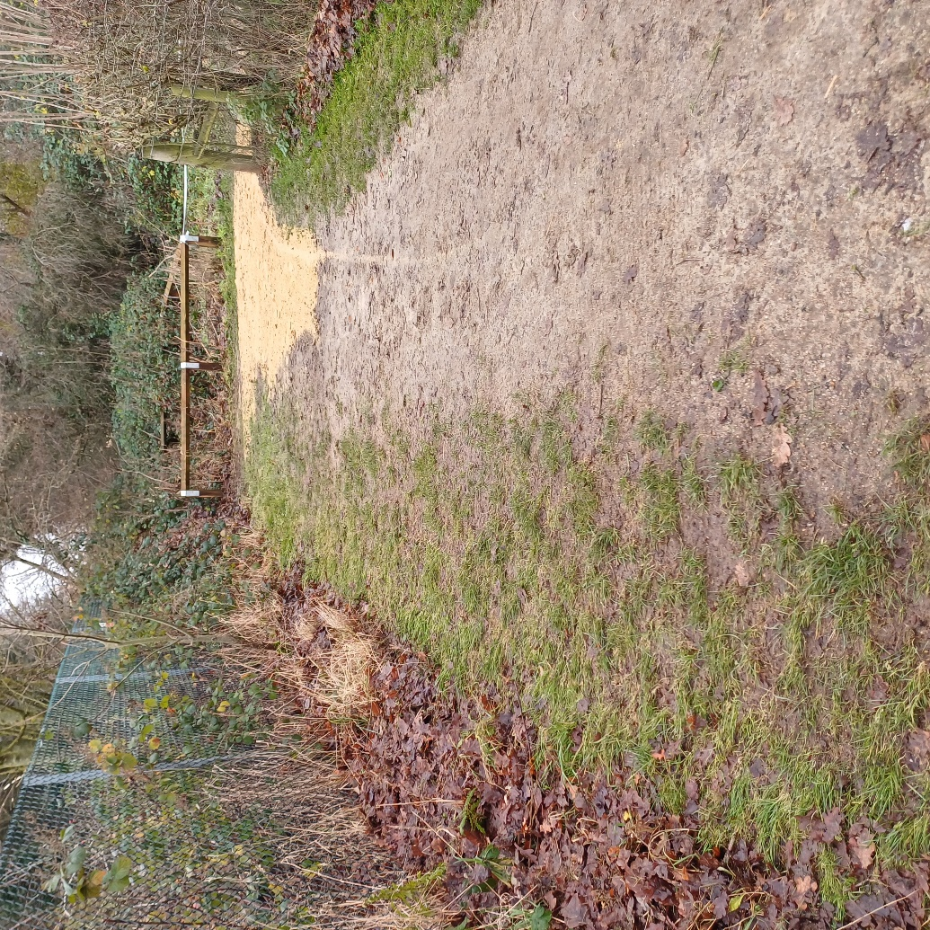

Issues you wish Land Management to discuss

Whilst conscious and respectful to the wider views of the volume of sand used in the past, for this winter we have gone from 14 Tonnes to 1 Tonne. Whilst the 1 Tonne was appreciated, and made a good difference to parts of the course, we would like to request another 1 Tonne for near immediate delivery. This will allow us to selectively treat a few more small areas of the course (largely corners) to improve participant safety for the remainder of the winter and into early Spring.

For Winter 2024-5, parkrun will liaise with the Countryside Park users to come up with a ‘Winter Maintenance Plan’. The aim will be to present this to Land Management committee in late Summer/early Autumn 2024 for consideration.

Help requested from within Land Management groups

None at this stage.

