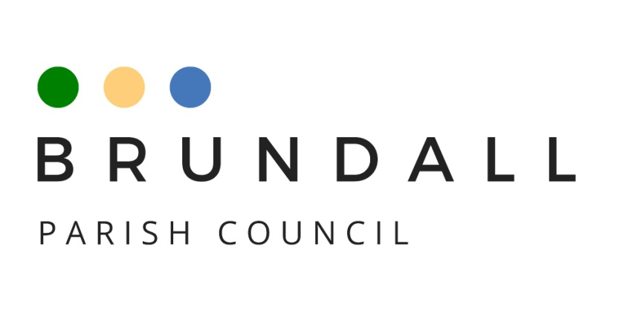
Community Infrastructure Levy Policy
This policy is designed for projects external to Brundall Parish Council but within the parish of Brundall, or those that will benefit the residents of Brundall.

What is Community Infrastructure Levy?
The Community Infrastructure Levy, often referred to as “CIL”, was introduced under the Planning Act 2008 and came into force in April 2010. On some forms of new developments CIL allows the District Council (Broadland District Council (“BDC”)) to raise funds to help fund the infrastructure needed to mitigate the impact of new development. CIL funds are used for either infrastructure of wider strategic benefit to the district or local infrastructure.

How is CIL allocated to Parish Councils?
15% percent of the CIL received by BDC is passed to parish/town councils where development is taking place. The amount rises to 25% in areas with an adopted Neighbourhood Development Plan. Brundall Parish Council adopted their Neighbourhood Development Plan in May 2016 and therefore receives 25% of any CIL for Brundall.

What can it be spent on?

The CIL Regulations 2010, as amended, state that the Parish Council must spend the CIL income they received from the District Council on either:
- The provision, improvement, replacement, operation or maintenance of infrastructure; or
- Anything else that is concerned with addressing the demands that development places on an area.

Therefore, Brundall Parish Council (“BPC”) has a duty to spend CIL income on providing, improving, replacing, operating or maintaining infrastructure that supports the development of the parish, or anything else concerned with addressing the demands that development places on the area.

‘Infrastructure’ is defined in the Parish and Country Planning Act 2008. There are typically three broad categories of infrastructure:
- physical infrastructure - highways, transport links, cycleways, energy supply, water, flood alleviation, waste management
- social infrastructure - education, health, social care, emergency services, art and culture, sports halls, community halls
- green infrastructure - parks, woodlands, play areas, public open space

The regulations provide BPC with the authority to spend the money on a wide range of projects based upon the support of the local community. Any CIL monies due to the Parish Council are confirmed by BDC at six monthly intervals in March and September with funds being paid to the Parish Council in April and October.

Providing CIL is spent in accordance with the above, CIL monies may be used to provide seed or matched funding with other income streams and/or may be spent collaboratively with other parish councils, community interest groups or other providers to make the most efficient use of funding to benefit the community.

Timescales for spending the funds

The Parish Council has a five-year period in which to spend CIL monies from the date received, thus funds may be accumulated to provide for major projects. Where money is not allocated within five years of receipt the regulations give BDC the power to recover those funds.

All decisions involving the allocation and spending of CIL must be made at full Council meetings.

CIL spending decision process

BPC will spend CIL funds on Council projects where appropriate but also welcomes applications from local groups or organisations for projects on which to spend CIL money. If the proposed projects are within the CIL regulations, and are items on which the Parish Council may lawfully spend, then a prioritisation process will be carried out and the criteria outlined in this policy will be used as a ranking mechanism. A prioritised “CIL Project List” will be maintained and will be referenced when CIL funding becomes available. Organisations proposing their own projects will be required to put forward costed and deliverable projects with multiple quotes and supporting information, such as financial accounts belonging to the beneficiary.

The full Council will hold triage sessions during Parish Council meetings to resolve whether to include the application on its future CIL Projects List and its level of priority in respect to other projects. Full council meetings are open to the public, however the Council may move into private session if commercial sensitivity is required in order to achieve best value for public money.

Project size will be categorised as follows: -
Small projects anything up to £2,000
Medium projects £2,000 to £10,000
Large projects more than £10,000

All projects must have matched funding.

For project applications over £2,000 the Finance group will review the application first then make recommendations to the full Parish Council. Applications over £2,000 should provide a business case and 3 years’ worth of financial records (organisations only). The applicant(s) will be expected to present, in person, to the Finance group.

After reviewing the application and assessing the presentation, the Finance group will put forward their recommendation to the next full Parish Council meeting for consideration. Any relevant, supporting documents, such as guarantees, letters of authority from landowners etc., will need to be made available to the Clerk for circulation to all Councillors at least 2 weeks before the relevant Parish Council meeting.

The higher the value of the project application, the more rigorous the information and evidence requirements.

For projects over £10,000 there will be a two-stage process:
- pre-approval in principle by the full Parish council based on current project objectives and estimated costs
- followed by a more detailed subsequent application when a more precise application can be submitted. Pre-approval does not guarantee formal approval of funding once the formal application is received and presented.

Projects over £10,000 will require due diligence and may require project liability insurance.

Criteria used by the parish council to rank projects for CIL expenditure

The CIL Project List is expected to cover projects providing, but not be limited to, the following benefit categories:
- Crime reduction
- Traffic/Road safety
- Community engagement
- Leisure/Sport/Amenity
- Communication
- Public services/Public Safety
- Heritage protection
- Environmental/Climate change

In general, the council will use the following primary criteria to rank CIL projects against each other:
- Community Benefit – how wide an impact will the project have for Brundall and how many people might benefit
- Costs and Funding – The overall cost of the project and any future expenditure it may generate, such as ongoing maintenance. Projects part-funded by the benefitting organisation or from grant funding may increase the ranking as it means more projects can be financed.
- Deliverability – how practical is the project and are there likely to be barriers around the planning or legal aspects
- Environmental Benefits – does the project offer benefits to the environment of the village and show no negative impact

Secondary criteria under consideration may include:
- Projects that have a lifespan more than 15 years
- Projects that demonstrate the benefit will be sustained with revenue expenditure
- Projects that reduce running costs or increase revenue generation
- Projects that mitigate the detrimental effects of development, such as those delivering infrastructure identified as being required in the community
- Projects that connect developments to parish services and assets

Points to note
- Inclusion on the CIL Projects List, or meeting some or all of the criteria for CIL ranking, does not commit BPC to fund the project;
- All Council spending decisions are made by a majority vote of Councillors present at the meeting;
- The Council will periodically review the CIL Projects List following receipt of CIL funds and may resolve to award funding on the basis of current priorities and available funds;
- The Council may ask for supporting information to be provided, such as group financial accounts, or multiple quotes for the work;
- this list is not exhaustive.

