CEMETARY FLOWER BED.
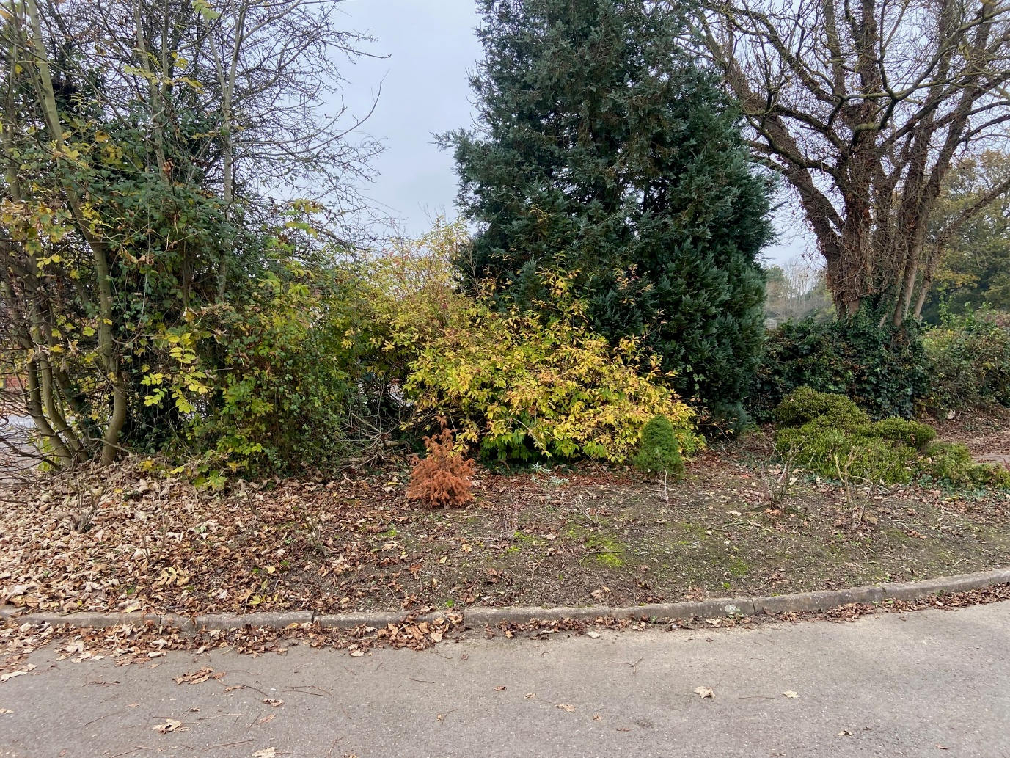

PROPOSAL:
Firstly, I would cut back the existing shrubs and remove unwanted plants. This can be done in February?
PH test identifies the soil as moderate acid which will suit the proposed plants.
pH 6.1 - 7.0
Moderately acid soil
A pH 6.5 is the best general-purpose pH for gardens, allowing a wide range of plants to grow, except lime-hating plants
The availability of major nutrients is at its highest and bacterial and earthworm activity is optimum at this pH
Action: It is not usually necessary to add anything to improve soil pH at this level
Put in a timber (or similar border) with the purpose of holding back mulch. This can also be done over the winter.
(https://www.rhs.org.uk/soil-composts-mulches/ph-and-testing-soil)
The roses look unhealthy, I need to find out what they were like over the summer and if OK they need feeding (We will see what happens in the spring).
I think a cemetery needs a butterfly attractor (Many civilizations believe butterflies are the symbol of a human sole) I would propose Buddleja butterfly bush) which can be set in spring.
In the back we need some evergreen like Rhododendron or Azalea (Acid soil) planted in leaf mould and coffee grounds.
Brundle Gardens station is very nice, have a look at the Michaelmas daisies and Callicarpa bodinieri Profusion for long lasting colours.
I do not know if there are any bulbs but propose we plant more daffodils next autumn.
Fertiliser examples:
You can make a homemade fertilizer for roses using ingredients from your kitchen and home, such as banana peels, coffee grounds, egg shells, and Epsom salts:
- 1. Banana peels
Contain potassium, calcium, magnesium, phosphates, and sulfur, which can help roses fight disease and support their immune system.
- 2. Coffee grounds
Provide a nitrogen boost. However, coffee is acidic, so you may need to adjust the soil pH with lime or another alkaline source.
- 3. Egg shells
Can be used in a homemade fertilizer.
- 4. Epsom salts
Promote bloom color, greener foliage, and more vigorous cane growth. Apply in spring or at the time of planting.
Here's how to mix a homemade rose fertilizer:
- Mix equal parts banana peels and coffee.
- Add crushed egg shells and Epsom salts half the amount of the banana peels.
- Make a small trench around the drip line of the roses and sprinkle the mixture in.

