Brundall Parish Council Land Management reports to be considered

Name of organisation/group: _Brundall Allotment Association____________________________________date: December 2023_________________

Highlights for sharing

Progress with re-erection of Youth Shelter – see photos.

Vacant Plots – Part way through viewing and re-letting of plots.

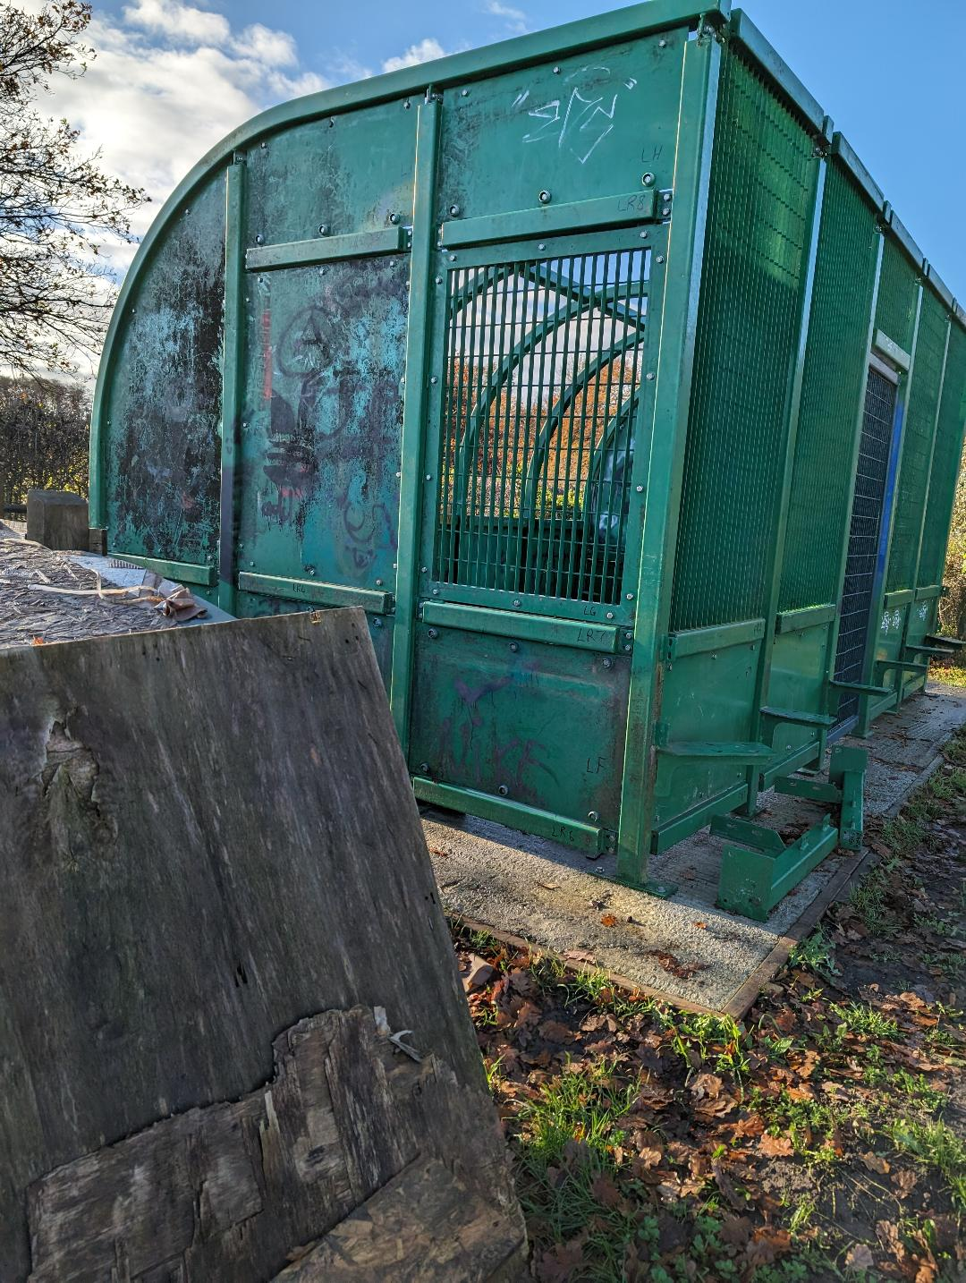

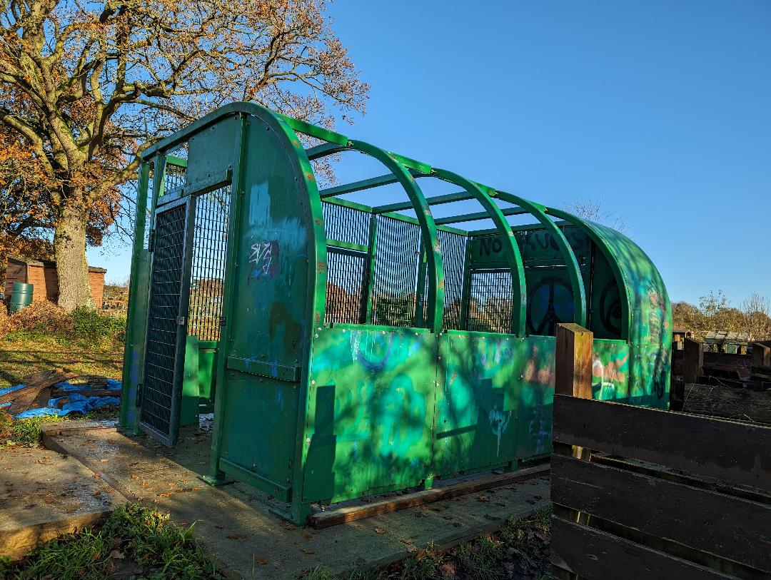

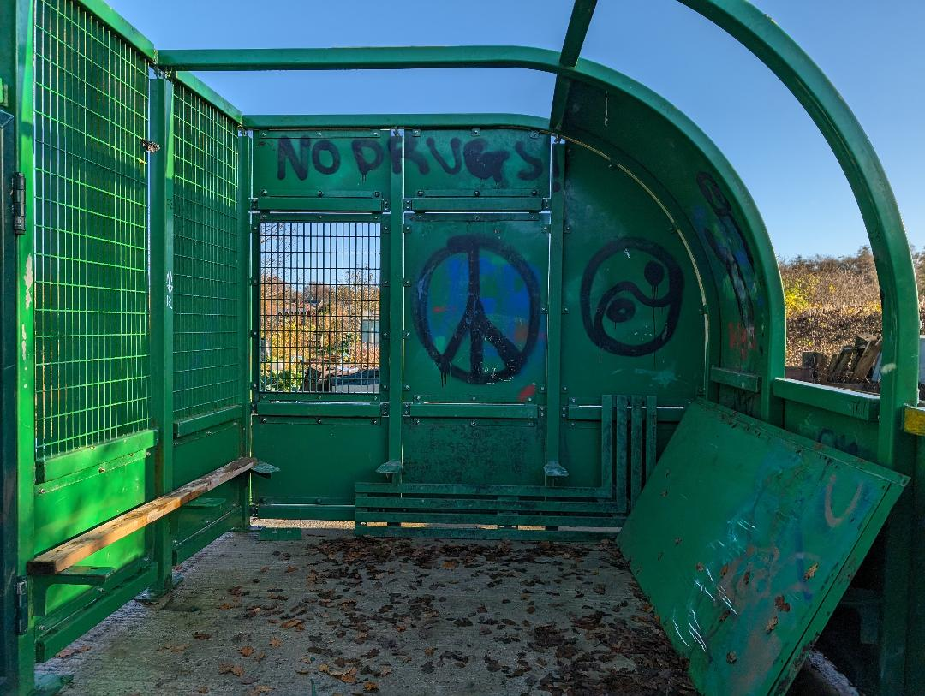

Issues you wish Land Management to discuss

None

Help requested from within Land Management groups

None

