

Standard conditions of contract, conditions of tender and specification for grass cutting and general grounds maintenance to:

- Parish Council owned/leased land

- Delegated Authority -Norfolk County Council Highways verges

Table of Contents
INTRODUCTION 4
1. GENERAL 4
2. THE CONTRACT PERIOD 4
3. SCOPE OF WORKS AND GENERAL RESPONSIBILITIES 4
4. INVITATION TO TENDER 4
STANDARD CONDITIONS OF CONTRACT 6
1. DEFINITIONS 6
2. VARIATION OF CONTRACT 7
3. THE SUPERVISING OFFICER 7
4. CONTRACT PERIOD AND COMMENCEMENT DATE 7
5. PERFORMANCE OF SERVICE 7
6. VARIATION 8
7. MONTHLY INVOICE 8
8. ADDITIONS AND DEDUCTIONS 8
9. PAYMENT 9
10. VALUE ADDED TAX 9
11. ASSIGNMENT 10
12. VEHICLES 10
13. PLANT, EQUIPMENT AND MACHINERY 10
14. FURTHER PROVISIONS FOR VEHICLES. PLANT, MACHINERY AND EQUIPMENT 10
15. SAFETY 10
16. CHEMICALS 11
17. SIGNS AND SECURITY 12
18. PESTS AND DISEASES OF SHRUBS/DETERIORATION OF TURF 13
19. POLLUTION 13
20. STAFF 13
21. DRESS AND IDENTIFICATION 13
22. AGENCY 14
23. LIABILITY OF CONTRACTOR 14
24. INSURANCE 14
25. BRIBERY OR CORRUPTION 15
26. NOTICES 15
27. ARBITRATION 15
28. BRITISH STANDARDS 15
29. OBSERVANCE OF STATUTORY REQUIREMENTS 16
30. STAMP DUTY AND LEGAL FEES 16
31. CLAUSE HEADINGS 16
32. METHOD OF REVIEW 16
33. TERMINATION 16
34. GRATUITIES 17
35. VANDALISM 17
36. COMPLAINTS 17
37. LIABILITIES OF THE PARISH COUNCIL 17
38. WAIVER 17
39. PROVISIONS OF STATISTICS 18
40. INTERPRETATION 18
CONDITIONS OF TENDER 19
GENERAL SPECIFICATION 21
1 Extent of Contract 21
2 Detailed Specifications 21
3 Specification for Grounds Maintenance 21
DETAILED SPECIFICATIONS 23
SPECIFIC 25
REGIMES & PLANS OF AREAS TO BE MAINTAINED 29

INTRODUCTION

1. GENERAL
Brundall Parish Council currently maintains 7 areas of Parish Council land and approximately 11000 m2 of Norfolk County Council Highway verges. These areas help to create a pleasant environment for those who both live and work in the area as well as those visiting as tourists.
In order to protect and enhance the environment for the residents of the Parish, the Parish Council aims to provide a quality customer service.
In general what is therefore required is best horticultural practice, the creation and maintenance of visually pleasing amenity areas adopting high standards of discipline, cleanliness and tidiness despite intensive levels of use.
This Contract relates to all areas detailed and will comprise a comprehensive range of grounds maintenance.

2. THE CONTRACT PERIOD
The term of the contract is as follows:
- For Parish Council owned areas, incorporating Brundall Cemetery and Playing Field, the Memorial Hall playing field, Brundall Countryside Park, Meadow View Play area, Cremer’s Meadow three years from 1 April 2025.
- For Norfolk County Council Highway verges, initially for 9 months, from 1 April 2025. The delegated authority bestowed upon Brundall Parish Council by Norfolk County Council is reviewed at least annually. Please note that if the contract for the cutting of grass verges is not renewed with the Parish Council by Norfolk County Council Highways, then the contract will not be renewed with the successful tenderer for this part of the work. The contract will be awarded on a fixed price basis for the first year up to 30 March 2026 and will then be subject to a price review in accordance with Clause 32 of the Standard Conditions of Contract.

3. SCOPE OF WORKS AND GENERAL RESPONSIBILITIES
In general, the work would include:
i) the regular maintenance to a high standard of grassed areas, hedges, shrub beds and hard landscaped areas
ii) the planting, establishment and maintenance of shrub beds, hedges, bulbs and replacement trees at the appropriate times.
iii) routine winter tasks such as leaf clearing and pruning.
iv) the re-instatement as necessary of grassed areas and shrubberies in special circumstances e.g. following engineering operations and excavations.
v) the contractor is expected to ensure that his staff co-operate as appropriate with Parish Council staff.

4. INVITATION TO TENDER
Persons invited to submit tenders should render for the whole of the specified service and not separate elements of it. The Council will not be bound to accept the lowest, or any, of the tenders submitted.
All persons invited to tender for this contract shall provide the following information at the time they submit their Tender:
1) Registered name and address of company name and directors.
2) Date of registration and company registration number, plus registered name and address of any parent or holding company.
3) List of current customers for grounds maintenance including at least three from whom references could be obtained.
4) Company structure details and number of years experience in management and grounds maintenance skills.
5) Copies of all insurance policies, certificates, cover notes, premium receipts and other documents deemed necessary to demonstrate compliance with all insurance requirements shown under Clause 24 of this document
Applications must contain information in response to all points requested above. The absence of response to any of the above items without reasonable explanation may exclude the respondent from consideration for the select list.

STANDARD CONDITIONS OF CONTRACT

1. DEFINITIONS
In this contract, save where the context otherwise requires, the following expressions shall have the meanings hereby assigned to them:-
"Interim Payment" means a monthly calculated sum payable by the Council to the contractor calculated in accordance with the Tender
"Commencement date" means the first day of April 2025 or such other date mutually agreed in writing.
"Conditions" means these conditions, and any variation thereof under Clause 2 hereof.
"Contract" means the contract set out in the Tender Documents.
"Contract Period" means:
- For Parish Council owned areas, the Memorial Hall playing field three years from 1 April 2025.
- For Norfolk County Council Highway verges, initially 9 months from 1 April 2025. It is anticipated that this yearly contract will be then be renewed each year from 1 January 2026 and then again on 1 January 2027. Please note that if the contract for the cutting of grass verges is not renewed with the Parish Council on these dates by Norfolk County Council Highways, then the contract will not be renewed with the successful tenderer for this part of the work
"Contract Standard" means in relation to the performance of any of the Services carrying out such Services:-
i) in good, safe and workable manner (to the extent related to horticultural practice) and;
ii) in accordance with all relevant provisions of the Contract;
iii) in a manner which is not, and is not likely to become, injurious to health of safety or detrimental to the environment to any buildings to any other property;
- in a manner which has due regard for the preservation of flora and fauna;
- and in a manner which shall promote and enhance the image and reputation of Brundall Parish Council.
"Contractor" means the person whose tender is accepted.
"Council" means Brundall Parish Council or any successor authority.
"The Cost of Living Index" means the index of Retail Prices (all items) contained in the Monthly Digest of Statistics issued by the Central office of Information or in such other Government publications as from time to time may supersede the same.
"Day rates" means the rates for the performance of additional services described in the Detailed Specifications forming part of the Tender documents.
"Index period" means
a) for the first Review the period of one year commencing one month prior to the Commencement Date.
b) for the second Review the period of one year commencing one month prior to the first Review Date
"Monthly Invoice" shall have the meaning given to it by clause 7 hereof.
"Programme" means the current approved programme of work in accordance with requirements of sub clause 5 (a) (b) and (c) hereof.
"Review" means the review of the Annual Sum and the Day Rates to be undertaken on Review Dates, in accordance with clause 32 hereof
"Review Dates" means the first and second anniversaries of the Commencement Date as the context requires.
"Services" means the services described in the Tender documents or any of them subject to any variations under clause 6 hereof.
"Site" means any piece of land coloured green, blue or pink on a 1:1250 or 1:2500 scale map in the Tender Documents.
"Supervising officer" means the Parish Clerk for the time being of the Council or any other officer appointed in his or her place or any other person duly authorised by him or her to act on his or her behalf.
"Tender Documents" means the signed and completed form of Tender and Appendices accompanied by the Conditions, General Specification, Detailed Specifications and relevant plans and Condition of Tender.

2. VARIATION OF CONTRACT
a) Without prejudice to and subject to any other of the Conditions herein no omission from, addition to or variation of the Contract shall be valid or of any effect until it is agreed in writing signed by the supervising officer and by a duly authorised representative of the Contractor.
b) Save for any omission, addition or variation agreed pursuant to paragraph (a) any provision inconsistent with the Conditions contained in any other documents or in any oral agreement is agreed to be void with no effect.

3. THE SUPERVISING OFFICER
The functions, rights and powers conferred by this Contract on the Council shall be exercised by the Supervising officer or anyone acting on his or her behalf.

4. CONTRACT PERIOD AND COMMENCEMENT DATE
This contract shall extend the contract period and shall not be terminable by either party within that period save in accordance with these conditions.

5. PERFORMANCE OF SERVICE
a) Within fourteen days of acceptance of the Tender the Contractor shall submit for the approval of the Supervising Officer a detailed programme for the first year outlining the frequency of works, machinery and equipment including the labour force and number of gangs used. The programme should also indicate that the geographical route be followed in the performance of the Services. Thereafter an annual repeat programme should be submitted one month prior to the commencement of the second year for the approval of the Supervising Officer.
b) During the Contract Period the Contractor shall perform the services (and any modifications thereof authorised under the Conditions) in a manner totally consistent with these Conditions and to the entire satisfaction of the Supervising Officer.
c) The Contractor shall at all times perform such Services in accordance with the approved programme (and any modification thereof).
d) All services shall be carried out on Mondays to Fridays inclusive between the hours of 08.00 and 18.00. EXCEPT THAT NO SERVICES MAY BE PROVIDED ON A BANK HOLIDAY.

6. VARIATION
The supervising Officer shall be entitled to issue to the Contractor instructions verbally, and with written confirmation in the case of 6a), 6b), 6c), 6d) below, requiring the Contractor to do all or any of the following:-
a) To omit and cease to perform any part of the Services for such period as the Supervising Officer may fix.
b) To perform the Services or any part thereof in such a manner that the Supervising Officer may require.
c) To perform such additional work as the Supervising Officer may require provided that such additional work shall be the same as or similar to the Services under the Contract in which the case the Schedule of Rates shall apply to such additional services at the discretion of the Supervising Officer.
d) To vary the Programme and to perform the Services in accordance with the Programme as so varied and the Contractor shall forthwith carry out all such instructions.
e) To temporarily postpone or delay any part of the Services at the Cucumber Lane Cemetery and Playing Field as the Supervising Officer may fix, whilst a funeral or interment service is taking place at the Cucumber Lane Cemetery

7. MONTHLY INVOICE
The Contractor shall submit to the Supervising Officer no later than the 20th day of each month a monthly invoice showing:-
a) an interim valuation/application for payment, for works carried out in accordance with the Contract during the preceding month
b) Amounts to which the Contractor considers himself entitled in connection with any variations or instructions for additional services carried out in the preceding month and duly authorised by the Supervising Officer.

8. ADDITIONS AND DEDUCTIONS
The supervising Officer shall have the power to amend any monthly interim valuation/application for payment in respect of:-
a) A deduction for work not done or not done to a satisfactory standard; and
b) The variations by addition or deduction of the value of any additional work or omissions which have been duly authorised.

9. PAYMENT
Within 30 days of the date of delivery to the Supervising Officer of Monthly Invoice by the Contractor, the Supervising Officer shall recommend that the Parish Council shall pay an Interim Payment to the Contractor (after deducting any previous payment on account and any other amounts which may be deducted under this Contract) the amount which, in the opinion of the Supervising Officer on the basis of the Monthly Invoice is due to the Contractor including the sum (if any) to be added by way of Value Added Tax and the sum (if any) to be deducted by way of Income Tax.

10. VALUE ADDED TAX
a) Sums payable to the Contractor pursuant to this Contract are exclusive of Value Added Tax (VAT).
b) The Parish Council shall pay to the Contractor in the manner hereinafter set out any VAT properly chargeable on the supply by the Contractor of the Services at the appropriate rate.
c) The Contractor shall, when submitting his Monthly Invoice, in accordance with the Conditions inform the Supervising Officer in writing in respect of the Services performed during that period:-
i) Which part or parts of such Services are exempt from VAT
ii) Which part or parts of such services bare a zero rate of VAT
iii) Which part or parts of such services bear a rate of VAT greater than zero, in each case specifying the exact rate chargeable.
d) Upon receipt of the Contractors written notice under (c), unless the Parish Council objects to any part of such notice, the Supervising Officer shall calculate the amount of VAT due in accordance with the contents of such Notice and shall so make payment pursuant to the Conditions.
e) Upon receipt by the Contractor of any payment made by the Council pursuant to the Conditions, being a payment including VAT the Contractor shall forthwith issue to the Parish Council an authenticated receipt in such form as may be required by the VAT Act 1983 (in this clause referred to as the Act) or any amendment or re-enactment thereof or by any regulations made there under.
f) If the Council objects to any part of such Notice and such objections cannot be resolved by agreement the Parish Council may require the Contractor to refer to the Commission of Customs and Excise (the commissioners) any dispute, difference or question in relation to any of the matters specified in section 40 (1) of the Act.
g) Notwithstanding any provision to the contrary in the Conditions the Parish Council shall not be obliged to make any further payment to the Contractor if the Contractor is in default in providing the receipt referred to in the (e) provided that this sub-clause shall only apply where the Parish Council shows that it requires such receipt to validate any claim for credit of VAT paid or payable which the Parish Council is entitled to make to the Commissioners.

11. ASSIGNMENT
a) The Parish Council shall be entitled to assign benefits of this Contract and any part thereof and shall give written notice of any assignment to the Contractor.
b) The Contractor shall in no circumstances assign, sub let or purport to assign or sub-let the whole or any part of this Contract WITHOUT THE WRITTEN CONSENT of the Supervising Officer.

12. VEHICLES
a) The Contractor shall be responsible for the provision of all vehicles for carrying out the duties of the Contract, and shall ensure that such vehicles are currently taxed, insured and in possession of an MOT Certificate, as necessary at all times through- out the Contract Period.
b) The Contractor shall ensure at all times all such vehicles are regularly maintained in a sound and roadworthy condition, are at all times suitable for their intended purposes and that the Contractor ensures all Road Traffic and other relevant legislation is compiled within their use.
c) The Contractor shall ensure full compliance with the relevant provisions of Part V of the Transport Act 1968 (as amended or re-enacted) and Regulations thereunder, regarding Goods Vehicle Operators' Licences, Drivers' Hours Regulations and the fitting and use of Tachographs, including the retention of all relevant records as may be appropriate.
d) The Contractor shall ensure that before any employee is permitted to drive any vehicle used as part of the Contract he or she shall hold a valid driving licence appropriate to it.

13. PLANT, EQUIPMENT AND MACHINERY
a) The Contractor shall be responsible for the provision of all plant, equipment and machinery used in connection with the contract and shall ensure that it is properly constructed, regularly maintained in proper working condition, and is entirely suitable for the task required.
b) The Contractor shall ensure that any employee using such plant equipment and machinery is competent to do so and in particular capable of operating it with due regard to the safety of himself and herself and all other people.
c) All plant equipment and machinery operated in connection with the Contract shall be covered by insurance as detailed in clause 24 of these Conditions.

14. FURTHER PROVISIONS FOR VEHICLES. PLANT, MACHINERY AND EQUIPMENT
a) The Contractor shall ensure that an adequate level of reserve vehicles, plant equipment and machinery are available to him at all times in order to carry out the requirements of the Contract.

15. SAFETY
a) In carrying out the works or services under this Contract the Contractor shall observe and shall ensure that all employees, sub-contractors and any other persons working to his order shall observe all provisions statutory or otherwise for the time being in force to ensure health and safety at work.
b) The Contractor shall have regard to Norfolk County Council Highways Department’s safety policy when preparing his own statement, a copy of which shall be supplied to the Parish Council prior to the commencement of the Contract. The Contractor shall nominate a person to be responsible for health and safety matters as required by the Act. Whilst on Council owned premises the Contractor shall require his employees to comply with the District and County Council’s safety advisers.
c) The Parish Council shall be supplied with a complete Health and Safety Assessment of the tasks to be performed in the Contract as required by the Management of Health and Safety at Work Regulations 1992. In the event of any serious defects or omissions in the Assessments or policy identified the Parish Council may terminate the entire contract in accordance with Clause 33 hereof.
d) The Contractor must comply as necessary with the Public Roads and Street Works Act 1992
e) Where any work is carried out on or adjacent to highways, high visibility jackets or other high visibility clothing must be worn.
f) Any work carried out in public places shall be suitably signed in accordance with chapter 8 of the Traffic Signs Manual and adequate precautions taken to keep children and other members of the public away from the immediate area.
g) Adequate arrangements shall be made to ensure that all operators have available to them suitable and sufficient washing facilities.
h) Adequate arrangements to comply with the requirements of the First Aid Regulations shall be made. A travelling first aid kit must be carried at all times and where appropriate advisory cards shall be available to the operators warning of symptoms that may occur from the use of certain chemicals.
i) Where food and drink is consumed on site, this must be undertaken in an area remote or isolated from any area where chemicals have been used or stored.
All accidents which occur during the performance of this Contract are to be notified to the Supervising officer within 24 hours of occurrence.

16. CHEMICALS
a) The Contractor shall be familiar with BASIS registration and to be able to produce the necessary annual certification on request.
b) No operation listed in the Specification shall be substituted or assisted by the use of any chemical without the prior consent of the Supervising Officer unless the use of a chemical is specified.
c) The contractor shall not apply pesticides or herbicides without submitting a programme of application 1 month in advance to the Supervising officer for his or her approval.
The programme must specify:
- identification of pesticides of herbicides and their active ingredients.
- application rates
- the Areas to be affected
- chemical safety measures
- recommended time both from a horticultural point of view and a health and safety point of view
- method of application
d) Items connected with spraying operations, e.g. pesticides, herbicides, sprayers and empty containers must never be left unattended. When not in use such items must be returned to a safe secure store, away from the site and members of the public.
e) The Contractor and its employees are to be fully conversant with the terms of the Codes of Practice published by the Health and Safety Executive and the Ministry of Agriculture Fisheries and Food (MAFF) and with the Agricultural Chemical Approval Scheme List of Approved chemicals.
f) Work will not take place in high wind, frost or other unsuitable conditions.
g) The Contractor and its employees must be aware of the risk of occurrence and dangers of air-borne vapour.
h) The Contractor must be registered with BASIS by the commencement date of the Contract.
i) The operations must in all respects follow the up to date instructions for use and any other recommendations by the manufacturer.
j) No chemicals shall be left on site unattended and must be kept under lock and key in a dry, ventilated store when not in use. This store shall conform to the Health and Safety at Work Act and any relevant Codes of Practice.
k) All empty chemical containers must be removed from site and disposed of in accordance with the MAFF guidelines for disposal of empty containers, and relevant statutory provisions, regulations, codes of conduct and other guidelines.
l) Random inspections by Health and Safety Officers at all reasonable hours must be allowed.
m) The Contractor and its employees shall be fully conversant with the control of Pesticides Regulations 1986, the Control of Substances Hazardous to Health Regulations 1988 and the Health and Safety at work Act 1974 and comply as far as it is reasonably practicable with these legislative requirements. Any amendments to the regulations or Acts shall also be complied with as though part of this Contract as soon as those amendments come into force.

17. SIGNS AND SECURITY
a) If required by law or requested by the Supervising Officer, the Contractor shall ensure that the public are aware that application of the pesticides or herbicides is taking place, and the Contractor shall put up and maintain notices thereof in prominent positions for as long as an area is being sprayed. The notices will make it clear that only approved pesticides are being used.
b) The Contractor shall not apply any pesticides or herbicides if members of the public are nearby. He is responsible for keeping the public away during the application and for as long after application as may be necessary, taping off areas as appropriate.

18. PESTS AND DISEASES OF SHRUBS/DETERIORATION OF TURF
The Contractor shall bring to the attention of the Supervising Officer immediately all symptoms that may be present of pests and diseases of shrubs and details of any deterioration of turf.

19. POLLUTION
The Contractor shall:-
i) take all reasonable precautions to avoid pollution of the environment
ii) remedy all consequences of such pollution that may occur as a result of his execution of the works under the Contract

20. STAFF
a) the Contractor shall at all times take all such precautions as are necessary to protect the Health and Safety of all persons employed by him and shall comply with the requirements of the Health and Safety at work etc., Act, 1974 (and any amendment or re-enactment (thereof) and of any other Acts, Regulations or Orders pertaining to the health or safety of employed persons)
b) the Contractor shall at all times during the Contract Period employ sufficient persons of sufficient abilities and skills for the proper performance of the Services. They shall be competent, trained and qualified or certified in respect of particular functions such as horticultural methods, e.g. pruning to City and Guilds or National Vocational Qualification level.
c) The Contractor shall at all times during the Contract Period employ sufficient persons of sufficient abilities and skills to supervise the performance of the services in a proper manner.
d) The Contractor shall notify the Supervising Officer of the names, addresses and telephone numbers of the persons who will be in charge of the Contract at local levels.

21. DRESS AND IDENTIFICATION
a) The Contractor shall ensure that all persons employed in the performance of the services shall at all times be properly attired.
b) Representatives of the Contractor shall carry at all times means of identification in the form approved by the supervising officer and make such documentation available for inspection on request by any officer of the Parish Council who similarly discloses their identity.
c) When requested to do so or when communicating with other persons as a representative of the Contractor all persons employed by the Contractor in the performance of the services shall disclose their identity and shall not attempt to avoid so doing.

22. AGENCY
a) The Contractor is not and shall in no circumstances hold himself out' as being the servant or agent of the Parish Council.
b) The Contractor is not and shall in no circumstances hold himself as being authorised to enter into any Contract on behalf of the Parish Council or in any way to bind the Parish Council to the performance, variation, release or discharge of any obligation.
c) The Contractor has not and shall in no circumstances hold himself out as having the power to make, vary, discharge or waive any byelaw or regulation of any kind.
d) The employees of the Contractor are not and shall not hold themselves out to be and shall be held out by the Contractor as being, servants or agents of the Parish Council for any purposes whatsoever.

23. LIABILITY OF CONTRACTOR
a) The Contractor shall fully and promptly indemnify the Parish Council against any liability to any person whatsoever arising out of or connected with the performance of the Services or any act or omission of any employee of the Contractor howsoever such liability may arise.
b) Without prejudice to the generality of a), the Contractor shall fully and promptly indemnify the Parish Council against all actions, costs, claims, proceedings and demands in respect of any personal injury suffered by any person and of any damage to any property caused or occasioned by the Contractor or any employee or agent of the Contractor.

24. INSURANCE
a) The Contractor shall at all times maintain in force such policies of insurance with reputable insurers or underwriters approved by the Parish Council and shall fully insure and indemnify the Contractor against liability:
i) to the Parish Council and to any employee of the Council up to a sum of not less than £5,000,000; AND
ii) to the employees of the Contractor a sum of not less than £5,000,000; AND
iii) to any other person a sum of not less than £5,000,000
b) The Supervising Officer may at any time during the term of the Contract require the Contractor to supply the Supervising Officer with copies of all insurance policies, cover notes, premium receipts and other documents necessary to demonstrate compliance with (a).
c) In the event of the Contractor or an employee thereof causing damage to any property the Contractor shall at its own expense arrange any necessary repair or replacement. Within 24 hours of the occurrence shall notify the Supervising Officer of it and the steps taken or to be taken to effect a remedy.
d) Should any person be injured by any vehicle, plant, machinery or equipment or the operation of any such item as a result of or III consequence of the action of neglect of the Contractor or any employee thereof the vehicle, plant, machinery or equipment involved shall be subjected to inspection by the Supervising Officer of her representative.

25. BRIBERY OR CORRUPTION
The Parish Council shall be entitled to cancel the contract and to recover from the Contractor the amount of any loss resulting from such cancellation if:
a) The Contractor shall have offered or given or agreed to give to any person any gift or consideration of any kind as inducement or reward for doing or forbearing to do or for having done or forborne to do any action in relation to the contract or any other contract with the Parish council; OR
b) The like acts shall have been done by any person employed by the Contractor or acting on his behalf (whether with or without the knowledge of the Contractor); OR
c) In relation to any contract with the Parish Council the Contractor or any person employed by him or acting on his behalf shall:
i) Have committed an offence under the various Prevention of Corruption Acts
OR
ii) have given any fee or reward the receipt of which is an offence under the Local Government Act 1972.

26. NOTICES
a) No notice to be served upon the Parish Council shall be valid or effective unless it is sent by pre-paid post or delivered by hand to the Parish Council at the address specified in the Form of Tender or to such other address as the Supervising Officer may notify the Contractor in writing.
b) Any notice to be served upon the Contractor shall be valid and effective if it is sent by pre-paid post or delivered by hand to the registered office, principle place of business or to the premises referred to in the Tender documents or is delivered by hand to a director, proprietor or any other responsible representative of the Contractor

27. ARBITRATION
a) All disputes between the parties arising out of or connected with this Contract or the performance of the Services by the Contractor shall be referred to an Arbitrator to be agreed upon by the parties or in default of such an agreement to be nominated by the President of the Chartered Institute of Arbitrators 75, Cannon Street, London. EC4N 5BH, or a person appointed by him.
b) The Arbitrator shall be entitled to make such decisions as he thinks just and equitable having regard to the circumstances then existing, the cost of such arbitration to follow the event or in the event of neither party succeeding to be apportioned between the parties by the Arbitrator in such proportions as he in his absolute discretion thinks fit.
c) Any reward or decision of such Arbitrator shall be final and binding on the parties hereto.

28. BRITISH STANDARDS
Where an appropriate British Standard Specification or British Standard Code of Practice issued by the British Standards Institute is current, all goods used or supplied and all workmanship shall be in accordance with that Standard.

29. OBSERVANCE OF STATUTORY REQUIREMENTS
The Contractor shall .comply with all statutory and other provisions to be observed and performed in connection with the services provided under the
Contract and shall indemnify the Parish Council against all actions, costs, claims, proceedings and demands arising as a result of a breach or breaches of such provisions.

30. STAMP DUTY AND LEGAL FEES
Each party should bear its own legal and other fees in relation to the preparation of the Tender documents and any formal Contract documents arising there from.

31. CLAUSE HEADINGS
The Clause headings shall not be construed as part of these conditions.

32. METHOD OF REVIEW
For the second and subsequent years of the Contract Period the Annual Sum and the Day Rates shall be increased or decreased on the Review Dates by a percentage equivalent to the percentage rise or fall in the Cost of Living Index during the index period in question, as notified to the Parish Council by the District Council and County Councils.

33. TERMINATION
a) The Council shall be entitled forthwith upon the happening of any of the following events to terminate this Contract by written Notice to the Contractor such events being:
i) any breach by the Contractor of any provision of this Contract;
ii) the Contractor having failed to perform a substantial part of the Services for a period of FOUR consecutive weeks;
iii) the Contractor suffering an execution to be levied on his goods or, if the Contractor consists of one or more individuals, any such individual dying, entering in a composition or arrangement for the benefit of his creditors or having a receiving order in bankruptcy made against him, or if the Contractor consists of a body corporate, the Contractor having a receiver or a receiver and a manager appointed or being the subject of a resolution or order for winding up, PROVIDED that an amalgamation or reconstruction of a limited company shall be deemed not a breach of this condition.
iv) termination of the delegated authority contract(s) between the Parish Council and Norfolk County Council Highways Department for any reason
b) Upon receipt of written notice of such termination (which shall be deemed to be two working days after the posting of such notice or the same day, if such is delivered by hand) and in addition to such consequences as are set out in other provisions of the Contract:
i) the Contractor shall forthwith cease to perform the Services;
ii) the Contractor shall fully and promptly indemnify the Council in respect of the cost of causing to be performed such Services as would have been performed during the remainder of the Contract period to the extent such sums as would have been lawfully payable to the Contractor for performing such services. The Council shall be at liberty to have such Services performed by persons (whether or not servants of the Council) as the Council shall in its entire discretion think fit and shall be under no obligation to employ the least expensive method of having such Services performed.
iii) the Council shall be under no obligation to make any payment to the Contractor and shall be entitled to retain in its hands any payment which may have fallen due to the Contractor before termination until the Contractor has paid in full to the Council all sums due under this Contract or to deduct there from any sum due from the Contractor to the Council under this Contract.

34. GRATUITIES
The Contractor shall not, whether by himself or by any person employed by him to perform the services, solicit any gratuity, tip, reward, charge or other benefit other benefit for any of the Services except the payment due from the Council under this Contract.

35. VANDALISM
Any instances of vandalism, damage or fly tipping on Council property however caused, shall be reported to the Supervising Officer immediately. In this regard wherever possible the contractor shall make safe anything that may cause injury to members of the public. If the Contractor or any of his employees sees any person or persons causing such vandalism, damage, fly tipping, he shall also take all reasonable steps as are necessary to identify the offenders, and shall notify the Supervising Officer of such identities as are determined.

36. COMPLAINTS
THE CONTRACTOR SHALL INVESTIGATE THOROUGHLY ALL COMPLAINTS RECEIVED ABOUT THE SERVICE AND SHALL REMEDY PROMPTLY ANY DEFECTS IN PERFORMANCE REVEALED BY THEM.
The Contractor shall promptly report in writing to the Supervising Officer all such complaints and the action taken on them, in accordance with Clause 24(e).
If the Contractor is unsure how best to deal with a complaint or feels that a complaint is not valid he shall bring the complaint to the attention of the Supervising Officer for the matter to be determined.

37. LIABILITIES OF THE PARISH COUNCIL
a) The Parish Council shall not be liable for any loss or damage whether caused by the negligence of the Contractor, its servants or agents or otherwise.
b) The Parish Council shall in no circumstances be liable to the Contractor for any loss of profit, business or production or for any similar loss or damage whether direct, indirect or consequential however caused.
c) The Parish Council does not warrant the truth or accuracy of any representation which may have been made to the contractor prior to its entering into this Contract and the Contractor acknowledges that it did not rely upon any representation made by or on behalf of the Council when entering into this Contract.

38. WAIVER
Failure by the Supervising Officer to enforce any of the provisions of the Contract or to require performance by the Contractor in accordance with these provisions shall not be construed as a waiver of any such provision and shall not affect the validity of the Contract or any part thereof or the right of the Parish Council to enforce any provision of the contract in accordance with its terms.

39. PROVISIONS OF STATISTICS
The Contractor shall be when required to provide statistical relevant information to the Services as and when required at no additional cost to the Council.

40. INTERPRETATION
For the purposes of this Contract it is hereby agreed as follows:
a) where the Contractor is two or more persons, obligations expressed or implied to be made by such party are deemed to be made by such persons jointly and severally;
b) words importing one gender include all other genders and words importing the singular include the plural and vice versa;
c) any obligation by the Contractor not to do an act, or thing to be done, shall be deemed to include an obligation not to permit or suffer such act or thing to be done by another person;
d) any reference to a specific statute includes any statutory extension or modification, amendment or re-enactment of such statute and any regulations or order made under such statute and any general reference to "statute" or "statutes" includes any regulations or orders made under such statute or statutes.

CONDITIONS OF TENDER
1. The Tender shall be made on the following documents:
A. Form of Tender (Appendix I)
B. Non-collusive and Canvassing Certificates (Appendix II and III)
C. Priced site details (Appendix IV)
D Day Rates - (Appendix IV)
The above tender documents are to be signed by the Tenderer and must all be submitted fully priced and totalled in ink.
2. The tender documents shall be delivered to The Parish Clerk, Brundall Parish Council, Brundall Memorial Hall, Links Avenue, Brundall NR13 5LL by either registered post or recorded delivery to arrive not later than on the date/time stipulated in the invitation to tender. Tenderers should note that any distinguishing name or logo, including personalised franking marks from which the Tenderer may be identified prior to the opening of this Tender may invalidate his tender and should be omitted from the official envelope.
3. The Tender shall be for the execution of the work in accordance with the Specification, Detailed Specifications, Conditions of Contract and drawings prepared.
4. Prior to detailed consideration being given to any Tender the Supervising Officer shall check the Tender Total. In the case of discrepancies being found the Tenderer will be requested to either amend his rate or prices or withdraw his tender. Any such amendment shall take place within seven days of the date of the letter requesting such amendment.
5. Should any additions to the Detailed Specifications issued to Tenderer be deemed necessary prior to the date for submission they will be issued in the form of a supplementary Specification which will form part of the Contract.
6. No authorised alterations, qualification or addition must be made to the Tender form, Detailed Specifications or to any other part of the Contract Documents. IF ANY SUCH ALTERATION, QUALIFICATION OR ADDITION IS MADE OR IF THE QUANTITIES ARE NOT PROPERLY COMPLETED THE TENDER MAY BE REJECTED.
7. The annual review of prices will be strictly in accordance with Clause 32 of this document
8. Tenderers should treat the details of the Contract Documents as private and confidential.
9. Unsuccessful Tenderers shall return any drawings and documents to the Supervising Officer when requested to do so.
10. When submitting their completed tender potential contractors will be required to sign and submit two certificates. In the first they should certify that there has been no collusion with any potential contractors. In the second they should certify that they have not canvassed or solicited any member, officer or employee of the authority. Embodied in the contracting out process is the notion .of competitive tendering. This is clearly invalidated if collusion or canvassing takes place. Examples of appropriate certificates are included as Appendices II and III
11. The Council do not bind themselves to accept the lowest Tender.
12. In submitting a Tender, the Tenderer shall be deemed to have offered to undertake the Services and any variations thereto in accordance with the provisions of the Health and Safety at Work, etc., Act, 1974 and any other current legislation covering such works.
13. In submitting a Tender, the Tenderer shall be deemed to have agreed that he could commence the Services in accordance with Clause 4 of the Conditions of Contract.
14. Tenderers shall seek to clarify any points of doubt or difficulty with the Council before submitting a Tender. For this purpose contact should be made in writing at least 7 days prior to the submission of the Tender, to:
The Parish Clerk, Brundall Parish Council, Brundall Memorial Hall, Links Avenue, Brundall NR13 5LL.
Tenderers are required to keep Tenders valid for acceptance for the period of 90 days from the date of the Tender. Written acceptance of a Tender will be binding.
16. Tenderers are advised to visit the area to ascertain all relevant conditions and means of access and thoroughly to acquaint themselves with the extent and nature of the proposed Services and will be deemed to have done so before submitting a Tender.
17. All rates and prices shall be exclusive of VAT.

GENERAL SPECIFICATION
The following specification describes in detail the standard and the level of working practice the Council requires.

1 Extent of Contract
The Contract requires the complete grounds maintenance of all sites described in the Appendices and indicated on the site plans annexed to the Tender Documents. The site details related to each area and plan indicate the extent of the work required. In pricing the work each site detail shall be read and interpreted with the plans, the Standard Conditions of Contract and the Specification of grounds maintenance.
Although the attached plans are to scale no guarantee or warranty is given as to the accuracy or delineation of the plans and the highlighting thereon. The Contractor shall be deemed to have satisfied himself by inspection or otherwise as to the sites required to be maintained under the Contract.
Should any major discrepancy in site details of each area and/or plan or in the Detailed Specifications come to light during the performance of the Contract such discrepancies are to be brought to the attention of the Supervising Officer within 24 hours of discovery of the same.

2 Detailed Specifications
The Detailed Specifications comprise the Contract Work Schedules, each schedule being related to the site plan attached.
The quantities where shown in the Detailed Specifications have been checked recently. Although the quantities are believed to be correct, the Council does not accept any liability for their inaccuracy and the Contractor shall not raise any objection to any amendment which the Supervising Officer shall be required to correct.

3 Specification for Grounds Maintenance

General Items
(1) Prior to the commencement of maintenance works to each site, the Contractor shall collect and remove to a tip as described in sub-clause 5 below any litter (including dog fouling), objects or debris that would either prevent him carrying out the specified work or constitute a hazard or a nuisance to the public by its presence in, on, under or over any area required to be maintained under the contract. The Contractor will, where reasonably practicable, recycle all collected litter in a manner approved by the Supervising Officer.
(2) The Contractor shall supply the Supervising Officer with a Programme of Works for each year of the Contract Period, giving the route and the site order of work to be carried out each week throughout each year. The Programme of Works shall commence on a day to be agreed by the Supervising Officer. The Programme of Works shall continue without interruption, except when affected by severe weather conditions and then only for such period as shall be expressly agreed by the Supervising Officer. In the event of an agreed break in the maintenance cycle, work shall be resumed immediately after the expiration of the agreed break.
(3) The Contractor shall, except where impracticable, keep the chute of his machinery facing the centre of the area being cut, for reasons of public safety and prevention of damage to adjoining sites or vehicles.
(4) During the grounds maintenance operation all fallen leaves within each site shall be collected and disposed of. All grassed edges shall be maintained by means approved by the Supervising Officer in order to maintain the edges and prevent growth encroachment onto paths and the like. (See Detailed Specification (Specific) 2.E1.) Similarly, maintenance treatments shall take place at the base of all obstructions within grassed areas, such as seats, fences, fence posts, manhole covers and the like, care being taken not to cause any damage. Where any damage does occur, the Council shall be notified promptly and damaged plants, trees or fixtures shall be replaced at the Contractor's expense to the satisfaction of the Supervising Officer.
(5) Where cuttings are required to be boxed, the Contractor shall ensure that machinery is fitted with a manufactured system for the collection of grass. The boxes shall be emptied sufficiently frequently to ensure that no spillage occurs and emptying shall be straight into the Contractor's vehicle. The arisings shall not be deposited at the location. Any arisings that are not caught in the box or which may spill at any time shall be collected before the Contractor leaves the location.
i) All arisings shall be disposed of as follows: the arisings shall be collected immediately after the relevant operation has taken place and shall be disposed of at a licensed disposal site either at a County Council's site or at a private site provided by the Contractor. All biodegradable waste will be composed. On no account shall the arisings be deposited on the Council's land without the prior consent of the Supervising Officer. Any charges for disposal shall be borne by the Contractor.
ii) The Contractor shall strictly follow all statutory provisions, regulations, codes of conduct and guidelines for the disposal of noxious waste, e.g. hazardous substances and waste.
- The Contractor will sweep clean all mess, grass clippings etc from all hard surfaces and footpaths after each visit. Where the weather is found to be causing the blown grass or trimmings to become slippery or dangerous, then more frequent sweepings shall be carried out in the interest of public safety.

DETAILED SPECIFICATIONS

GENERAL
(1) Mowing
Prior to mowing sites, the Contractor will remove and dispose of all leaves and rubbish such as litter (dog fouling), stones, debris or twigs which may impede his work. Particular care must be taken to avoid skidding, balding or the effects of fast turns. Grass must be cut as close as possible up to and around obstructions without causing damage to shrubs, trees or other features such as seats or fences.
For all types of mowing the height of cut specified is defined as the height from ground level to the cutting blade measured with the machine standing on a level firm surface. Rollers should be kept clean and blades finely adjusted to maintain a uniform cutting height.
Where a poor quality cut is obtained after one pass with the mower, further passes will be made at no extra charge to the Council with correctly adjusted cutters until the required standard is met.
(2) Damage
Any damage caused during mowing operations will be reported to the Council and made good at no extra charge to the Council.
(3) Drought Conditions
During very dry conditions, on the direction of the Council mowing frequencies may be reduced and/or rotary mowers used in some instances.
(4) Mowing Season
The mowing season shall normally be between the second week in March (except in the first year of the contract which shall be the second week in April) and the end of October unless otherwise advised. The Council reserves the right to instruct the Contractor to carry out further cuts outside the mowing season at extra cost to the Council in accordance with the Day Rates set out in Appendix IV.
The frequency of mowing will depend upon the weather conditions and it is the responsibility of the Contractor to carry out the appropriate number of mowings during the Season even when that number exceeds that which might be regarded as normal. (See detailed specification.)
(5) Machinery Breakdown
In the event of mowing machinery breaking down so that the Programme of Works cannot be maintained by the Contractor, the Contractor shall report the breakdown to the Supervising Officer immediately. Payment will not be made for cutting the relevant site until normal working can be resumed.
(6) Weed Control
The Contractor and all his staff who may be involved in maintaining District Council land or any other land forming part of the Contract must be able to recognise those weeds under the Weeds Act 1959 and Wildlife and Countryside Act 1981 which are classed as injurious or toxic and take the best appropriate action to eradicate them.
(7) Herbicide Application in Grass - General
The Contractor will where necessary apply suitable selective herbicides to grassed areas to control weeds and mosses.
(8) Unsatisfactory Weed Killing
If it is apparent that any part of the area treated with herbicide has been missed or the herbicide has been ineffective the Contractor is responsible for repeating at his own expense the application to the satisfaction of the Supervising Officer.
(9) Weed Control - Footpaths and Paved Areas
The work to be carried out comprises the application of herbicide to all paved areas in all sites.
The potential for herbicides to run off the surface and contaminate other areas is high. Spot treatment with a contact and residual acting combination product will be used as necessary to give optimum control while minimising the risks from a blanket application or a purely residual herbicide.
Paved and cracked hard surfaces where weeds grow in the fissures are a common problem. To reduce the potential for excessive applications only the fissures shall be targeted at the recommended application rate, using the area of the fissures (length by width) not the total area of the site.
Paved areas are defined as all roads, footpaths, kick-about areas, mowing strips, courtyards, gullies, footings by walls or fences, gravel or any other hard areas to which a Supervising Officer shall instruct the Contractor to apply herbicides. The herbicides shall be applied twice only unless otherwise instructed by the Supervising Officer to keep the area free from weed for a twelve-month period. On any area of the paving treated where it is apparent that an area has been missed or the herbicide applied has been ineffective the Contractor shall at his own expense treat the area again as soon as it becomes apparent that the herbicide has been ineffective.
(10) Edge Maintenance
Where plants overlap hard areas growth will be allowed until growth restricts use of that area or needs pruning back. Where plants overlap grass border edges the encroaching growth can be pruned back by secateurs so far as to allow free passage to the mower. At the edges of shrub beds the soil/mulch level shall be kept to 50mm below the adjacent hard or grass surface at all times.
(11) Salt bins
On each visit to a site check and top up as required.
(12) Underground Services
The Contractor shall be responsible for checking that underground services are not disturbed. The Contractor shall be responsible for paying for the repair of any such services disturbed by him.
(13) Litter and Clinical Waste
Litter is as defined in the Litter Act 1983, i.e.
"anything whatsoever in such circumstances as to cause or contribute to or tend to lead to, the defacement by litter of any place in the open air".
The interpretation of Clinical Waste is taken from the Controlled Waste Resolutions 1992 and covers such things as syringes.
The Contractor and his staff shall be fully conversant with the responsibilities of disposing of litter and clinical waste in the approved way.
(14) Watering
At times to be determined with the Supervising Officer it may be necessary to water newly planted trees.

SPECIFIC
(1) Mowing
Mowing will take place over all areas of grass at the sites listed, up to paving, fencing, or other boundaries or obstacles.
M0 Every week - Mown to a cutting height of between 10mm and 15mm and should not be allowed to exceed 20mm. A cutting frequency of at least 34 cuts per season is required. Playing fields and Cemetery to be cut using a gang mower/cylinder cutter, all other areas to be cut using mulch mowers to reduce the amount of clippings left after each cut. Grass clippings must be removed from footways, highways and hardstandings. (please note that an optional “extra over” price is required for clippings to be boxed off and disposed off to the satisfaction of the Council)
M1 Every 2 weeks - Mown to a cutting height of between 15mm and 25mm and should not be allowed to exceed 30mm. A cutting frequency of at least 18 cuts per season is required. Playing fields and Cemetery to be cut using a gang mower/cylinder cutter, all other areas to be cut using mulch mowers to reduce the amount of clippings left after each cut. Grass clippings must be removed from footways, highways and hardstandings. (please note that an optional “extra over” price is required for clippings to be boxed off and disposed off to the satisfaction of the Council)
M2 Every 3 weeks - Mown to a cutting height of between 25mm - 35mm and should not be allowed to exceed 50mm. A cutting frequency of at least 12 cuts per season is required. Playing fields and Cemetery to be cut using a gang mower/cylinder cutter, all other areas to be cut using mulch mowers to reduce the amount of clippings left after each cut. Grass clippings must be removed from footways, highways and hardstandings. (please note that an optional “extra over” price is required for clippings to be boxed off and disposed off to the satisfaction of the Council)
M3 Every 3 weeks - Mown to a cutting height of between 75mm - 100mm and should not be allowed to exceed 150mm. A cutting frequency of at least 12 cuts per season is required.
M/GB All areas planted with bulbs shall be left unmown in the vicinity of the bulbs, when they are emerging and after flowering until the leaves of the bulbs have died down UNLESS written permission to mow the bulb area has been given in advance by the Council. Outside of this period the grass shall be mowed to the same specification as the surrounding area. Grass clippings must be removed from footways, highways and hardstandings.
MX3 Rough areas of grass to be cut a minimum of 3 times during the growing season. The Supervising Officer may request additional cuts as and when required and at addition cost. Grass clippings must be removed from footways, highways and hardstandings.
MX4 Rough areas of grass to be cut every 4 weeks in the mowing season. Grass clippings must be removed from footways, highways and hardstandings.
(2) Edging
The Contractor will be required to maintain and reform as necessary all channels required, to provide suitable mowing margins, and will keep them clean and weed-free.
The width and depth of channels will be as agreed by the Supervising Officer. All finished edges will be sharp, neat and vertical.
All arisings from edging will be collected, removed and disposed of immediately after edging.
Edges shall be cut at the same time as the grass is mown (as set out in the site specification) and also at the time flower beds or plant areas are cultivated if this does not coincide with mowing times.
Hard standing
E1 The Contractor will be required to cut a clean edge to all grass edges where they meet kerbing and paths or paved areas. Except where otherwise agreed in writing with the Supervising Officer, strimmers or shears shall be used.
Shrub beds
E2 The Contractor will re-form edges to grassed areas where grass meets shrub beds, as necessary to maintain good and true edges.
Walls & Fences
E3 Mowing must be carried out as close as possible to all walls, fences, railing etc and edging carried out as necessary.
(3) Scarifying
SC During November and December scarify grass areas to remove from the sward any thatch which is impeding aeration, and at other times during the Season whenever necessary.
(4) Spiking/Hollow-Tining/Slitting
SHS The Contractor may be required to carry out these maintenance tasks if necessary.
(5) Herbicides
Pesticide application in grass
HB1 (Grass) The Contractor will where necessary apply approved selected herbicides to grassed areas to control weeds and grasses on at least 2 occasions between March and September.
HB2 (Shrubs) To be treated with an approved herbicide on at least 2 occasions between March and September.
HB3 (Hedges) Base of hedge to be treated with an approved herbicide on at least 2 occasions between March and September.
HB4 (Hard standing) To be treated with an approved weed killer on at least 2 occasions during the period March to September.
HB5 (Shingle) To be treated with an approved weed killer on at least 2 occasions during the period March to September.
(6) Sweeping
SW During the period March to September sweep on at least a monthly basis all hard standing areas. All sweepings to be removed and disposed of to the satisfaction of the Council.
(7) Raking
RK During the period March to September rake and weed and remove arisings from the shingle areas on at least a monthly basis. Dispose of arisings to the satisfaction of the Council.
(8) Leaf Clearance
LC1 The final clearance of all autumn leaves from grassed areas shall be completed by the end of January.
LC2 All leaves are to be cleared from shrub beds by the end of February.
(9) Shrub Pruning
PS Shrubs will be pruned in accordance with the cultural techniques set out in the Royal Horticultural Society (RHS) book on Pruning. As a guide, pruning of flowering shrubs will conform to the following guide:-
Category (a) Shrubs flowering in winter plus those with coloured barks/stems shall be pruned in Spring.
Category (b) Shrubs flowering in March to July shall be pruned immediately after flowering.
Category (c) Shrubs flowering July to September shall be cut back to old wood by the second week of February.
(10) Hedge Pruning
PH1 Pruning of existing hedges will be such as to encourage a stable hedge. The width of the top will be slightly less than at the base. Pruning will remove new rather than old wood.
As a general guide hedges should normally be clipped when the new shoots have achieved the length and at the frequency specified below.
(a) All hedges containing mixed species, and hedges of Ligustrum ovalifolium or Crataegus monogyna (privet and hawthorn) - 60mm. To be cut not less than 3 times during the summer months.
(b) Fagus sylvatica and Carpinus betulus (beech and hornbeam) - 150mm. To be cut in April before growth commences and again in July.
(c) Elaeagnus, Berberis and Pyracantha - 100mm. To be cut twice a year normally in June and September.
All pruning of shrubs and hedges is to be in a manner and at the time suitable to the species concerned to maintain each in good habit and good health under the direction of the Supervising Officer.
Cuttings to be removed and disposed of to the satisfaction of the Council.
PH2 On every occasion that the Contractor cuts a hedge he will also clean out the base of the hedge removing all rubbish and all weed growth.
(11) Mulching
MU The Supervising Officer may request the supply and application of bark mulch to shrub beds. No mulch is to be applied until after all weeds have been cleared, all rubbish removed and any necessary herbicide applied.
Mulching will usually be carried out between September and March or when the ground conditions are moist. A slow-release non-peat general fertilizer may be applied immediately prior to mulching.
The Contractor will ensure that the thickness of the mulch is maintained to an even depth of 75mm across the entire area of new or existing beds.
(12) Bed Maintenance
BM Generally, in maintaining shrub areas care must be taken so as not to damage the stem, bark or roots of shrubs or trees.
BM1 Individual weed growth should be removed by hand cultivation, prior to any further treatment. Weed growth must be removed from the soil surface. All roots of deep-rooted perennial weeds must be forked out to remove the root systems.
BM2 Shrub beds or hedging which have been planted for less than 3 growing seasons should be weeded by hand using a Dutch hoe at monthly intervals throughout the growing season unless otherwise instructed.
BM3 Shrub beds which have been established for more than 3 complete growing seasons may be treated with a residual herbicide during the months of January to March. The areas will be hand cultivated as described in BM2 prior to the herbicide application, except where access is impossible due to the density of shrubs.
F The Contractor is required to spot-treat once a month any weeds that subsequently appears.
The Contractor should check the susceptibility of the shrub species to particular residual herbicides and avoid using them if damage might be caused. The Contractor will bear the total cost of supply and replacement of damaged plants and contaminated topsoil.
(13) Litter
L Excess litter (including dog fouling) and debris to be collected prior to each cut, including stones and twigs.
(14) Trimming
STR Trimming using hand shears or a growth control chemical. Where hand trimming is used it must be carried out at least to the same frequency as mowing. The use of a growth control chemical should be at a frequency recommended by the supplier. Both methods will apply to around fences, walls and other hard obstacles abutting grassed areas. BUT NOT TO TREES.

REGIMES AND PLANS OF AREAS TO BE MAINTAINED
Note:
- Although quantities shown are as accurate as possible they should be checked on site by tenderers prior to submission of tender. The Parish Council will not accept any discrepancies for quantities shown
- Plans are not to scale due to reductions/enlargements necessary to be included in these tender documents

Brundall 1 – Brundall Countryside Park
Grassed areas (seasonal 18 cuts)
Cutting Glades and Avenues (18 cuts)
Cutting between trees (3 cuts)
Allow for clearing weeds to area on and around grass paths at least once per annum

Brundall 2 – Brundall Cemetery
 | Regime | Quantity | Unit
Grass | M1  E1  L | Overall approx 3.5 (total for area 2 and 3) | Acres
Shrubs / Elaeagnus collection | PS  LC2  BM3  L  E2  HB2  PH1  PH2
Hedges  Hardstandings, including circular path to Cemetery and car park | PH1  PH2  SW⁽⁵⁾
Note:
- Grass around the graves to be collected and clippings brushed from Memorials
- Allow for maintaining and managing 2 bay compost heap and depositing compost on shrub beds at least once every year
- PH1 and PH2 to apply to both sides of hedge along lane to south of Cemetery off Cucumber Lane
- Allow for cutting back brambles from all hedges particularly to both sides of hedges to car park at least 3 times per year
- SW (Sweeping) on hardstandings to be extended monthly from March to September to all year round i.e. 12 sweeps per annum and to include blowing off rabbit droppings and any leaves
- Allow for litter picking to the Cemetery grassed area at every mow

Brundall 3 – Cemetery Playing Field
 | Regime | Quantity | Unit
Grass | M1  E1  STR | See above
Hedges | PH1  PH2

Note:
- Allow for cutting back brambles from all hedges particularly to both sides of hedges at boundary with Cemetery at least 3 times per year
- Allow for clearing weeds to area around concrete rings adjacent to Yarmouth Road at least once per annum including the use of appropriate weed killer
- Allow for litter picking to the Cemetery Playing Field grassed area at every mow

Brundall 2 & 3

Cemetery and Cemetery Playing Field

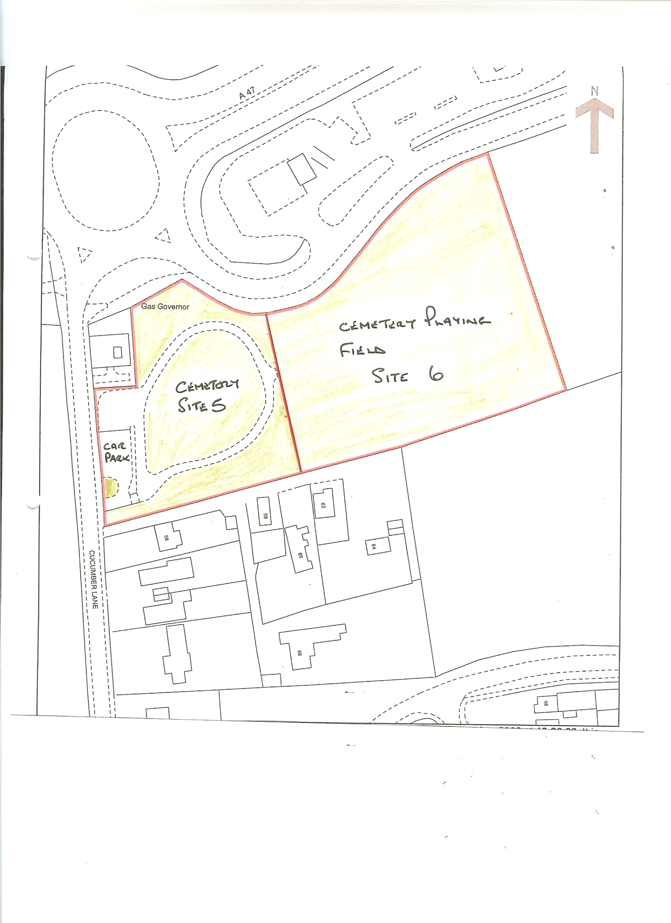

Brundall 4 – Memorial Hall Play Area
 | Regime | Quantity | Unit
Grass | M1  E1  STR | Approx 0.42 | HA
Hedges | PH1  PH2

Note:
(1) Allow for weed killing to the base of the fence surrounding tennis courts on at least 2 occasions during March to September

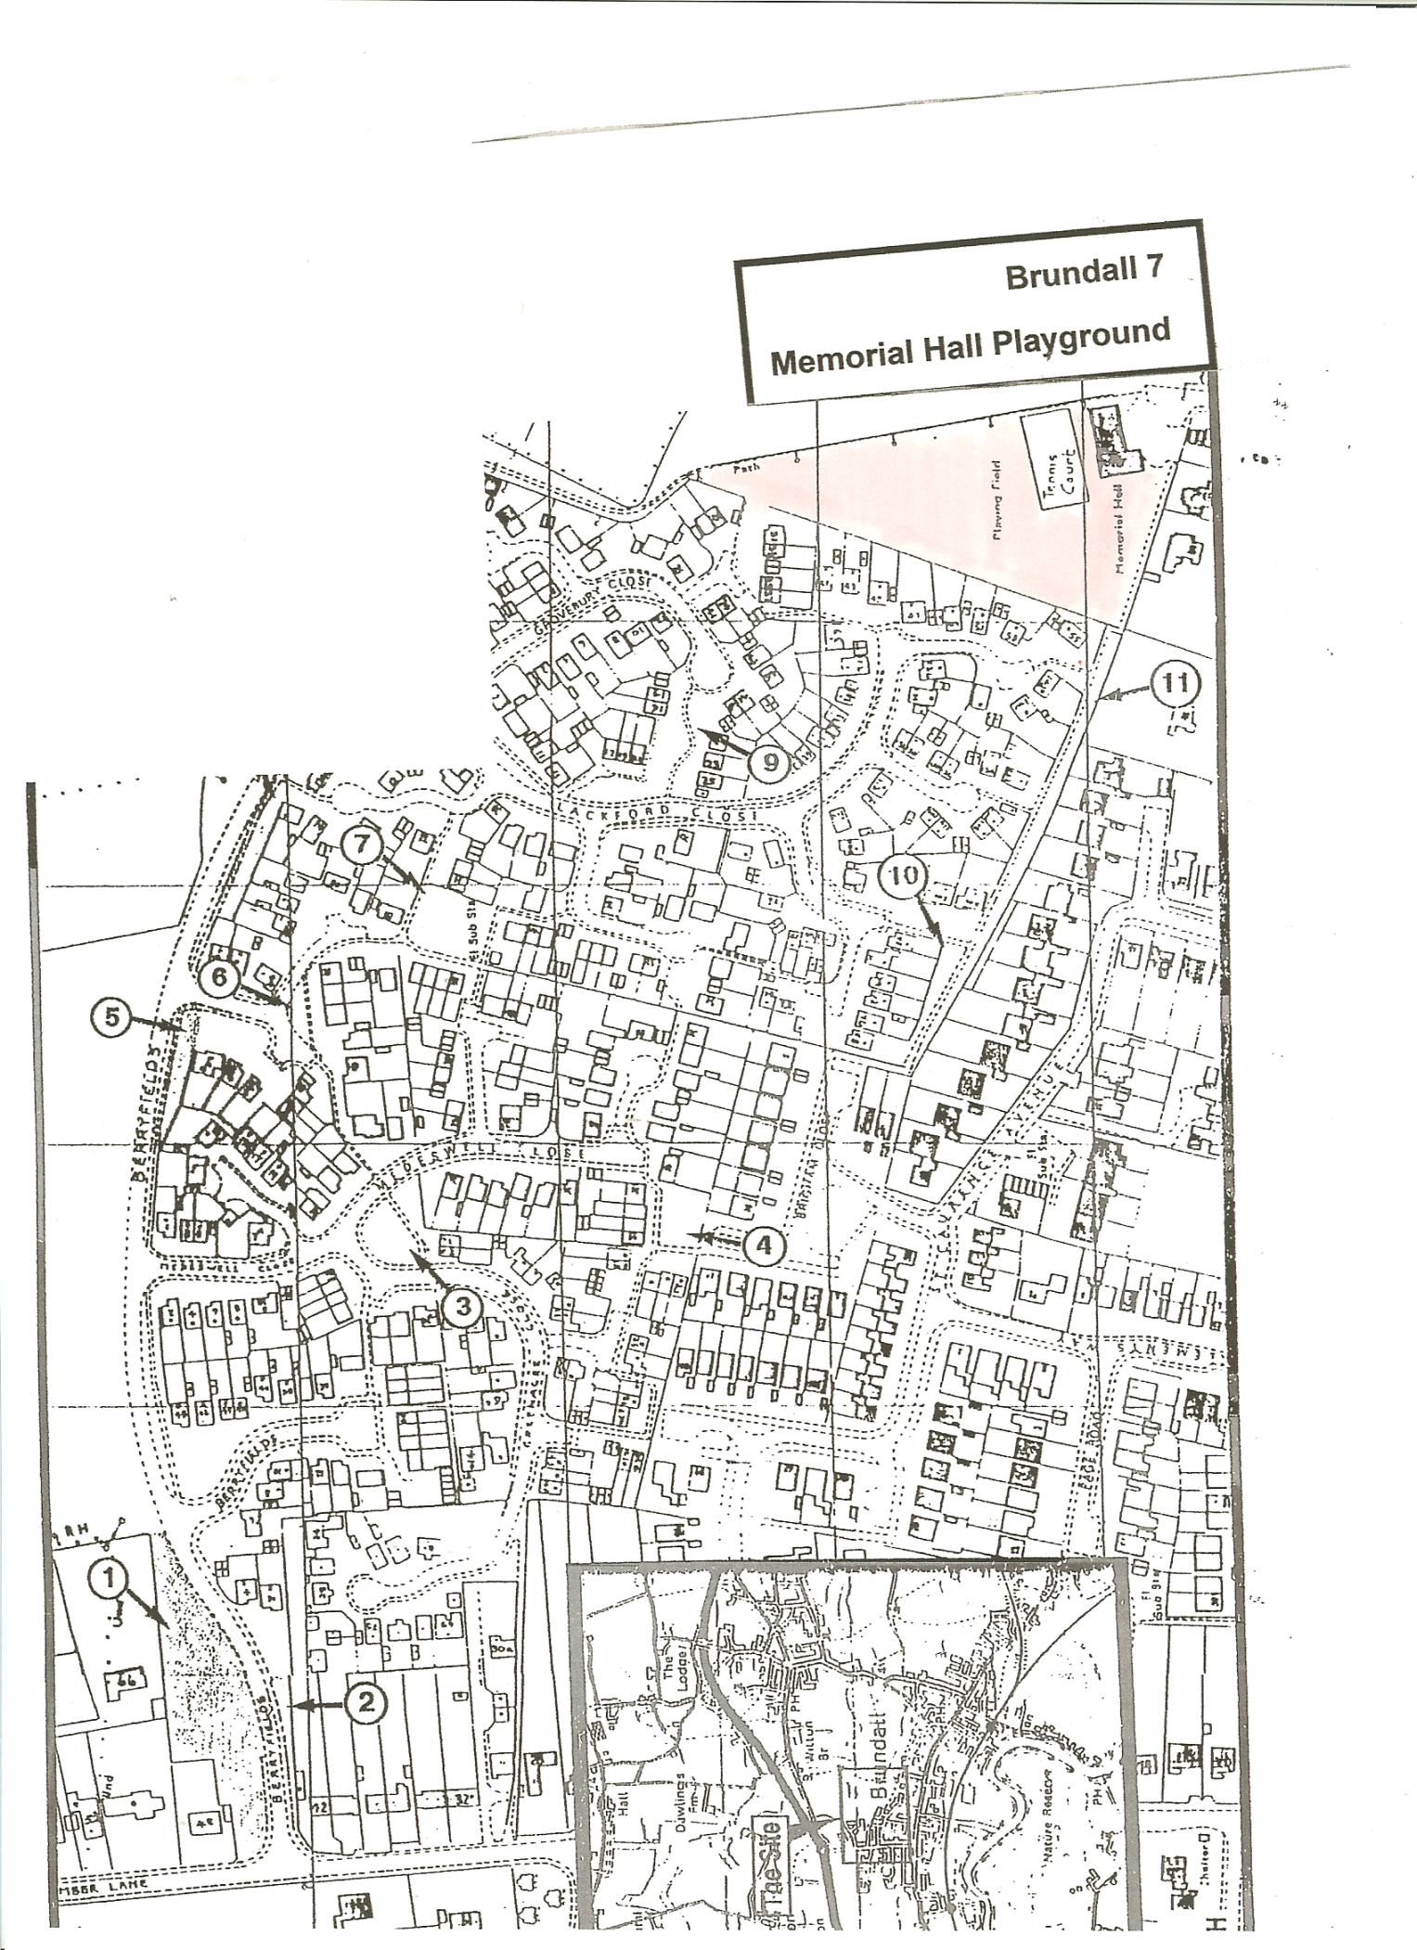
Brundall 4

Memorial Hall Playground
Brundall 8 – Meadow View Play Area
 | Regime | Quantity | Unit
Grass and shrub beds | M1  E1  E2  E3  BM3  STR  PS  L | Approx 0.25 | Acres

Note:
(1) All grass clippings to be removed from the enclosed play area
Brundall 4 – Memorial Hall Play Area

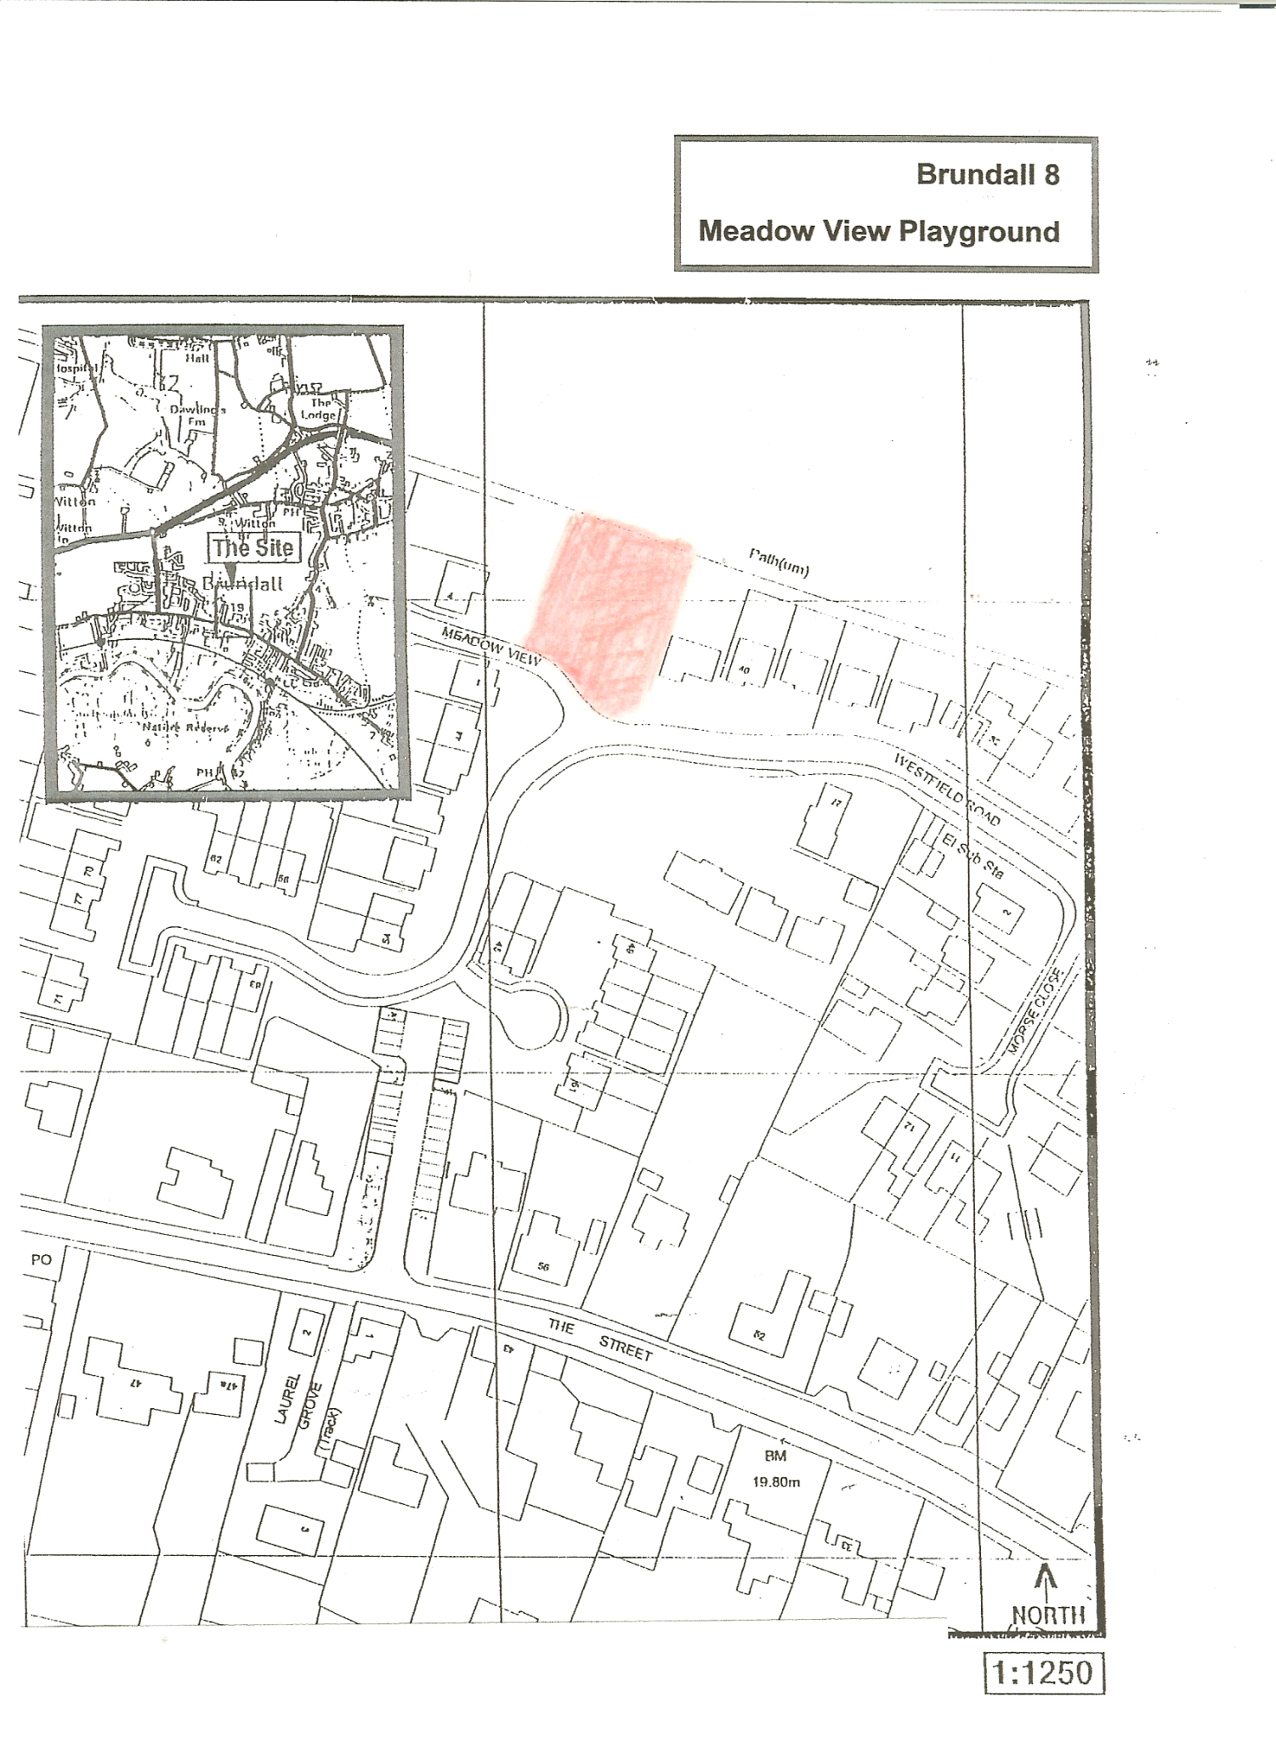
8

Brundall 9 – Cremer’s Meadow

8 cuts

Allow for clearing weeds to area on and around grass paths at least once per annum

Brundall 10 – Brundall Sports Hub

 | Regime | Quantity | Unit
Grass areas including front verges | M1  E1  E2  E3
Weed killing – shrub bed along car park | HB2
Weed killing – kerbs and pitch fence perimeter | HB4
Shrubs | PS
Hedges – including on verge and in Cemetery field | PH1  PH2

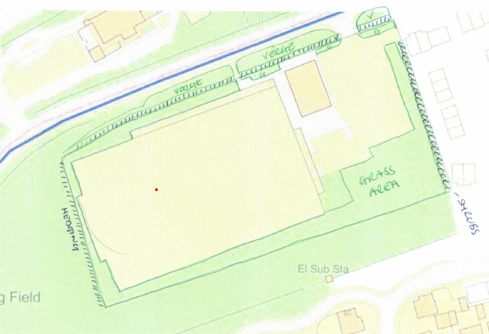

Brundall 11 – Norfolk County Council Delegated Functions
Grass cutting areas Urban schedule

BRUNDALL URBAN GRASS CUTTING SCHEDULE
ROAD NAME | VERGE CUTTING
BERRYFIELDS | 2023
BLOFIELD ROAD (added since 2014) | 100
BRANDON COURT | 292
BRECKLANDS ROAD | 525
BRIGHAM CLOSE | 625
CUCUMBER LANE | 172
CUCUMBER LANE JCT HOMESDALE ROAD | 76
GREENACRE CLOSE | 64
GROVEBURY CLOSE | 194
HIGHFIELD AVENUE | 625
HOMESDALE JCT POSTWICK LANE | 212
LACKFORD CLOSE | 897
LAKE VIEW DRIVE | 75
MEDSWELL CLOSE | 90
POSTWICK LANE | 1357
RIVERDALE COURT | 265
SPRINGDALE ROAD | 363
SPRINGDALE CRESCENT | 568
ST LAWRENCE AVENUE | 1357
ST MICHAELS WAY | 633
STATION NEW ROAD | 75
STRUMPSHAW ROAD JUNC WITH STATION NEW ROAD | 170
THE STREET | 875
THE STREET (BANK ADJ TO ST LAWRENCE AVE) | 30
THE STREET (ROUNDABOUT SHRUBBED AREA) | 108
WESTFIELD ROAD | 560
Highfield Ave bank j/w The Street | 20
TOTAL SQ.M | 12351
COST PER SQ.M | 0.0436
NO OF CUTS | 5

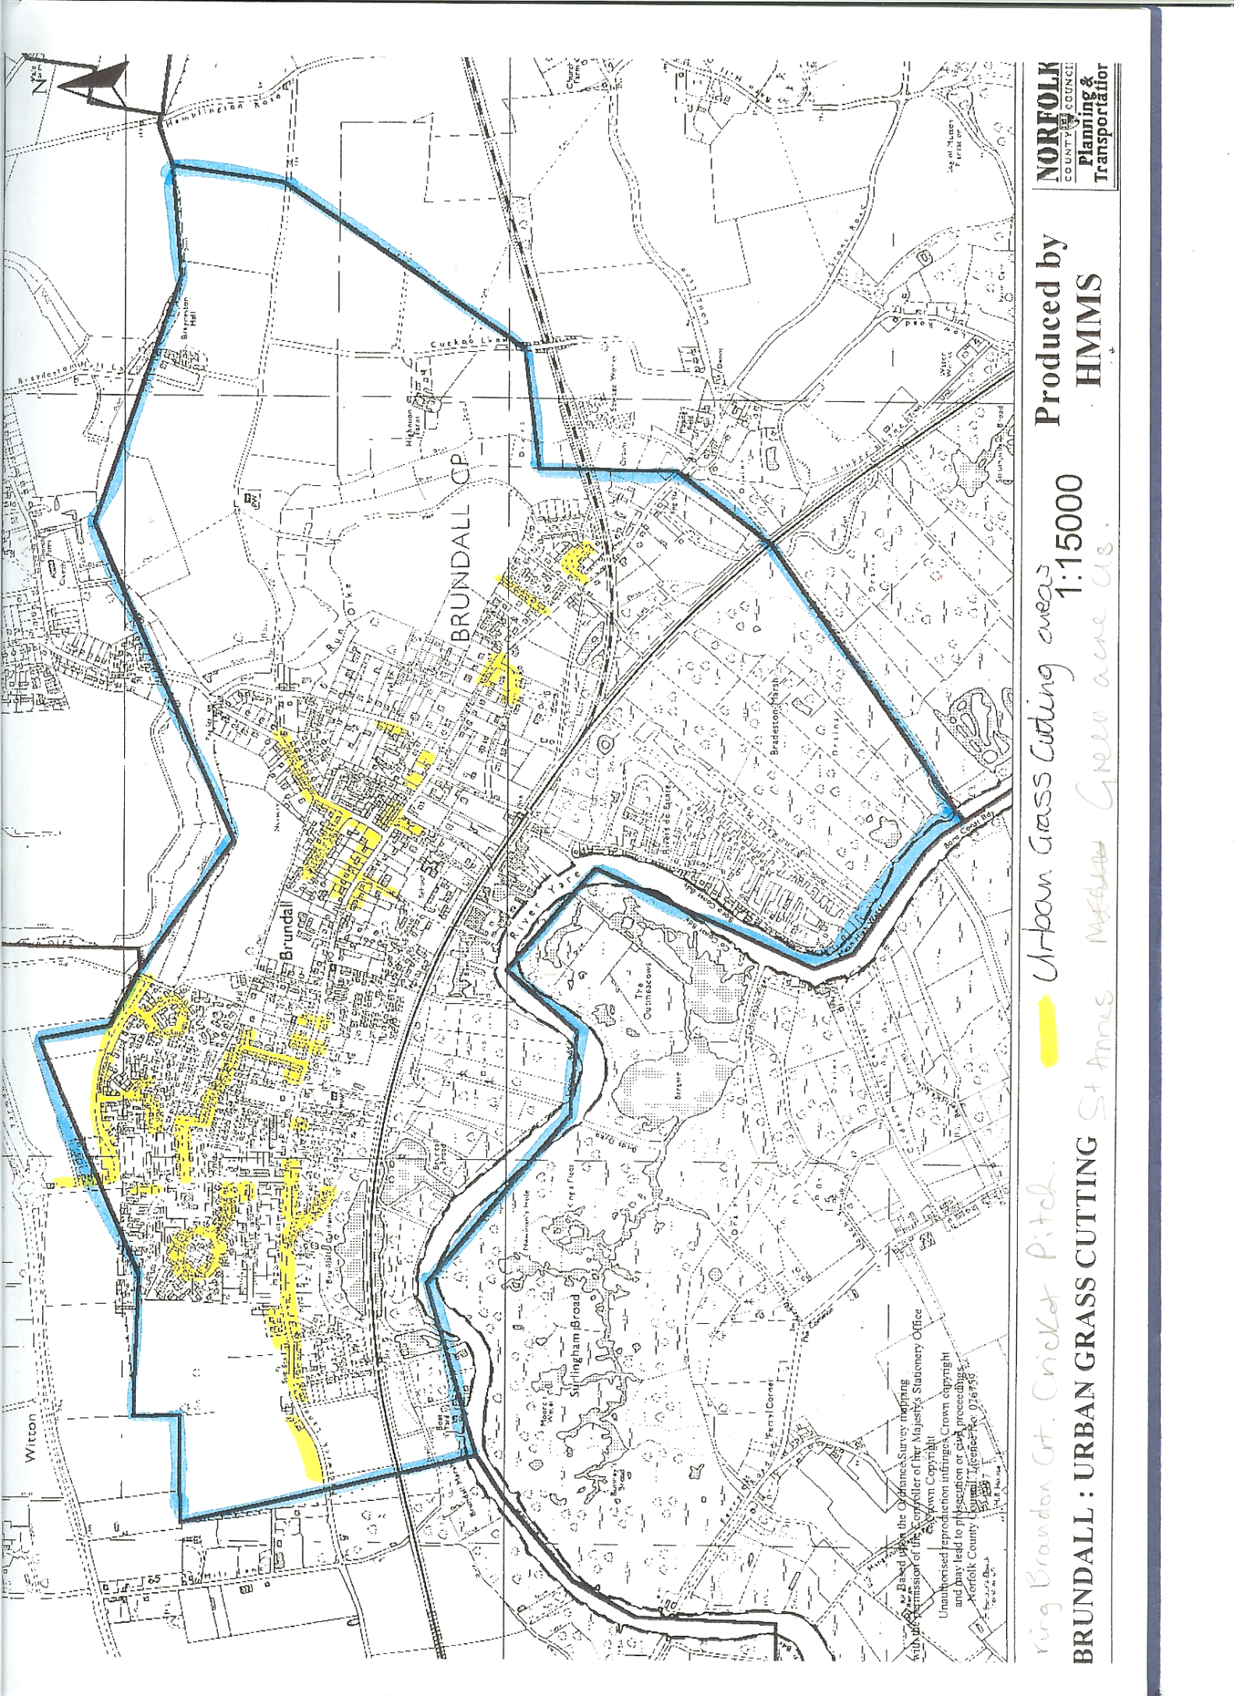
Brundall 9, Norfolk County Council Highways Verge Cutting
Norfolk County Council specification for grass cutting to verges
Standards
(See Drawings Appendix A1 for example areas involved).
Cutting shall be carried out in careful and safe manner and shall be in accordance with the standards and to the areas shown on the drawings held by the District Council as referenced in the schedule (Appendix B), and guidance notes (Appendix C).
The grass height should" not exceed 150mm before a cut is ordered. The cut height shall be no more than 50mm.
Grass shall be cut right up to road signs, market posts, lighting columns etc by hand or strimmer. This work shall be completed within the same week (7 calendar days) as mowing is carried out. The cost of this work shall be included in the appropriate mowing rates.
Mowing
All areas shall normally be every 2 weeks per season. Flail mowers shall not be used for this cutting.
Linear Habitats and Licensed Verges
Sites where linear habitats or licensed verges are marked will be subject to different standards. A list of linear habitats is included in Appendix A-3 to the Specification. Grass shall be cut in order of road priority. The frequencies given in the standards are for guidance only.

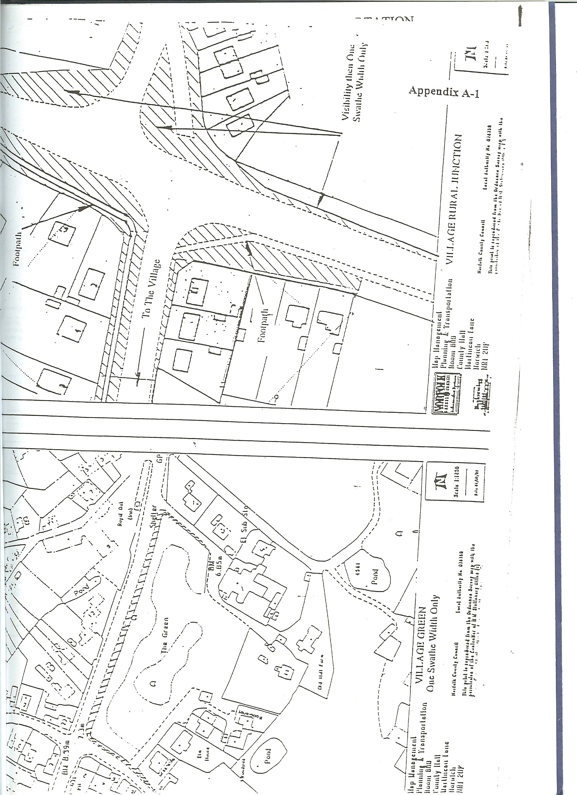

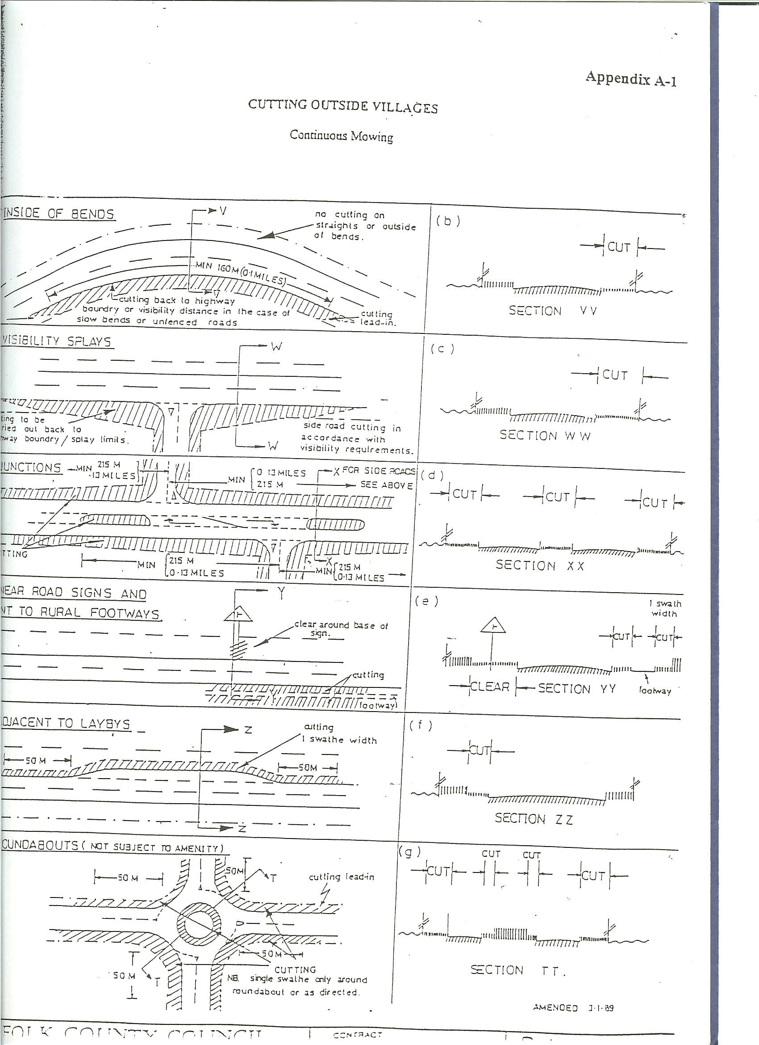

Appendix A-2

PARISH GRASS CUTTING AGREEMENTS
GUIDANCE NOTES FOR GRASS CUTTING TO NCC HIGHWAYS VERGES
- The Plant supplied for the Service must be licensed and insured to comply with current regulations.
- Vehicles used as Plant shall be fitted with a cab mounted flashing amber light which must be operating when engaged in grass cutting. Each vehicle must also carry alternative red and yellow reflective markings in accordance with SI 1989 No. 1796 (Lighting Regulations on Vehicles) and BS AD 152 (Specification for Rear Marking Plates for Vehicles) 1970 (Rev 1990), and an arrow mounted on the rear of the cutting unit. (See sub-Clause 4.5).
- All operatives must wear high visibility clothing to BS 6629, 1985, Class A, Appendix G, incorporating additional reflective material for extra safety, boots with steel toe-caps and, where appropriate, helmets, all to be provided by the Contractor. This also applies to where plant is being delivered to work sites.
- Traffic Signs
4.1 The Parish Council shall at all times comply with Chapter 8 of the Traffic Signs Manual 'Traffic Safety measures for Roadworks' as appropriate (published by HMSO in 1991).
4.2 Warning signs used shall be Class 1 retroreflective signs to Table 1 of BS 873 Part 6 : 1993. Triangular signs shall be minimum size 750 mm and wording of supplementary plates shall be to minimum 'x' height of 62.5mm.
4.3 Particular requirements for single carriageways shall be:
Sign to Diagram 7001 (Road Works Ahead) with supplementary plate to diagram 7001.1 with legend "Grass cutting" to be provided and erected on both approaches to all cutting vehicles. The maximum distance between opposing signs shall be 1 mile.
4.4 Road Works Ahead signs should be sited in order that all approaching drivers from either direction and road junctions shall have been adequately warned of the operation by passing at least one warning sign erected in a clear and legible position in advance of the cutting operation.
4.5 A Keep Left/Right sign (as appropriate) to Diagram 610 shall be provided as described in Clause 6. Sign diameter to be 600mm minimum.
  - All signs shall be maintained in a clean and legible condition.

