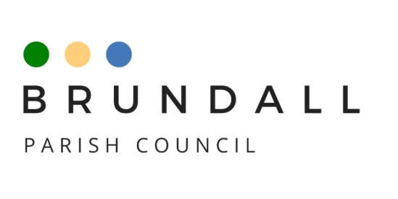

Recreation and Wellbeing Committee Terms of Reference

1. Objective
The Committee is appointed by the Parish Council to advise on and/or co-ordinate recreational and well-being opportunities in Brundall.
The Committee recognises that it has a responsibility to support in the communication between the Community and the Parish Council.

Membership
The Committee shall comprise 12 members of whom a minimum of four shall be elected Parish Councillors. These will be confirmed at the Annual meeting of the Parish Council in May along with the non-Councillor members, who shall be nominated by organisations within the parish boundaries. Each organisation may put forward one representative.
The Committee may, during the year, co-opt additional members for specific projects on a temporary basis.
Any change in membership of the Committee shall be confirmed by the Parish Council at its next ordinary meeting.
A representative of the Land Management Committee may attend meetings.

Chairman
A Chairman will be elected at the first meeting after the Annual meeting of the Parish Council, or at the first meeting after the resignation of the previous Chairman. The Chairman will always be an elected member of the Council.
The Chairman will be the main point of contact for the Clerk to the Council, Council and Committee members, and members of the public.

Quorum
A quorum will be a minimum of 4 members of the Committee, 2 of whom must be elected members of the Council.

Voting rights
All members of the Committee shall have equal voting rights.

Reporting Structure
The Recreation and Wellbeing Committee will report to full Council.
The Chairman, if unable to attend a full Council meeting, will nominate another member of the Committee to give an update.

Meetings
The Committee shall have a minimum of four meetings between Annual meetings of the Parish Council.
The Clerk or a Deputy Clerk will be in attendance.
The Committee shall follow the rules and regulations regarding committees as contained in the Council’s Standing Orders.

Budget
The Committee will have access to a budget but any activities or proposals will be subject to approval by full Council.
The budget can be spent on Committee projects or any non-Council events the Committee decides meets the recreation or wellbeing brief of the committee.
The maximum proposed spend on any non-Council project will be £300.

