BRUNDALL PARISH COUNCIL BIODIVERSITY WORKING GROUP

ANNUAL REPORT 2025

Prepared by:
Brundall Parish Council Biodiversity Working Group

DECEMBER 2025

CONTENTS

- Introduction
- Habitat and Species Survey of Church Land
- Breeding Bird Surveys
- Biodiversity Audit
- Biodiversity Improvement Project
- Management Plans
- Norfolk Nature Recovery Strategy
- Community Engagement Initiatives
REFERENCES
- Brundall Parish Council Wildlife and Diversity Vision 2021
- Biodiversity Working Group Report on Activities 2024
- BWG Breeding Birds Survey Report 2024

APPENDICES
- Species Lists St. Laurence and St. Michael & All Angels Churchyards
- Impact Assessment and Actions for Control of invasive Species at Church Fen

Prepared By | Date | Status
BWG | 15 December, 2025 | Draft Rev.0
BWG | 4 February, 2026 | Final

Introduction
Brundall Parish Council’s Biodiversity Working Group (BWG) was formed in 2022 in response to the publication of the Council’s ‘Wildlife and Diversity Vision [1]. The main purpose of BWG is to assist the Council with implementing its Vision and to provide advice and assistance to the Council on biodiversity matters in general. Since its creation in 2022, BWG has been engaged in various activities relating to the assessment of the biodiversity status of the Parish and what measures might be taken to maintain and/or enhance this. These activities have included conducting formal habitat and vegetation species surveys at sites owned/leased or managed by the Council and documenting the findings of these surveys.
BWG published its first report on its activities in December 2023 [Report on Biodiversity at Church Fen, Cremers Meadow, Low Farm Wood and Countryside Park December 202,3 2]. This report provided initial information on the biodiversity status of four sites in the Parish which are owned, leased or managed by Brundall Parish Council. This early work by BWG has enabled us to compile an initial biodiversity baseline for certain sites in the parish, against which it will be possible to identify any future changes. During 2025 our activities have focused on how best to manage the sites owned/leased and managed by Brundall Parish Council (BPC) so that their current biodiversity status is at least maintained and, wherever possible, enhanced in the future. Additional biodiversity surveys were also carried out on church land owned by Yare Valley Churches.
BWG is also conducting a biodiversity audit of all species recorded in Brundall in various published databases. This is an ongoing exercise involving extensive reviews of published information and extracting and collating relevant data from this information. When completed, this audit will provide a comprehensive up to date source of data on all species recorded in Brundall Parish.
A survey of breeding birds in Brundall was commenced in 2023 and has continued in subsequent years. In 2025, the geographical coverage of the breeding birds surveys was extended to include farmland, adding useful further data to the Breeding Birds Surveys conducted in 2023 and 2024
During 2025 BWG also conducted an assessment of a number of the Parish’s ‘Green Spaces’ (i.e. areas of open land/amenity grassland) with potential for biodiversity improvement. A biodiversity improvement plan was developed for some of these sites and a plot study commenced on how such improvement might be achieved.
In addition to data collection exercises, the BWG has engaged in community awareness activities so that members of the public are informed of the work BWG is carrying out on behalf of Brundall Parish Council. During 2025 BWG held a public meeting at Brundall Memorial Hall designed to provide the community with advice on how to make gardens more attractive to wildlife. We have also started engaging with Brundall’s allotment community, providing information and support to members on wildlife friendly allotment practices.
This report provides a summary of BWG’s work during 2025. It also provides updated information on the various surveys conducted in 2023 and 2024.

HABITATS AND SPECIES SURVEYS of church land
Churchyards provide important habitats for a diverse collection of plant and animal species They are also important areas for conservation of flora and fauna, since they typically have a long history of protection from adverse human interference, which allows species to establish themselves over long periods of time. In Norfolk and elsewhere, churchyards provide refuges for some key species of conservation concern.
Following initial discussions with representatives of Yare Valley Churches, BWG conducted habitat and species surveys on church land at the two churches in the Parish- St Laurences and St. Michaels & All Angels. These surveys were designed to update previous studies of these sites done by Norfolk Wildlife Trust (NWT).
A team from BWG visited the churchyards between 9th and 12th May 2025 and conducted systematic recording of all vegetation species present on the sites, together with the habitats present. Ad-hoc recording of insects and bird species were also made during the surveys. Follow-up visits were made during May 2025 to confirm previously collected site data. The methodology and habitat descriptors were based on the latest UK recommended strategy for biodiversity surveys as detailed in the UK Habitat Classification System UK HAB [3]. This methodology provides a systematic classification of habitat types based on the species present and designation codes. It is applicable to sites of all sizes and facilitates comparisons between sites of different types.
Data from the surveys was subsequently compiled into species lists and habitat maps for each site.
The results are shown in Figures 1 and 2.

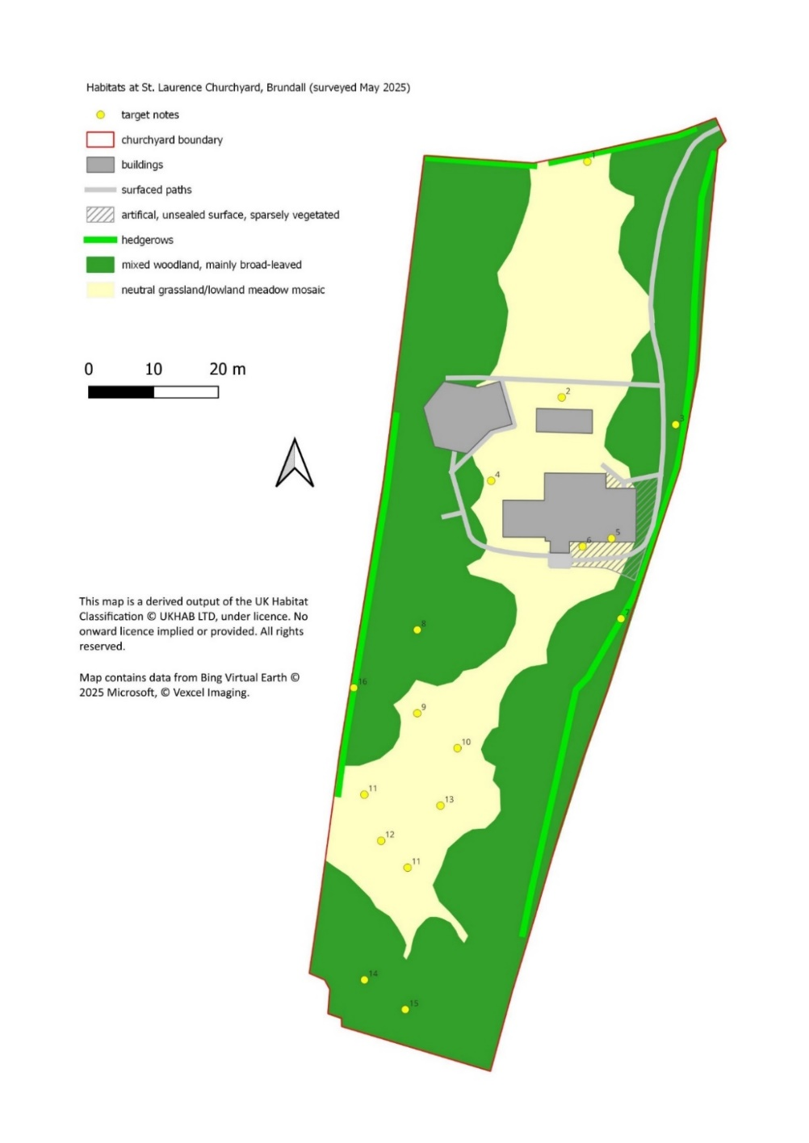

IGURE 3: HABITAT MAP – ST LAURENCE CHURCH

FIGURE 1: St. LAURENCE CHURCHYARD-HABITATS

The species recorded at St Laurence Churchyard during the May 2025 survey are listed in Appendix A, together with the results of the previous NWT survey for comparison. 117 species of plant were recorded (108 in 2022); 10 bird species; 30 bee species, 13 other insect species and 3 mammals were also found. The present survey recorded 9 more plant species than found in the 2022 survey.

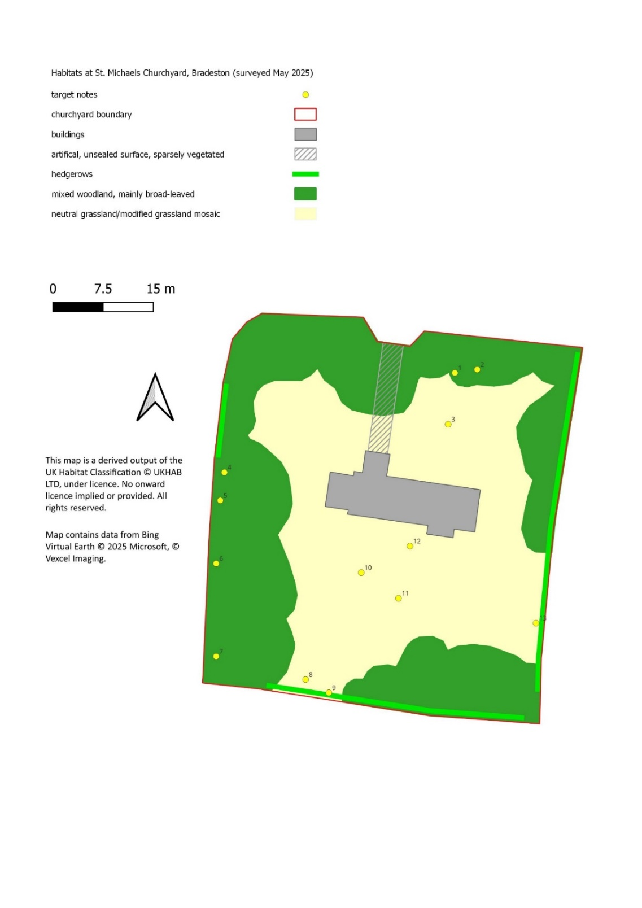

FIGURE 2: ST MICHAEL & ALL ANGELS CHURCHYARD-HABITATS

The species recorded at St Michael & All Angels Churchyard during the May 2025 survey are listed in Appendix A, together with the results of the previous NWT survey for comparison. 88 species of vascular plant were recorded during the 2025 survey (87 in 2022); 13 species of bird and 11 bee species.
The number of plant species recorded in 2025 is closely similar to that found in the previous 2022 survey.
The results of the 2025 BWG surveys confirm the findings of previous studies that both churchyards provide important habitat for a wide range of species and with appropriate management, should continue to do so in the coming years. The management of St. Laurence Churchyard since 2022 has been broadly successful in terms of maintaining and enhancing plant species diversity. For St Michael & All Angels Churchyard, no significant change in plant species numbers was observed, suggesting no change in the biodiversity status of the site.
BWG provided guidance on the future management of land at both church sites to Yare Valley Churches.

Breeding Birds Surveys
Surveys of breeding birds in the Brundall were carried out during 2023 and 2024 and the results reported in annual BWG reports[1]. During 2025 further surveys of breeding birds in the parish were conducted at various locations.
Breeding Bird Survey of Farmland to the East of Brundall
One of the gaps in our biodiversity knowledge in Brundall Parish is the status of some declining farmland breeding bird species, including Skylark, Yellowhammer, Grey Partridge, Linnet, Swallow and Lapwing. These birds were once common in east Norfolk but have declined dramatically in the past 50 years. To address this gap, a survey was carried out in spring 2025 covering around 82 ha of farmland on the eastern side of Brundall Parish. This land is managed by Bradeston Hall Farm and High Noon Farm. The method used was a five-visit territory mapping exercise, as recommended for such surveys. The area surveyed was confined to that which could be accessed from public footpaths and roads.
Results
59 species of bird were observed during the survey, and 33 species showed behaviors indicative of breeding.
Species | RDB Status | Breeding prs | Species | RDB Status | Breeding prs
Blackbird | Green | 9 | Pheasant | Green | 5
Blackcap | Green | 1 | Magpie | Green | 2
Blue tit | Green | 18 | Mallard | Amber | 2
Carrion crow | Green | 2 | Moorhen | Amber | 3
Chaffinch | Green | 6 | Pied Wagtail | Green | 2
Chiffchaff | Green | 3 | Red-legged Partridge | Green | 6
Collared dove | Green | 2 | Robin | Green | 20
Common Whitethroat | Amber | 4 | Rook | Amber | 18
Dunnock | Amber | 11 | Sedge Warbler | Amber | 1
Goldfinch | Green | 3 | Skylark | Red | 7
Great Tit | Green | 8 | Starling | Red | 3
Grey Partridge | Red | 2 | Stock Dove | Amber | 7
House Sparrow | Red | 25 | Swallow | Green | 2
Jackdaw | Green | 5 | Woodpigeon | Amber | 12
Kestrel | Amber | 1 | Wren | Amber | 16
Linnet | Red | 9 | Yellowhammer | Red | 7
Little Owl | Green | 1
 |  |  | No. of breeding species |  | 33

The survey established that Skylark, Yellowhammer, Grey Partridge and Linnet, all threatened species, are still breeding in the Parish (although it is understood that Grey Partridge are the result of a recent release by gamekeepers). Lapwing nested in this area around 5 years ago but none were seen on the 2025 survey and it seems they have joined other species such as Turtle Dove and Tree Sparrow, which have been lost from the Brundall parish farmland in the past 40 years.
Some of the species recorded in Brundall are designated as ‘Red List’ species i.e. regarded by the IUCN as endangered and at risk of extinction. [4]. The locations where these Red List Species were found to be breeding are shown below:
Location* of four red-listed species breeding on Farmland in Brundall Parish
*Center of each territory is indicated
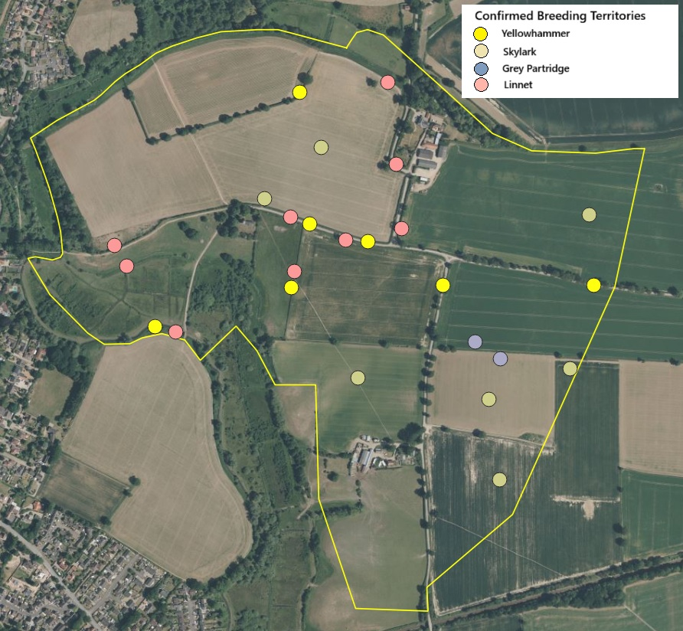

Breeding Owls in Brundall Parish
Owls were another gap in our knowledge of breeding birds in Brundall and required dedicated nocturnal survey work to determine breeding populations. Between late February and early April 2025, survey visits took place on six dates. Each visit started at dusk and continued for around 2 hours and covered around a third of the parish. All areas were covered on at least 2 nights. Additional observations of barn owls and little owls during other daytime surveys were also carried out and this helped to clarify their status.
Three species of owls were recorded: Tawny Owl, Little Owl and Barn Owl. Tawny owls were by far the most widespread, and were the only owl regularly found within the village. One pair of little owls was located on the farmland east of the village. No nesting barn owls were located but birds nesting in neighbouring parishes were seen hunting on marshy grasslands along the Run Dyke. The Results are summarised in the table and maps below.
Breeding Owl Populations in Brundall Parish in 2025
Species | No. of territorial pairs |  | Comments
Species | Confirmed | Possible | Comments
Tawny Owl | 5 | 2 | Found in most parts of the village where mature trees are present.
Little Owl | 1 | 0 | Cuckoo Lane/Braydeston Hall Lane
Barn Owl | 0 | 1 | Seen hunting on three occasions, in the SW corner, the future “village park” and Bradeston Marshes, but no evidence of breeding and probably from pairs nesting in Strumpshaw and Surlingham parishes.

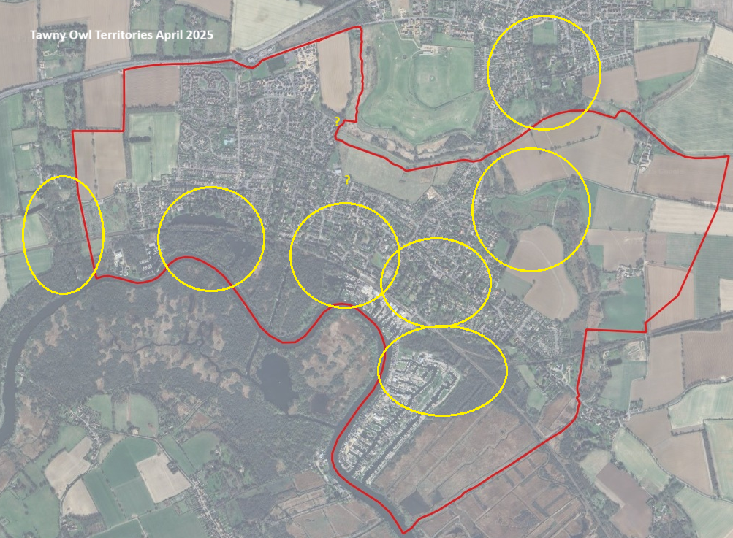
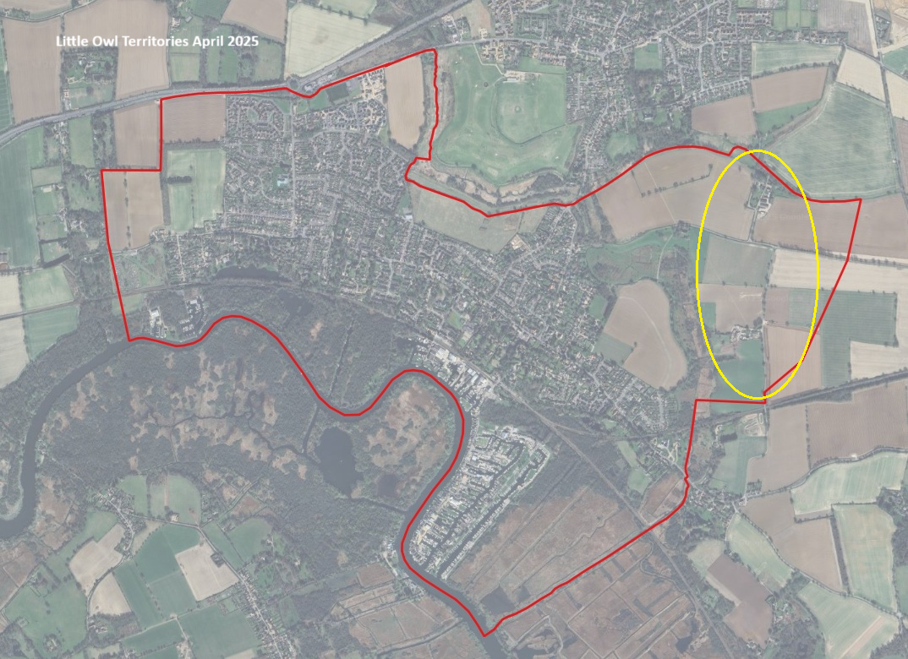
Map Data: Google, Airbus, Maxar Technologies, Copyright 2025.

Changes in the Breeding Bird Population at Brundall Countryside Park 2023-2025
Since their creation in 2014, the woodland, scrub and grassland habitats and the allotments at the Countryside Park have been steadily maturing. A breeding bird survey in 2023 demonstrated how the new habitats were already supporting a range of breeding birds with 31 pairs of 14 species, including 10 pairs of species of conservation concern (red/amber listed species). To assess how the bird community is evolving, the survey was repeated during spring 2025, and the results compared with the 2023 survey.
The results showed an approximately 50% increase in the diversity of species breeding, from 14 to 21 species, and a similar scale increase in the total number of breeding pairs, from 30 to 43. Most species had increased or maintained population size. The only significant decrease was Goldfinches, which like to nest in fruit trees at a height of 3-4m and may have been affected by the enforcement of tree height policy at the Allotments. The presence of red and amber listed species like Linnet, Chaffinch, Greenfinch, Dunnock and Kestrel, which are also identified as priority species in the recently published Norfolk Local Nature Recovery Strategy [5], demonstrate the success of the Countryside Park in enhancing biodiversity.

Breeding Bird Population at Brundall Countryside Park in 2023 and 2025
Species | RDB Status | No. of territories*
Species | RDB Status | 2023 | 2025 | Change | Direction
Blackbird | Green | 2 | 5 | +3 | Increase
Chiffchaff | Green | 0 | 3 | +3 | Increase
Dunnock | Amber | 2 | 5 | +3 | Increase
Bullfinch | Amber | 0 | 1 | +1 | Increase
Great Spotted Woodpecker | Green | 0 | 1 | +1 | Increase
Great Tit | Green | 1 | 2 | +1 | Increase
Green Woodpecker | Green | 0 | 1 | +1 | Increase
Kestrel | Amber | 0 | 1 | +1 | Increase
Linnet | Red | 0 | 1 | +1 | Increase
Red-legged Partridge | Green | 0 | 1 | +1 | Increase
Robin | Green | 3 | 4 | +1 | Increase
Stock Dove | Amber | 0 | 1 | +1 | Increase
Whitethroat | Amber | 0 | 2 | +1 | Increase
Willow Warbler | Amber | 0 | 1 | +1 | Increase
Blue tit | Green | 6 | 6 | 0 | No Change
Chaffinch | Green | 1 | 1 | 0 | No Change
Long-tailed Tit | Green | 1 | 1 | 0 | No Change
Wren | Amber | 1 | 1 | 0 | No Change
Blackcap | Green | 1 | 0 | -1 | Decrease
Greenfinch | Red | 4 | 3 | -1 | Decrease
Mallard | Amber | 1 | 0 | -1 | Decrease
Woodpigeon | Amber | 2 | 1 | -1 | Decrease
Goldfinch | Green | 5 | 2 | -3 | Decrease
No. of breeding species | All species | 14 | 21 | +7
No. of breeding prs | Red/Amber-listed | 11 | 17 | +6
No. of breeding prs | All species | 31 | 43 | +12
*territories were included where >50% of the territory area was inside the survey area, including some which will have been nesting outside the survey area.

Brundall Biodiversity Audit
In 2023, biodiversity data from all known sources was collated to produce a list of all species known from Brundall parish. This was updated in 2024, and in 2025 the database was again updated. The new records came from surveys carried out by the Biodiversity Working Group, casual species recording, and from online recording sites (iNaturalist, iRecord). In 2025, 99 new species were added to the database, taking the total number to 2296. The new species included 16 spiders, 10 flies, 9 beetles, 7 true bugs, 10 wasps, 6 bees, 4 moths, 15 flowering plants and 3 fungi. Those of particular interest are listed in the table below. Many of these are recent arrivals in Norfolk, benefitting from a warming climate.
There is still work to do researching existing records and we are still seeking volunteers to help with this.
Selection of Rare and Scarce Species Found in Brundall for the first time
Order/Family | Species | Location(s) | Notes
Coleoptera Ptinidae | Ptinus sexpunctatus | Allotments | A rare but increasing beetle that breeds in detritus in nests of mason bees.
Diptera Tachinidae | Ectophasia crassipennis | Allotments | A scarce recent UK colonist. The larvae are parasites of adult shieldbugs and other Hemiptera.
Diptera Conopidae | Myopa vicaria | Brundall Countryside Park | A scarce early spring fly which visits willow flowers. Its larvae parasitise willow-feeding mining bees.
Hymenoptera Andrenidae | Andrena proxima | Brundall Church | A scarce mining bee that visits cow parsley, rough chervil and other tall Apiaceae.
Hymenoptera Apidae | Bombus ruderatus | Allotments | The Large Garden Bumblebee is a scarce species with very few records in east Norfolk. It likes tall, damp grasslands.
Hymenoptera Apidae | Nomada guttulata | Allotments | A rare bee which is a cleptoparasite of Andrena labiata, a speedwell pollen specialist.
Hymenoptera Chrysididae | Omalus puncticollis | Cremers Meadow | A scarce jewel wasp which is a parasitoid of aphid-hunting digger wasps.
Hymenoptera Colletidae | Colletes fodiens | Allotments | A scarce bee associated with ragwort and other yellow Asteraceae. It is the only Norfolk bee which is considered threatened in Europe.
Hymenoptera Crabronidae | Crossocerus congener | Beech Way | This digger wasp is a recent UK colonist, first seen in Norfolk in 2015 and still scarce. It hunts flies and nests in hollow stems.
Hymenoptera Crabronidae | Mimumesa unicolor | Allotments | A rare digger wasp which likes tall, flower-rich grasslands.
Lepidoptera Nymphalidae | Apatura iris | River Yare nr. Church Fen | The Purple Emperor is a large butterfly of mature woodlands, lost from Norfolk in the 1960s, but returned from around 2015 and is slowly increasing. Larvae feed on Goat Willow.
Lepidoptera Nymphalidae | Argynnis paphia | Beech Way | The Silver-washed fritillary is another large woodland butterfly which was lost from Norfolk but returned about 20 years ago and is still spreading. Its larvae feed on dog violets.
Aranaea Linyphidae | Hypomma fulvum | RSPB Reserve | A scarce spider of reedbeds.

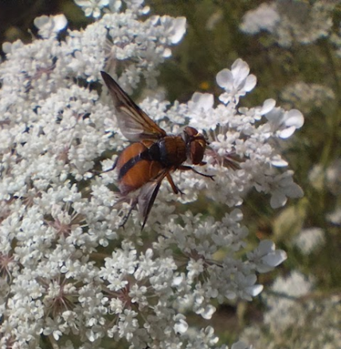
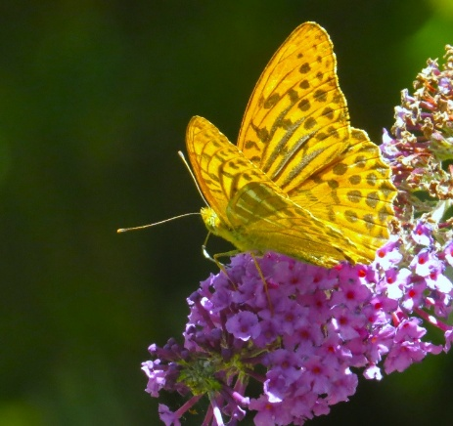
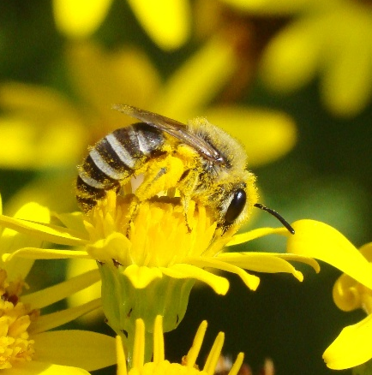
From left to right: Colletes fodiens; Ectophasia crassipennis; Silver Washed Fritillary

biodiversity improvement project
There are a number of areas within the Parish that comprise amenity grassland which is either unmanaged or subject to minimal management, such as periodic mowing. These ‘Green Spaces’ were identified and mapped by BWG and the results reported in the BWG 2024 Annual Report. During 2025 a further survey of the Parish was conducted to identify which parcels of land could potentially be managed proactively to enhance their biodiversity. As the number of such sites is quite large, managing them to facilitate biodiversity enhancement could potentially provide significant biodiversity gains for Brundall. The principal objectives of this project were to:
- Identify and map specific green spaces in Brundall which might be candidates for biodiversity improvement
- Consider options for what work/actions could be initiated at these sites which could potentially enhance their biodiversity
- Review the current land uses of these sites and any constraints these may have on biodiversity enhancement plans
- Identify 2 to 3 sites for a pilot study into how in practice this initiative could be implemented at other sites in Brundall.
- Assess the overall value of the initiative in biodiversity terms.
- Candidate sites for this project were identified using a combination of desk top research and field survey. The desk top element comprised a review of available OS mapping at various scales and identification of potential sites using ‘Google Earth’ satellite imagery. A long list of potentially suitable sites was then identified, and the information transferred on 1: 25000 base maps.
The survey identified a long list of over 20 sites that have the potential for biodiversity improvement through interventions such as habitat changes from amenity grassland to wildflower areas. This was subsequently reduced to short list of some 8 sites deemed most suitable for further investigation. The locations of these sites is shown in below. Two sites at Brundall cemetery were subsequently selected for a pilot study on biodiversity improvement. These have been cleared and planted/seeded with a selection of wildflowers designed to attract bees, butterflies and other insects. The development of these areas will be monitored during 2026 so that an assessment can be made of the effectiveness of this approach to biodiversity improvement.

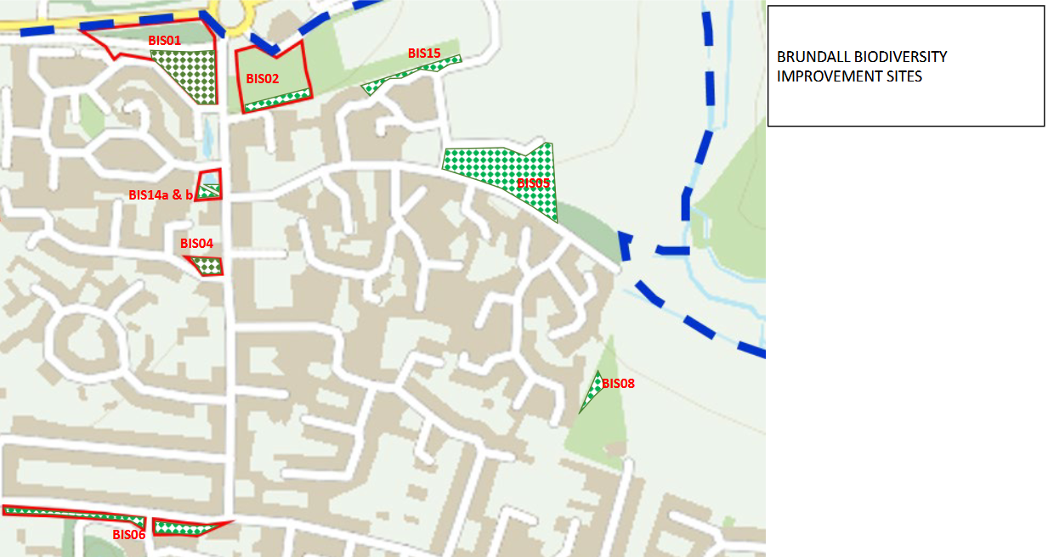
Location of Some Possible Biodiversity Improvement Sites in Brundall

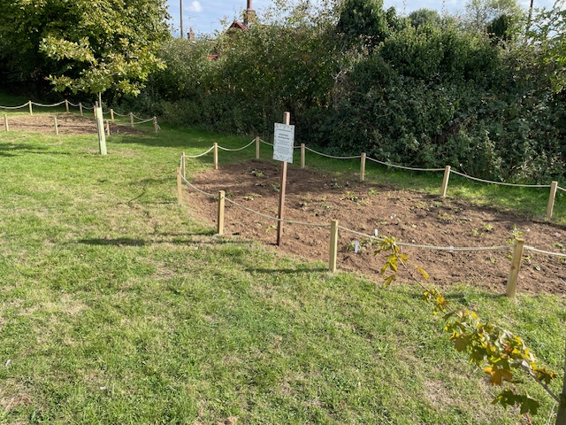
Biodiversity Improvement sites at Brundall Cemetery at Site Preparation Stage Autumn 2025

ManagemEnt Plans
The BWG 2023 Report [1] identified a number of opportunities and recommendations for enhancing biodiversity at each of the BPC owned/leased/managed sites. During 2024, members of BWG commenced a consultation exercise with the individuals/groups that are currently responsible for managing the individual sites, in order to identify how the recommended biodiversity enhancement opportunities might best be realised. These consultations have continued in 2025.
One of the stated aims of Brundall Parish Council’s Wildlife and Biodiversity Vision is to ‘ensure there is a high-quality management plan for all areas of land owned by the PC’ [1]. In order to maintain a consistent approach to managing these sites, BWG has developed a template for the content of a site management plan which is currently being trialled by the Countryside Park Steering Group. Draft Management Plans for Cremers Meadow and Church Fen are also under development and are expected to be finalised during 2026.
A particular problem at Church Fen is the presence of non-native invasive species such as Himalayan balsam, Snowberry, Laurel and Japanese Knotweed. These species require management to avoid them becoming dominant in the habitat and displacing indigenous species. During 2025, BWG with the assistance of members of the community Payback Team, started work on removing some of these invasive species to minimise spreading. An assessment of the impact of these invasive species and recommended actions for their ongoing management of is included in Appendix B.

Norfolk NATURE RECOVERY STRATEGY
Nature Recovery is broadly defined as the process of helping nature and wildlife return to areas where they have declined. This is achieved through the creation and restoration of habitats, creating wildlife-rich places, and corridors and stepping-stones that help populations to recolonise and adapt to a changing climate. Nature recovery recognizes that there are areas of land that are already of high importance to biodiversity which should be maintained (where there may still be the opportunity to enhance) and there is land with impoverished biodiversity, where there are opportunities to create and restore.
Norfolk County Council (NCC) developed and published its draft Local Nature Recovery Strategy early in 2025. Following consultation on the draft document, a final version of the Norfolk Local Nature Recovery Strategy was published by Norfolk County Council on 31/10/2025 [5]. The LNRS document provides some clear priorities for Nature Recovery in Norfolk and there is an online habitat map to support the LNRS document.
The LNRS provides a framework to guide all parties engaged in nature recovery in Norfolk in deciding which habitats to create, restore or enhance, which species they should aim to benefit, and the primary actions which should be carried out to ensure they do.
It is the intention that public bodies, including Parish Councils, should use the strategy to guide their contribution to Nature Recovery under their duty to conserve and enhance biodiversity as embedded in Section 40 of the Natural Environment and Rural Communities Act 2006 and strengthened under the Environment Act 2021.
Nature Recovery Priorities in Brundall Parish
The Norfolk LNRS is large document and drawing out of it the relevant priorities for Brundall is not a simple task. The Strategy identifies a long list of species and habitat priorities for the county, many of which are relevant to Brundall Parish, and many are not. To narrow down the opportunities for Nature Recovery for our parish, an assessment was carried out of current habitats and species present, the potential for habitat restoration or creation, and the species which could benefit. The result of this exercise is a Priority Species List for Brundall. This includes those important species which we know from the Biodiversity Audit are already present, and some priority species which are not present, but could be attracted by enhanced habitats. The “important species” include LNRS priority and priority assemblage species known to be present, plus NERC Act Section 41 list species and other Rare or Scarce species present which should be protected through appropriate land management. The list is a working document, based on most recent information available, and it will need to evolve as new information becomes available.

Proposed Priority Species List for Brundall Parish V.1 Nov 2025
Taxon group | Species/Assemblage | Source Lists |  | Post-2000 records? | Built Environment | Woodland and Trees | Scrub and grassland | Wetlands/Waterbodies | Arable Farmland
Taxon group | Species/Assemblage | LNRS Priority | NERC Act S.41
Mammal | All bat species (5 key species) | 2 |  | Yes | P | P | P | P
Mammal | Brown Hare |  | Yes | Yes |  |  | P |  | P
Mammal | Harvest Mouse |  | Yes | Yes |  |  | P | P
Mammal | Hedgehog |  | Yes | Yes | P | P | P
Mammal | Otter | 2 | Yes | Yes |  |  |  | P
Mammal | Water shrews | 2 |  | Yes |  |  |  | P
Mammal | Water Vole | 1a | Yes | Yes |  |  |  | P
Bird | Barn Owl |  |  | Yes |  |  | P | P | P
Bird | Bittern |  | Yes | Yes |  |  |  | P
Bird | Bullfinch | 1 | Yes | Yes |  | P | P
Bird | Chaffinch | 1 |  | Yes | P | P | P
Bird | Cuckoo | 1 | Yes | Yes |  | P | P | P
Bird | Dunnock (Hedge Accentor) |  | Yes | Yes | P | P | P
Bird | Grasshopper Warbler |  | Yes | Yes |  |  |  | P
Bird | Greenfinch | 1 |  | Yes | P |  | P
Bird | House Martin | 1 |  | Yes | P
Bird | House sparrow | 1 | Yes | Yes | P
Bird | Kestrel | 1 |  | Yes |  |  | P |  | P
Bird | Kingfisher | 2 |  | Yes |  |  |  | P
Bird | Linnet | 1 | Yes | Yes |  |  | P |  | P
Bird | Marsh tit | 1 | Yes | Yes |  | P | P
Bird | Other red/amber listed species |  | Yes | Yes |  | P
Bird | Redpoll | 1 |  | Yes |  | P | P
Bird | Reed Bunting |  | Yes | Yes |  |  |  | P | P
Bird | Skylark | 1 | Yes | Yes |  |  |  |  | P
Bird | Song Thrush |  | Yes | Yes | P | P | P
Bird | Spotted flycatcher | 1 | Yes | Yes |  | P | P
Bird | Starling | 1 | Yes | Yes | P | P | P
Bird | Swallow | 1 |  | Yes | P
Bird | Swift | 1 |  | Yes | P
Bird | Turtle Dove |  | Yes | Yes |  |  | P |  | P
Bird | Yellowhammer | 1 | Yes | Yes |  |  | P |  | P
Amphibian | Common Toad | 1 | Yes | Yes |  | P |  | P
Amphibian | Great Crested Newt | 1 |  | No |  |  |  | P
Reptile | Common Lizard |  | Yes | Yes |  |  | P | P
Reptile | Grass Snake | 1 | Yes | Yes |  |  |  | P
Reptile | Slow-worm |  | Yes | Yes | P |  | P | P
Fish | Brook lamprey | 1 |  | No |  |  |  | P
Fish | European Eel | 1a | Yes | Yes |  |  |  | P
Spider | Fen Raft Spider | 1a | Yes | No |  |  |  | P
Insect | Aquatic beetles | 2 |  | Yes |  |  |  | P
Insect | Bee and pollinator species | 2 |  | Yes | P |  | P | P
Insect | Cigarillo Gall-fly |  | Yes | Yes |  |  |  | P
Insect | Fen Mason-wasp |  | Yes | No |  |  |  | P
Insect | Fenn's wainscot | 1 |  | No |  |  |  | P
Insect | Five-Banded Weevil Wasp |  | Yes | Yes |  |  | P
Insect | Garden Tiger |  | Yes | Yes |  |  | P | P
Insect | Grassland Butterflies | 2 |  | Yes |  |  | P
Insect | Hedgerow butterflies | 2 |  | Yes |  |  | P |  | P
Insect | Large Wainscot |  | Yes | Yes |  |  |  | P
Insect | Norfolk Hawker |  | Yes | Yes |  |  |  | P
Insect | Orange-horned green colonel | 1 |  | No |  |  |  | P
Insect | Purple emperor | 1 |  | No |  | P
Insect | Red-shanked Carder-bee |  | Yes | No |  |  | P |  | P
Insect | Saproxylic beetles | 2 |  | Yes |  | P | P
Insect | Small Heath |  | Yes | Yes |  |  | P
Insect | Southern Yellow Splinter |  | Yes | Yes |  |  |  | P
Insect | Swallowtail | 1 |  | Yes |  |  |  | P
Insect | Wall |  | Yes | Yes
Insect | White Admiral |  | Yes | Yes |  | P | P
Insect | White Letter Hairstreak | 1 | Yes | Yes |  | P | P
Insect | Woodland Butterflies | 2 |  | Yes |  | P | P
Mollusc | Desmoulin's whorl snail | 1 | Yes | Yes |  |  |  | P
Mollusc | Wetland grazing molluscs | 2 |  | Yes |  |  |  | P
Plant | All scarce fen plant species |  |  | Yes |  |  |  | P
Plant | All Veteran Trees | 2 |  | Yes |  | P | P
Plant | Aquatic macrophytes | 2 |  | Yes |  |  |  | P
Plant | Black poplar (native ssp.) | 1 |  | Yes |  |  | P | P
Plant | Elms | 1 |  | Yes |  |  | P
Plant | Field maple | 2 |  | Yes |  | P | P
Plant | Frogbit | 1 |  | Yes |  |  |  | P
Plant | Greater water parsnip | 1 |  | No |  |  |  | P
Plant | Hedgerow trees | 2 |  | Yes | P |  | P |  | P
Plant | Marsh Stitchwort |  | Yes | Yes |  |  |  | P
Plant | Milk parsley | 1 |  | Yes |  |  |  | P
Plant | Opposite-leaved pondweed | 1 |  | No |  |  |  | P
Plant | Orchids | 2 |  | Yes |  |  | P | P
Plant | Other native tree species | 2 |  | Yes | P | P
Plant | Rowan | 2 |  | Yes |  | P
Plant | Stonewort species | 1 |  | Yes |  |  |  | P
Plant | Tubular Water-dropwort |  | Yes | Yes |  |  |  | P
Plant | Urban Trees | 2 |  | Yes | P | P
Plant | Water-violet | 1 |  | No |  |  |  | P
Lower Plant | Bryophytes | 2 |  | Yes |  | P
Fungi | Fungi and Lichens | 2 |  | Yes |  | P | P

The list is for the Parish as a whole, and Brundall Parish Council will only be able to influence species on this list where they occur on land within its control. The list will be most immediately relevant where the PC is considering how to manage land under its control and where there is some biodiversity objective. Developing the Management Plans for Cremers Meadow, Church Fen, the Countryside Park, and the future “Village Park” are obvious opportunities, and draft priority species list for Cremers Meadow, the Countryside Park and Church Fen are in preparation by BWG. It may also be used to guide small scale actions to enhance biodiversity elsewhere, such as at the cemetery or allotments.
It is likely that most capital grants for biodiversity work over the next few years will be directed to actions that are aligned to this strategy, so embedding the LNRS priorities in land management objectives for Brundall will help with securing funding opportunities.
It is recognised in the LNRS that housing and other developments can provide opportunities for nature recovery, with habitat creation and enhancement delivered alongside public green space, so the LNRS provides an opportunity for the Parish Council to influence development proposals and seek maximum benefit for nature recovery.

Community EngagemenT
Community engagement is an important element of BWG’s work and is included in Brundall Parish Council’s Wildlife and Diversity Vision. As part of its community engagement activities in 2025, BWG held a public meeting in May entitled ‘Gardening For Nature’ . The theme of this meeting was how gardens can be made to be more wildlife friendly through relatively simple changes, such as selecting plant species which are attractive to insects/pollinators, creating places where animals can live in suitable habitat, such as compost heaps and log piles and providing water features, such as wildlife ponds. Because the total area of gardens is cumulatively large, even small changes over a community of gardens can have a big positive impact on wildlife and biodiversity.
Members of BWG have also held discussions with Brundall allotment holders about how allotments can also be managed to encourage wildlife, and it is planned to hold a meeting with the wider allotment community next year to provide further guidance.
The work of BWG is also published on the Council website and social media so the wider public are kept up to date with its activities and progress.

REFERENCES
- BWG Report on Activities 2023 and 2024
- BWG Breeding Birds Survey Report 2024
- UK Habitat Classification System UK HAB v2 https://www.ukhab.org/
- International Union for the Conservation of Nature (IUCN) Re List of Threatened Species
- Norfolk County Council Local Nature Recovery Strategy, available at https://www.norfolk.gov.uk/article/73317/Norfolks-Local-Nature-Recovery-Strategy.

APPENDICES
A: Species Lists for St. Laurence and St. Michael & All Angels Church Yards
B: Impact Assessment and Actions for Control of Non-Native Invasive Species -Church Fen

St. LAURENCE CHURCH
Vascular Plants |  | NWT 2022 |  | BWG 2025
Sycamore | Acer pseudoplatanus | P |  | P
Yarrow | Achillea millefolium | P |  | P
Common Bent | Agrostis capillaris | P
Bugle | Ajuga reptans |  |  | P
Garlic Mustard | Alliaria petiolata | P |  | P
Few-Flowered Leek | Allium paradoxum |  |  | P
Common Fiddleneck | Amsinckia micrantha | P
Yellow-Flowered Monkshood | Anconitum lycoctonum |  |  | P
Sweet Vernal Grass | Anthoxanthum odoratum |  |  | P
Cow Parsley | Anthriscus sylvestris | P |  | P
Lady Fern | Anthyrium felix-femina |  |  | P
Common Columbine | Aquilegia vulgaris |  |  | P
Burdock Sp. | Arctium sp. |  |  | P
Cuckoo-Pint | Arum maculatum | P |  | P
Maidenhair Spleenwort | Asplenium trichomanes | P
Daisy | Bellis perennis | P |  | P
Silver Birch | Betula pendula | P |  | P
Slender False Brome | Brachypodium sylvaticum |  |  | P
White Bryony | Bryonia dioica |  |  | P
Shepherd's Purse | Capsella bursa-pastoris | P
Hairy Bittercress | Cardamine hirsuta | P |  | P
Cuckooflower (Lady’s Smock) | Cardamine pratensis | P |  | P
Prickly Sedge | Carex muricata | P |  | P
Hornbeam | Carpinus betulus |  |  | P
Black Knapweed | Centaurea nigra |  |  | P
Common Mouse-ear | Cerastium fontanum | P
Lawson's Cypress | Chamaecyparis lawsoniana | P |  | P
Glory Of The Snow | Chionodoxa | P
Creeping Thistle | Cirsium arvense |  |  | P
Spear Thistle | Cirsium vulgare | P
Field Bindweed | Convolvulus arvensis | P
Canadian Fleabane | Conyza canadensis | P
Common Hazel | Corylus avellana |  |  | P
Hawthorn | Crataegus monogyna | P |  | P
Smooth Hawksbeard | Crepis capillaris | P
Cyclamen | Cyclamen hederifolium | P
Foxglove | Digitalis purpurea | P
Wild Teasel | Dipsacus fullonum |  |  | P
Male Fern | Dryopteris filix-mas | P |  | P
American Willowherb | Epilobium ciliatum | P |  | P
Common Storksbill | Erodium cicutarium | P
Petty Spurge | Euphorbia peplus | P |  | P
Beech | Fagus sylvatica |  |  | P
Red Fescue | Festuca rubra agg. |  |  | P
Lesser Celandine | Ficaria verna | P
Ash | Fraxinus excelsior | P |  | P
Snowdrop | Galanthus nivalis | P |  | P
Cleavers | Galium aparine | P |  | P
Meadow Cranebill | Geranium pratense |  |  | P
Hedgerow Cranesbill | Geranium pyrenaicum | P
Herb Robert | Geranium robertianum | P |  | P
Wood Avens | Geum urbanum | P |  | P
Ground-Ivy | Glechoma hederacea | P |  | P
Ivy | Hedera helix |  |  | P
Hogweed | Heracleum sphondylium |  |  | P
Yorkshire Fog | Holcus lanatus | P |  | P
Spanish Bluebell | Hyacinthoides hispanica | P |  | P
Bluebell | Hyacinthoides non-scripta |  |  | P
Mophead Hydrangea | Hydrangea macrophylla |  |  | P
Tutsan | Hypericum androsaemum |  |  | P
Holly | Ilex aquifolium | P |  | P
Yellow Flag | Iris pseudacorus | P
Ragwort | Jacobaea vulgaris | P |  | P
(Himalayan?) Juniper | Juniperus sp. |  |  | P
Bitter Lettuce | Lactuca virosa |  |  | P
White Deadnettle | Lamium album | P |  | P
Red Deadnettle | Lamium purpureum | P |  | P
Nipplewort | Lapsana communis | P |  | P
Common Lavender | Lavandula angustifolia |  |  | P
Rough Hawkbit | Leontodon hispidus | P
Lesser Hawkbit | Leontodon saxatilus | P
Ox-Eye Daisy | Leucanthemum vulgare | P |  | P
Snowflake | Leucojum aestivum | P
Himalayan Honeysuckle | Leycesteria formosa | P |  | P
Garden Privet | Ligustrum ovalifolium | P |  | P
Purple Toadflax | Linaria purpurea |  |  | P
Perennial Ryegrass | Lolium perenne | P |  | P
Boxleaf Honeysuckle | Lonicera ligustrina |  |  | P
Honeysuckle | Lonicera periclymenum | P |  | P
Honesty | Lunaria annua | P
Field Woodrush | Luzula campestris | P |  | P
Dwarf Mallow | Malva neglecta |  |  | P
Pineappleweed | Matricaria discoidea | P
Three-Nerved Sandwort | Moehringia trinervia |  |  | P
Grape Hyacinth | Muscari neglectum | P |  | P
Field Forget-me-not | Myosotis arvensis | P |  | P
Wood Forget-Me-Not | Myosotis sylvatica | P |  | P
Cultivated Daffodils | Narcissus agg. | P |  | P
Star-Of-Bethlehem | Ornithogalum umbellatum |  |  | P
Pink Sorrel | Oxalis articulata | P |  | P
Procumbent Yellow Sorrel | Oxalis corniculata | P |  | P
Pellitory-Of-The-Wall | Parietaria judaica | P
Green Alkanet | Pentaglottis sempervirens | P |  | P
Timothy | Phleum pratense | P
Hart's-Tongue Fern | Phyllitis scolopendrium | P |  | P
Fox & Cubs | Pilosella aurantiaca | P
Mouse-Eared Hawkweed | Pilosella officinarum |  |  | P
Pine | Pinus sp. | P |  | P
Ribwort Plantain | Plantago lanceolata | P |  | P
Greater Plantain | Plantago major | P |  | P
Annual Meadow Grass | Poa annua | P |  | P
Knotgrass | Polygonum aviculare | P
Barren Strawberry | Potentilla sterilis |  |  | P
Garden Primula | Primula sp. | P |  | P
Primrose | Primula vulgaris | P |  | P
Selfheal | Prunella vulgaris | P |  | P
Cherry Laurel | Prunus laurocerasus | P |  | P
Flowering Cherry | Prunus sp. |  |  | P
Bracken | Pteridium aquilinum | P
Lungwort | Pulmonaria officinalis | P |  | P
Holm Oak | Quercus ilex |  |  | P
English Oak | Quercus robur | P |  | P
Meadow Buttercup | Ranunculus acris | P |  | P
Bulbous Buttercup | Ranunculus bulbosus |  |  | P
Creeping Buttercup | Ranunculus repens | P |  | P
Bramble | Rubus fruticosus agg. | P |  | P
Common Sorrel | Rumex acetosa |  |  | P
Sheep’s Sorrel | Rumex acetosella | P |  | P
Curled Dock | Rumex crispus | P |  | P
Broad-Leaved Dock | Rumex obtusifolius |  |  | P
Wood Dock | Rumex sanguineus | P |  | P
Procumbent Pearlwort | Sagina procumbens | P
Elder | Sambucus nigra | P |  | P
Mossy Saxifrage | Saxifraga × arendsii |  |  | P
Meadow Saxifrage | Saxifraga granulata |  |  | P
White Stonecrop | Sedum album | P
Oxford Ragwort | Senecio squalidus | P
Groundsel | Senecio vulgaris | P
Red Campion | Silene dioicia | P |  | P
Alexanders | Smyrnium olusatrum | P |  | P
Mind Your Own Business | Soleirolia soleirolii | P
Prickly Sowthistle | Sonchus asper |  |  | P
Smooth Sowthistle | Sonchus oleraceus |  |  | P
Lesser Stitchwort | Stellaria graminea | P
Common Chickweed | Stellaria media | P
Common Snowberry | Symphoricarpos albus | P |  | P
White Comfrey | Symphytum orientale | P
Dandelion | Taraxacum officinale agg. | P |  | P
Yew | Taxus baccata | P |  | P
Western Red Cedar | Thuja plicata | P |  | P
Lime | Tilia sp. | P |  | P
Red Clover | Trifolium pratense |  |  | P
Stinging Nettle | Urtica dioica |  |  | P
Germander Speedwell | Veronica chamaedrys | P |  | P
Slender Speedwell | Veronica filiformis |  |  | P
Ivy-Leaved Speedwell | Veronica hederifolia | P |  | P
Common Field Speedwell | Veronica persica | P
Thyme-Leaved Speedwell | Veronica serpyllifolia |  |  | P
Common Vetch | Vicia sativa | P
Greater Periwinkle | Vinca major |  |  | P
Field Pansy | Viola arvensis | P
Sweet Violet | Viola odorata | P |  | P
Early Dog Violet | Viola reichenbachiana | P |  | P
Common Dog-Violet | Viola riviniana | P |  | P

- Highlighted species are those of conservation importance in churchyards (Norfolk Wildlife Trust)
Mammals
Grey Squirrel
Hedgehog
Mole
Birds
Blackbird
Blue Tit
Chiffchaff
Goldcrest
Goldfinch
Robin
Song Thrush
Starling
Woodpigeon
Wren
Insect - bees
Andrena bicolor
Andrena haemorrhoa
Andrena labiata
Andrena proxima
Andrena scotica
Andrena semilaevis
Andrena subopaca
Andrena synadelpha
Andrena tibialis
Anthophora plumipes
Apis mellifera
Bombus hortorum
Bombus hypnorum
Bombus lapidarius
Bombus pascuorum
Bombus pratorum
Bombus sylvestris
Bombus terrestris
Hylaeus hyalinatus
Hylaeus hyalinatus
Lasioglossum calceatum
Lasioglossum smeathmanellum
Melecta albifrons
Nomada flava
Nomada flavoguttata
Nomada goodeniana
Nomada marshamella
Nomada ruficornis
Osmia bicornis
Osmia caerulescens
Insect - wasps
Anoplius nigerrimus
Auplopus carbonarius
Chrysis ignita agg.
Pemphredon inornatus
Pseudomalus auratus
Rhopalum coarctatum
Vespula germanica
Insect - Butterflies
Holly Blue
Large White
Orange Tip
Insect - Dragonflies
Azure Damselfly
Large Red Damselfly
Scarce Chaser

ST MICHAEL AND ALL ANGELS
Vascular Plants |  | NWT 2022 | BWG 2025
Sycamore | Acer pseudoplatanus | P | P
Yarrow | Achillea millefolium | P | P
Ground Elder | Aegopodium podagraria | P
Common Bent | Agrostis capillaris | P
Creeping Bent | Agrostis stolonifera |  | P
Garlic Mustard | Alliaria petiolata | P | P
Few-Flowered Leek | Allium paradoxum |  | P
Ornamental Allium | Allium sp. |  | P
Sweet Vernal Grass | Anthoxanthum odoratum | P | P
Cow Parsley | Anthriscus sylvestris | P | P
Burdock Sp. | Arctium sp. |  | P
Mugwort | Artemisia vulgaris | P | P
Cuckoo-Pint | Arum maculatum | P | P
Black Horehound | Ballota nigra | P | P
Daisy | Bellis perennis | P | P
Barren Brome | Bromus sterilis | P | P
White Bryony | Bryonia dioica | P | P
Shepherd's Purse | Capsella bursa-pastoris | P
Hairy Bittercress | Cardamine hirsuta | P
Cuckooflower (Lady’s Smock) | Cardamine pratensis | P
Prickly Sedge | Carex muricata | P | P
Black Knapweed | Centaurea nigra |  | P
Common Mouse-ear | Cerastium fontanum | P
Rough Chervil | Chaerophyllum temulum |  | P
Greater Celandine | Chelidonium majus | P | P
Creeping Thistle | Cirsium arvense | P | P
Spear Thistle | Cirsium vulgare | P | P
Pignut | Conopodium majus | P | P
Field Bindweed | Convolvulus arvensis | P | P
Common Hazel | Corylus avellana | P
Hawthorn | Crataegus monogyna | P | P
Cocksfoot | Dactylis glomerata |  | P
Foxglove | Digitalis purpurea | P
Wild Teasel | Dipsacus fullonum | P
Winter Aconite | Eranthus hyemalis |  | P
Common Storksbill | Erodium cicutarium | P
Spindle | Euonymus europaeus |  | P
Petty Spurge | Euphorbia peplus |  | P
Red Fescue | Festuca rubra agg. |  | P
Lesser Celandine | Ficaria verna | P
Ash | Fraxinus excelsior | P | P
Snowdrop | Galanthus nivalis | P | P
Cleavers | Galium aparine | P | P
Lady’s Bedstraw | Galium verum | P
Dove's-foot Cranesbill | Geranium molle |  | P
Herb Robert | Geranium robertianum | P | P
Wood Avens | Geum urbanum | P
Ground-Ivy | Glechoma hederacea | P | P
Ivy | Hedera helix |  | P
Hogweed | Heracleum sphondylium | P | P
Yorkshire Fog | Holcus lanatus |  | P
Hop | Humulus lupulus |  | P
Spanish Bluebell | Hyacinthoides hispanica | P
Bluebell | Hyacinthoides non-scripta | P | P
Common Cats-Ear | Hypochaeris radicata |  | P
Holly | Ilex aquifolium | P | P
Stinking Iris | Iris foetidissima |  | P
Ragwort | Jacobaea vulgaris |  | P
White Deadnettle | Lamium album | P | P
Red Deadnettle | Lamium purpureum | P | P
Spanish Lavender | Lavandula stoechas |  | P
Rough Hawkbit | Leontodon hispidus |  | P
Ox-Eye Daisy | Leucanthemum vulgare | P | P
Perennial Ryegrass | Lolium perenne | P | P
Birds Foot Trefoil | Lotus corniculatus | P
Field Woodrush | Luzula campestris | P | P
Pineappleweed | Matricaria discoidea | P
Black Medick | Medicago minima | P
Cultivated Daffodils | Narcissus agg. | P | P
Star-Of-Bethlehem | Ornithogalum umbellatum |  | P
Pink Sorrel | Oxalis articulata |  | P
Green Alkanet | Pentaglottis sempervirens |  | P
Timothy | Phleum pratense | P
Mouse-Eared Hawkweed | Pilosella officinarum |  | P
Ribwort Plantain | Plantago lanceolata | P | P
Annual Meadow Grass | Poa annua |  | P
Smooth Meadow Grass | Poa pratensis | P
Knotgrass | Polygonum aviculare | P
Barren Strawberry | Potentilla sterilis | P | P
Garden Primula | Primula sp. | P
Cowslip | Primula veris | P
Primrose | Primula vulgaris | P | P
Selfheal | Prunella vulgaris | P
Wild Cherry | Prunus avium | P | P
Blackthorn | Prunus spinosa | P | P
English Oak | Quercus robur | P | P
Meadow Buttercup | Ranunculus acris | P | P
Bulbous Buttercup | Ranunculus bulbosus | P | P
Creeping Buttercup | Ranunculus repens |  | P
Bramble | Rubus fruticosus agg. | P | P
Common Sorrel | Rumex acetosa | P | P
Sheep’s Sorrel | Rumex acetosella | P
Broad-leaved Dock | Rumex obtusifolius | P | P
Wood Dock | Rumex sanguineus | P
Elder | Sambucus nigra | P | P
White Stonecrop | Sedum album | P | P
Groundsel | Senecio vulgaris | P
Red Campion | Silene dioicia | P | P
Alexanders | Smyrnium olusatrum | P | P
Prickly Sowthistle | Sonchus asper | P | P
Smooth Sowthistle | Sonchus oleraceus | P
Rowan | Sorbus aucuparia |  | P
Whitebeam Sp. | Sorbus sp. |  | P
Lesser Stitchwort | Stellaria graminea | P
Common Chickweed | Stellaria media | P | P
Dandelion | Taraxacum officinale agg. | P | P
Yew | Taxus baccata | P
Lime | Tilia sp | P | P
Goat's-beard | Tragopogon pratensis | P
Red Clover | Trifolium pratense |  | P
White Clover | Trifolium repens |  | P
Stinging Nettle | Urtica dioica | P | P
Dark Mullein | Verbascum nigrum | P | P
Wall Speedwell | Veronica arvense |  | P
Germander Speedwell | Veronica chamaedrys | P | P
Slender Speedwell | Veronica filiformis |  | P
Ivy-Leaved Speedwell | Veronica hederifolia | P | P
Hairy Tare | Vicia hirsuta | P
Common Vetch | Vicia sativa | P
Sweet Violet | Viola odorata |  | P
Garden Pansy | Viola sp. |  | P
 | No. of vascular plant species | 87 | 88

- Highlighted species are those of conservation importance in churchyards (Norfolk Wildlife Trust)

Birds
Blackbird
Blackcap
Blue Tit
Chaffinch
Common Whitethroat
Dunnock
Goldfinch
Great Tit
Pied Wagtail
Robin
Woodpigeon
Wren
Insect - bees
Andrena bicolor
Andrena florea
Andrena haemorrhoa
Andrena labiata
Andrena minutula
Andrena semilaevis
Andrena synadelpha
Apis mellifera
Bombus hortorum
Bombus pascuorum
Bombus pratorum

APPENDIX B: Impact Assessment and Actions for Control of Non-Native Invasive Species at Church Fen
The biggest management task at Church Fen, and the most important conservation management task, is to control invasive non-native plant species. This document provides an assessment of the risk from all species known to be present and a proposed work programme for the next 5 years. Not all INNS pose a significant threat to biodiversity, and these proposals prioritise the species that have the greatest current impact and those that pose a significant future risk of not controlled. The work programme takes into account that limited resources available and initially prioritises work that we can do with the manpower available. Some work will require specialist contractors and will need grant funding to pay for that.
Issues to resolve to enable this work to progress
1. Legalities of volunteers using herbicides – this will depend on legal compliance for training, storage, transporting chemicals, and insurance provision, all of which need looking into.
2. Short term costs to support CPB/volunteer manual clearance – this may include the following
Tools - where tools cannot be borrowed (and where CPB cannot provide their own), they may need to be purchased.
Herbicides and associated kit for volunteer use, or where volunteers cannot use herbicides, for limited contractor input
3. How to dispose of large quantities of woody material – there will be too much to pile up; burning would require clearing of a safe burning site away from paths and railway.
4. Consent from neighbour to work on land near railway.
5. Funding large scale contractor work.

Table 1: Assessment of Risk from Potentially Invasive Non-native species at Church Fen
Species | Distribution at Church Fen | Invasive behaviour¹ | Control Priority² | Proposed Action
Trees
Sycamore | Abundant  (see Map) | High | High | Remove small trees ands prevent establishment of new trees by annual surveillance and digging up new saplings. Some larger trees to be removed to restore open swamp habitats..
Norway Maple | Frequent  (see Map) | High | High | Remove small trees ands prevent establishment of new trees by annual surveillance and digging up new saplings. Likely to need contractor.
Horse Chestnut | Abundant  (see Map) | High | High | Remove small trees ands prevent establishment of new trees by annual surveillance and digging up new saplings. Some larger trees to be removed to restore open swamp habitats.
Poplar species | Occasional (see Map) | Low | Medium | Remove any young trees that get established.
Holm Oak | Not seen | Low | Medium | Remove if any young trees that get established.
Quince | Rare | Low | Low | None.
Silver Maple | Not Seen | Medium | Low | None.
Shrubs
Box-leaved Honeysuckle | Occasional  (see Map) | Medium | High | Dense, slowly spreading evergreen. Remove before spreads further. Could be done largely or wholly by volunteers/CPB team.
Rhododendron | Occasional (see Map) | Medium | High | Remove all.
Cherry Laurel | Frequent  (see Map) | High | High | Remove as toxic evergreen.
Red Osier Dogwood | Abundant  (see Map) | High | High | Remove as far as terrain allows. Suggest aim to eradicate from E path westwards.
Snowberry | Frequent  (see Map) | Medium | High | Remove all. Could be done largely or wholly by volunteers/CPB team.
Buddleia | Not Seen | Low | Medium | Only control if starts to expand into open areas. Could be done largely or wholly by volunteers/CPB team.
Japanese spindle | Not Seen | Low | Medium | Remove if found as toxic evergreen.
Oval-leaved Privet | Frequent | Medium | Medium | Monitor, and prevent establishment if it appears away from the established large shrubs on the eastern side.
Bullate Cotoneaster | Rare | ? | High | Remove as Cotoneasters are often very invasive
Cherry plum | Not Seen | Low | Low
Glossy privet | Not Seen | Low | Low | Not seen. If found, assess impact.
Non-woody species
Giant Hogweed | Rare | High | High | Establishes sporadically from floating seeds. Maintain high vigilance during Apr-Aug, and dig up any young plants before flowering.
Japanese Knotweed | Not seen | High | High | Not seen recently, but requires swift action if it appears again.
Himalayan Balsam | Abundant | High | High | Continue pulling over a 3 year period. Map extent annually. Review effectiveness of control and continue if allowing native flora to thrive.
Coneflower | Occasional | Medium | Medium | Monitor. It does not appear to be increasing, but remove if this changes.
Few-glowered Garlic | Not seen | High | Medium | Remove if seen. This can be done manually.
Apple-of Peru | Not seen | Low | Low | None.
Canadian Goldenrod | Not seen | Med | Low | Not seen. If found, assess impact.
Green Alkanet | Occasional | Medium | Low | None.
Nutall’s Pondweed | Not seen | High | Low | None.
Orange Balsam | Frequent | Low | Low | Monitor.
Shoofly Plant | Not seen | Low | Low | None.
Sunflower | Not seen | Low | Low | None.
Winter Heliotrope | Frequent | Medium | Low | Monitor.

¹ Based on UK Non-Native Species Secretariat assessment and observed change at Church Fen over the past 20 years.
² Based on impact and achievability of control; high = current or likely future high impact; take immediate action to significantly reduce or eliminate; medium = current or likely future impact; take action to reduce once high species are addressed; low = current and likely future impact low or none; no action beyond surveillance.

Table 2: Proposed Work Programme
Progress will be constrained by available manpower and funds to pay contractors
Task | What is involved | Who will do it | 2025 | 2026 | 2027 | 2028 | 2029
Pulling Himalayan Balsam | Hand pulling, at least once per month from May-Oct wherever it is not too wet or unstable to reach it; pulled materials to be piled in designated area above flood level and composted. Review effectiveness after 3 years; if an opportunity to test the rust fungus arises, we should take it. | CPB Team; other volunteers. |  |  |  | ? | ?
Removal of Red Osier Dogwood | Either dig up small shrubs or cut to the base using handsaws (pruning saws, bowsaws) or loppers. Stumps will need spraying with herbicide, or regrowth spraying in spring (or both). All cut material to be stacked on dry ground, and once dry burnt or otherwise removed from site. Aim to cover the accessible areas (see map) for these species. Initially targeting all areas from Eastern path westwards. | CPB Team; other volunteers; contractors/ qualified volunteers will be required to spray herbicide. |  |  |  | ? | ?
Removal of Snowberry | Either dig up roots (feasibility of this will be tested autumn 2025) or cut to 10cm above the base with loppers/handsaws, and follow up by spraying regrowth with herbicide in the spring for two years or until no regrowth appears. Starting on the riverbank and aiming to remove from all locations within 3 years. | CPB Team; other volunteers; contractors or qualified volunteers will be required to spray herbicide. | cut | cut  spray | spray
Removal of cherry laurel, box-leaved honeysuckle, rhododendron, cotoneaster, and smaller sycamore and Norway maple. | Either dig up small shrubs/saplings or, where not practical, cut to the base using handsaws (pruning saws, bowsaws) or loppers. Stumps will need spraying with herbicide, or regrowth spraying in spring (or both). All cut material to be stacked on dry ground, and once dry burnt or otherwise removed from site. Aim to cover all the accessible areas (see map) for these species. | Local volunteers, possibly CPB Team; volunteers; contractors or qualified volunteers will be required to cut material > 75mm, and treat stumps with herbicide.
Removal of larger non-native trees | While we should expect a reduction in dominance over time through prevention of new trees establishing and the stress from the increasingly wet conditions leading to premature death of mature trees, if/when significant funding was available it would be desirable to fell and treat stumps of selected sycamore, Norway maple, horse chestnut and possibly poplars, prioritizing the wet woodland zone (this may overlap with the restoration of reedswamp by tree removal). The larger timber would be left as deadwood but the smaller material should be removed by burning or otherwise. | Contractors |  |  | ?

