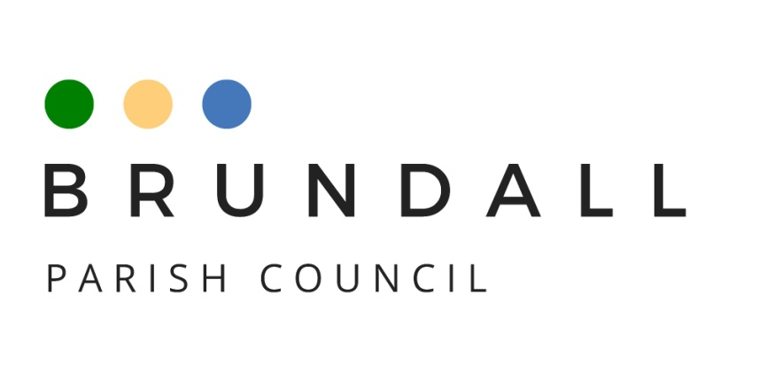

Social Media Policy

The use of digital and social media and electronic communication enables the Parish Council to interact in a way that improves the communications both within the Parish Council and between the Parish Council and the people, businesses and agencies it works with and serves.

The Parish Council has a website, a Facebook page, and uses email to communicate. The Parish Council will always try to use the most effective channel for its communications. Over time the Parish Council may add to the channels of communication that it uses as it seeks to improve and expand the services it delivers. When these changes occur this Policy will be updated to reflect the new arrangements.

The Parish Council Facebook page and website are intended to provide information and updates regarding activities and opportunities within our Parish and promote our community positively.

Rules of engagement

Communications from the Parish Council will meet the following criteria:
- Be civil, tasteful and relevant;
- Not contain content that is knowingly unlawful, libellous, harassing, defamatory, abusive, threatening, harmful, obscene, profane, sexually oriented or racially offensive;
- Not contain content knowingly copied from elsewhere, for which we do not own the copyright;
- Not contain any personal information, other than necessary basic contact details;

- Posts on the Council’s Facebook page will be approved by a majority decision of the Social Media Group. It will be moderated by either the Chair of the Parish Council or by the Clerk to the Parish Council
- Social media will not be used for the dissemination of any political advertising.

Facebook

In order to ensure that all discussions on the Parish Council’s Facebook page are productive, respectful and consistent with the Council’s aims and objectives, we ask you to follow these guidelines:
- Be considerate and respectful of others. Vulgarity, threats or abuse of language will not be tolerated.
- Differing opinions and discussion of diverse ideas are encouraged, but personal attacks on anyone, including the Parish Council members or staff, will not be permitted.
- Share freely and be generous, but be aware of copyright laws; be accurate and give credit where credit is due.
- Stay on topic.
- Refrain from using the Council’s Facebook page for commercial purposes or to advertise, market or sell products.
The sites are not monitored 24/7 and we will not always be able to reply individually to all messages or comments received. However, we will endeavour to ensure that any emerging themes or helpful suggestions are passed to the relevant people or authorities. Please do not include personal/private information in your social media posts to us.

Sending a message/post via Facebook will not be considered as contacting the Council for official purposes and we will not be obliged to monitor or respond to requests for information through these channels. Instead, please make direct contact with the Council’s Clerk and/or members of the council by emailing.

The Council retains the right to remove comments or content that includes:
- Obscene or racist content
- Personal attacks, insults, or threatening language
- Potentially libellous statements.
- Plagiarised material; any material in violation of any laws, including copyright
- Private, personal information published without consent
- Information or links unrelated to the content of the forum
- Commercial promotions or spam
- Allegations of a breach of a Council’s policy or the law

The Parish Council’s response to any communications received not meeting the above criteria will be to either ignore, inform the sender of our policy or send a brief response as appropriate. This will be at the Council’s discretion based on the message received, given our limited resources available. Any information posted on the Facebook page not in line with the above criteria will be removed as quickly as practically possible. Repeat offenders will be blocked from the Facebook page. The Parish Council may post a statement that, ‘A post breaching the Council’s Social Media Policy has been removed’. If the post alleges a breach of a Council’s policy or the law the person who posted it will be asked to submit a formal complaint to the Council or report the matter to the Police as soon as possible to allow due process.

